How to Review an eForm
How to review any submitted eForm and the approval process.

1 | Under the Teaching, Advising & Support homepage
2 | Choose Student Forms Pending Approval  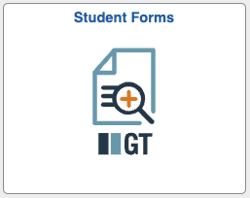
3 | Choose Evaluate Student Forms
4 | You can click search to see all forms available to you OR search using the fields provided to look up a specific form  - Your Form ID is a 6-digit number, this number is also in the emails you received if you happen to have more than one form  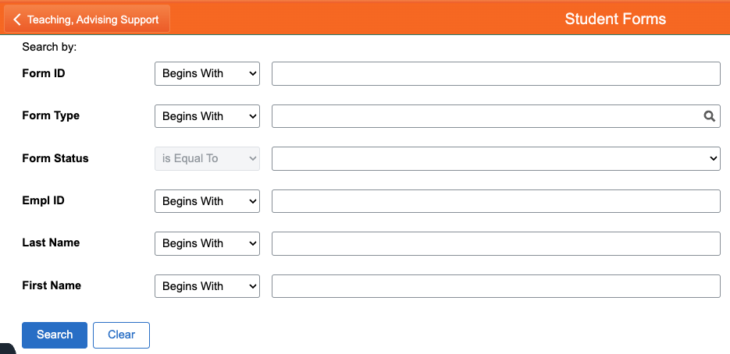
5 | Click the form ID to open your form
6 | On the page that opens you can see all the details of the student and form
7 | Click Next at the bottom to go to approvals
8 | This will be a list of who has approved and signed the form  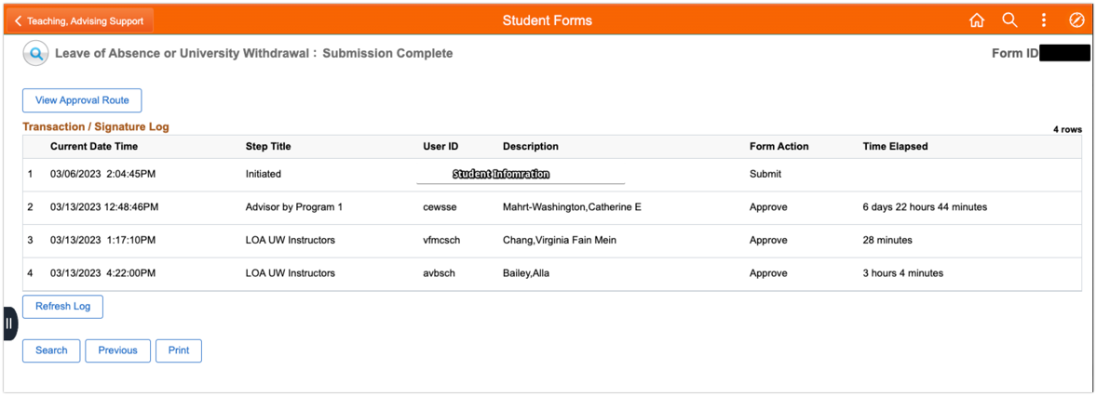
9 | To view what approvals are left click View Approval Route
10 | Opening the carrot will show the approver names  