Rochester INSTITUTE OF TECHNOLOGY
Minor Program proposal form

College of Applied Science & Technology
Department of Packaging Science

Name of Minor: Packaging Science

Brief description of the minor to be used in university publications
The packaging science minor offers courses covering a broad range of packaging activities, including development/design, testing, marketing, and production. Related legal, economic, and environmental/sustainability concerns are also addressed. Students from majors such as engineering, engineering technology, multidisciplinary studies, management, marketing, international business, industrial design, and print media could all benefit from the packaging science minor.

1.0 Minor Program Approvals
 | Approval request date: | Approval granted date:
Academic Unit Curriculum Committee
College Curriculum Committee |  | May 2014
Inter-College Curriculum Committee

2.0 Rationale:
A minor at RIT is a related set of academic courses consisting of no fewer than 15 semester credit hours leading to a formal designation on a student's baccalaureate transcript

How is this set of academic courses related?
The course set begins with the basic terminology and technology for the packaging field. This is accomplished in PACK 301 and PACK 302. These courses are designed for and are only available to students in the Packaging Science minor or other non-Packaging Science programs of study. The packaging electives offer the opportunity to focus on specific areas within the industry, allowing the student insight into possible career directions.

3.0 Multidisciplinary involvement:

If this is a multidisciplinary minor spanning two or more academic units, list the units and their role in offering and managing this minor.
NA

4.0 Students ineligible to pursue this minor:
The purpose of the minor is both to broaden a student's college education and deepen it in an area outside the student’s major program. A minor may be related to and complement a student’s major, or it may be in a completely different academic/professional area. It is the responsibility of the academic unit proposing a minor and the unit’s curriculum committee to indicate any home programs for which the minor is not a broadening experience.

Please list below any home programs whose students will not be allowed to pursue this minor, provide the reasoning, and indicate if this exclusion has been discussed with the affected programs:
Packaging Science majors are ineligible for this minor. This is stated on the course outlines for PACK 301 and PACK 302. The content would be redundant.

5.0 Minor Program Structure, Sequence and Course Offering Schedule:
Describe the structure of the proposed minor and list all courses, their anticipated offering schedule, and any prerequisites.
- All minors must contain at least fifteen semester credit hours;
- Minors may be discipline-based or interdisciplinary;
- In most cases, minors shall consist of a minimum of two upper division courses (300 or above) to provide reasonable breadth and depth within the minor;
- As per New York State requirements, courses within the minor must be offered with sufficient frequency to allow students to complete the minor within the same time frame allowed for the completion of the baccalaureate degree;
- Provide a program mask showing how students will complete the minor.

Narrative of Minor Program Structure:
Students begin their minor with an overview of packaging materials and container structures. Basic product applications are included in the overview. Students then survey the areas of focus and select a minimum of three electives from the packaging science course listings that will enhance their career options.
Students would typically complete the minor by taking PACK 301 and 302 in one academic year and adding at least 9 more credit hours from the optional course list over the next academic year. PACK 301 and 302 are available to non-Packaging Science majors only. The minor requires a minimum of 15 semester credit hours.

Course Number & Title | SCH | Required | Optional  (Elective) | Fall | Spring | Annual/Biennial | Prerequisites for minor
PACK 301 Packaging Materials | 3 | X |  | X | X
PACK 302 Packaging Containers | 3 | X |  | X | X
Electives choose 3: (Other courses require approval of the minor advisor)
PACK 471 Packaging Supply Chain | 3 |  | X |  | X |  | PACK 301, 302
PACK 530 Packaging Sustainability/Environment | 3 |  | X | X |  |  | PACK 301, 302
PACK 535 Characterization and Evaluation of Polymer Packaging | 3 |  | X | X | X |  | PACK 301, 302  CHMG 121, CHMG 123, CHMG 201
PACK 546 Pharm and Med Packaging/  PACK 547 Lab | 2  1 |  | X |  | X |  | PACK 301, 302
PACK 550 Packaging Machinery | 3 |  | X |  | X |  | PACK 301, 302
PACK 555 Import/Export Packaging | 3 |  | X |  | X |  | PACK 301, 302
Total credit hours: | 15

Policy Name: D1.1 MINORS POLICY
1. Definition
A minor at RIT is a related set of academic courses consisting of no fewer than 15 semester credit hours leading to a formal designation on a student's baccalaureate transcript.
The purpose of the minor is both to broaden a student's college education and deepen it in an area outside the student’s major program. A minor may be related to and complement a student’s major, or it may be in a completely different academic/professional area. It is the responsibility of the academic unit proposing a minor and the unit’s curriculum committee to indicate any home programs for which the minor is not a broadening experience.

In most cases, minors shall consist of a minimum of two upper division courses to provide reasonable breadth and depth within the minor.
2. Institutional parameters
- Minors may be discipline-based or interdisciplinary;
- Only matriculated students may enroll in a minor;
- At least nine semester credit hours of the minor must consist of courses not required by the student's home program;
- Students may pursue multiple minors. A minimum of nine semester credit hours must be designated towards each minor; these courses may not be counted towards other minors;
- The residency requirement for a minor is a minimum of nine semester credit hours consisting of RIT courses (excluding "X" graded courses);
- Posting of the minor on the student's academic transcript requires a minimum GPA of 2.0 in each of the minor courses;
- Minors may not be added to the student's academic record after the granting of the bachelor's degree.
3. Development/approval/administration processes
  - Minors may be developed by faculty at the departmental, inter-departmental, college, or inter-college level. As part of the minor development process:
    - students ineligible for the proposed minor will be identified;
    - prerequisites, if any, will be identified;
  - Minor proposals must be approved by the appropriate academic unit(s) curriculum committee, and college curriculum committee(s), before being sent to the Inter-College Curriculum Committee (ICC) for final consideration and approval.
  - The academic unit offering the minor (in the case of interdisciplinary minors, the designated college/department) is responsible for the following:
    - enrolling students in the minor (as space permits);
    - monitoring students progress toward completion of the minor;
    - authorizing the recording of the minor's completion on student's academic records;
    - granting of transfer credit, credit by exam, credit by experience, course substitutions, and advanced placement;
    - responding to student requests for removal from the minor.

  - As per New York State requirements, courses within the minor must be offered with sufficient frequency to allow students to complete the minor within the same time frame allowed for the completion of the baccalaureate degree.
4. Procedures for Minor revision
It is the duty of the college curriculum committee(s) involved with a minor to maintain the program’s structure and coherence. Once a minor is approved by the ICC, changes to the minor that do not have a significant effect on its focus may be completed with the approval of the involved academic unit(s) and the college curriculum committee(s). Significant changes in the focus of the minor must be approved by the appropriate academic unit(s) curriculum committee(s), the college curriculum committee(s) and be resubmitted to the ICC for final consideration and approval.

(2/13/12; rev 8/2/16 jm)

For CAST reference only file screenshot edits/bulletin corrections originally submitted May 2016
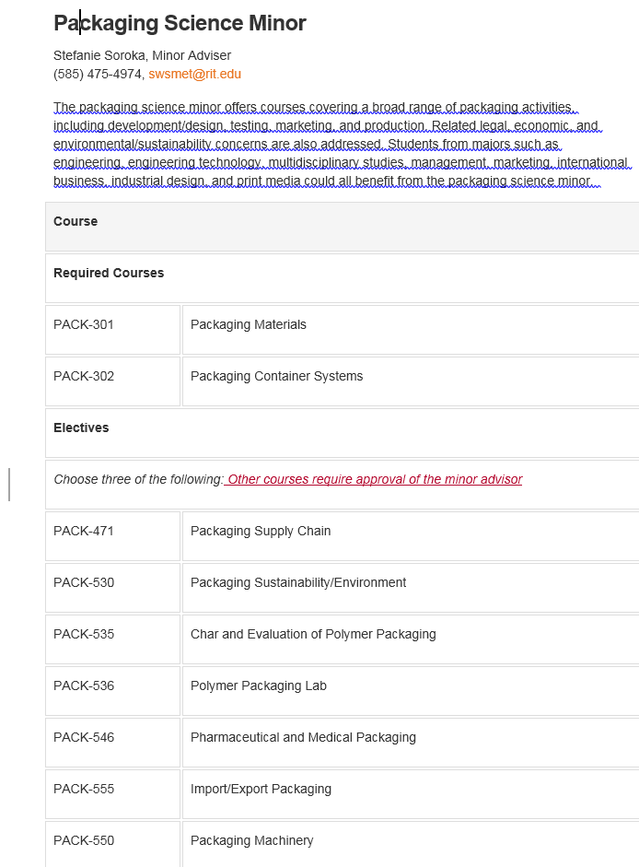8/2/16 additional correction required: PACK 535 now LEL, 3 credits >delete 536 Lab; add lab to lecture listed PACK 546/ 547 lab

