Index of the Concept Paper for the proposed
NTID 3D Computer Graphics program

- Revised Concept Paper
- Appendix A. Previous version of the Concept Paper
- Appendix B. Community feedback from Dr. David Schwartz, IGM faculty
- Appendix C. Community feedback from Marla Schweppe, Chair of 3DDD
- 3DCG Program Costs

Revised Concept Paper for the proposed
NTID 3D Computer Graphics program

I. Title/Department/College

3D Computer Graphics

A new associate in applied science (AAS) degree program supported by the Arts & Imaging Studies (AIS) department at the National Technical Institute for the Deaf, a college of RIT.

II. Describe goals and justification for the proposed program

With the growth in the use of entertainment and simulation software, mobile applications (“apps”), animated training material, architectural visualization from blueprints, and pre-visualization of high end computer imagery that span various industries in the working world, there has been an increase in interest in the creation and development of 3D Computer Graphics by prospective students and students who are already enrolled in the college of NTID. There has also been a documented increase in interest from prospective students at NTID for the opportunity to acquire skills in the creation of 3D Computer Graphics. The proposed 3D Computer Graphics program will meet the demand at the AAS associates degree level by focusing on the production and creation of graphics, 3D models, and animations that are used in architectural visualization, animation, multimedia, computer imagery, and 3D modeling. The 3D Computer Graphics associate degree will provide students exposure and experience in both the creative and technical areas of 3D Computer Graphics while working in both individual and team-based project environments.

The goals of the proposed program are to:

- Provide students with an understanding of the project workflows in the 3D Computer Graphics industry.
- Develop production skills in creating 3D Computer Graphics.
- Foster creative approaches to 3D graphics for use in visualization and multimedia.
- Apply traditional and computer-based skills to the creation of 3D Graphics.
- Implement 3D Computer Graphics in various multimedia formats.
- Develop skills in computer software required for the creation of 3D Computer Graphics
- Develop team-based collaboration and communication skills.
- Understand the employment opportunities for students with an associate level degree in this major.

III. Description of the new program: summarize program curriculum and other program aspects

NTID is always exploring opportunities to expand the range of its programmatic offerings to Deaf and hard-of-hearing students. As part of this effort, the Arts and Imaging Studies department initiated discussion and development of a 3D computer graphics -focused program. The preliminary discussions and research into this field suggested that creating 3D Computer Graphics requires an interdisciplinary approach to the creation of successful 3D imagery that combines skills from art, design, engineering, and communication.

After identifying the broad scope of jobs and skills expected in the 3D Computer Graphics industry, the AIS department identified the area of graphics and imaging that are used for 3D modeling, animation, and visualization as being the primary areas of focus in the program for training for students at the associate degree level.

The goal of the proposed program is to attract students qualified for the AAS degree level who possess creative visual communication skills, who are interested in working in the 3D Computer Graphics field while preparing and training them for entry-level employment in industry. The proposed 3D Computer Graphics program will cover the “artistic” side of the industry, with a specific focus on the modeling, animation, and visualization aspects of 3D Computer Graphics. Students will acquire the creative and technical skills required to create 3D graphics, 3D printouts, architectural visualization graphics, and building 3D models used in multimedia and animation.

The program will also require students to acquire skills in traditional media drawing and painting, as well as in animation, modeling, 3D printing, reading and understanding architectural plans, and computer-based skills in 2D and 3D graphics software. In addition, students will acquire skills related to project management and teamwork.

The marketplace for employment in the 3D Computer Graphics area has grown considerably, and jobs can be found worldwide. Generally, jobs can be found that are full-time, part-time, or on a contract basis; however, the nature of employment in this industry is primarily project based. Many of the available jobs are contract based. There is a high level of competition for employment at all levels, but many entry-level jobs can be found in the 3D computer graphics industry. For employment, students in the 3D Computer Graphics program will be prepared and qualified for obtaining entry-level employment in the industry, finding jobs with titles such as: Junior Computer Graphic Designer, Junior Computer Animator, Technical Illustrator, 3D Illustrator, 3D Animator, Junior Environment Artist, Junior Animator, 3D Generalist, Modeler, Animator, Texture Artist, 3D Visualization Artist, and Rigger.

An initial outline of the courses that will be offered for the 3D Computer Graphics program from the AIS department, and excluding general education courses, is offered below:

3DCG Technical Courses
Semester 1 | Cr.
NAIS-130 Raster & Vector Graphics | 3
NGRD-111 Drawing I | 3
NAIS-120 Prin. of Design & Color | 3
3D Modeling Fundamentals | 3
Semester 2
NCAD-150 Engineering Graphics in AEC | 3
3D Printing | 3
3D Lighting and Textures | 3
Semester 3
ARTH-135 SWAA | 3
3D Motion | 3
3D Visualization | 3
NAIS-201 Employment Seminar | 3
Semester 4
ARTH-136 SWAA | 3
4D Design | 3
Advanced 3D Techniques | 3
COOP
Semester 5
NAIS-292 Portfolio Workshop | 3
Capstone  (Team Project) | 3

For the proposed curriculum plan, there will be eight courses that will be created for the new program (shown above in bold) and the program will also draw on existing courses (shown in italics): five from AIS department course offerings, two Survey of Western Art and Architecture (SWAA) courses from CIAS, and one course from the NTID Engineering Studies department, NCAD-150 Engineering Graphics in Architecture, Engineering and Construction (AEC). Doing this will allow students to draw their skills from a broad mix of faculty and student perspectives. With the curriculum working within the associate degree structure, there will be no electives offered in this program.

The proposed 3D Computer Graphics program will fit a niche at NTID and RIT that is not fully served in existing NTID academic programs at the AAS degree level.

b. Visual summary of new program curriculum
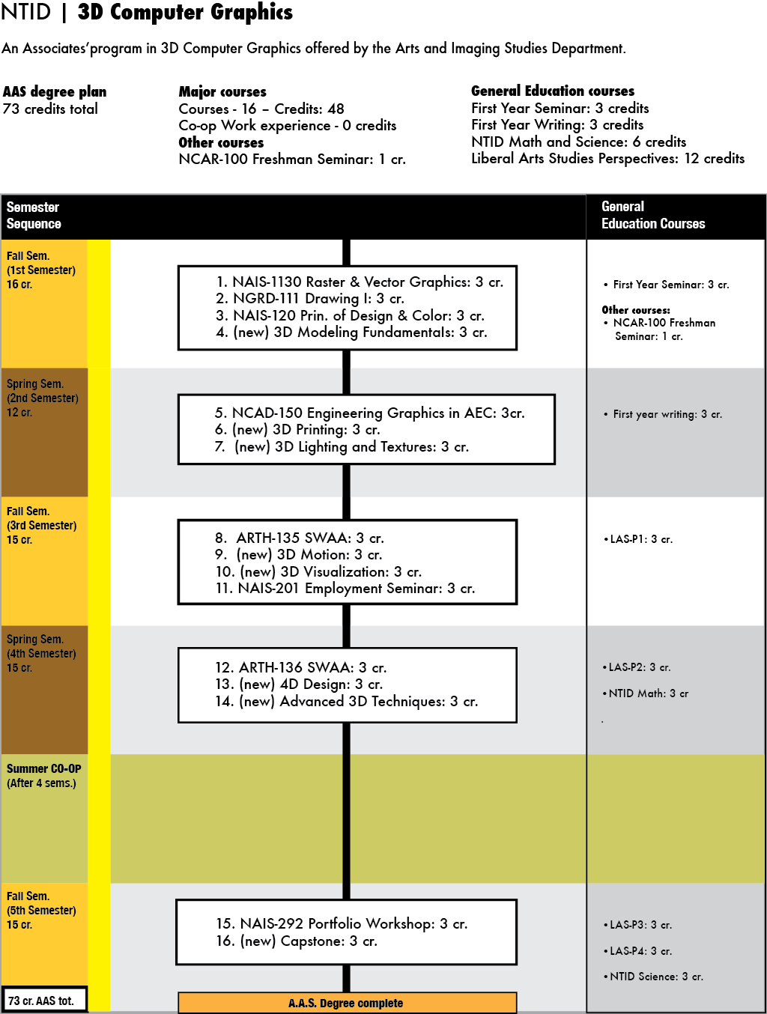

IV. Describe new program’s fit with RIT’s Mission and strategic directions

From the RIT Strategic plan, and its mission statement:

“Our mission is to provide technology-based educational tracks for personal and professional development. We rigorously pursue new and emerging career areas. We develop and deliver curricula and advance scholarship relevant to emerging technologies and social conditions.”
The 3D Computer Graphics program will be a new addition to the NTID education portfolio that will allow students to earn an associate degree in new and rapidly growing fields and will lead to opportunities for students to enter baccalaureate degree tracks in other colleges within RIT. The proposed program addresses the new and rapidly growing field of 3D Computer Graphics. The growth of this area over the last few years in the consumer market has been exponential, and the use of the technologies and products from multimedia to 3D printing and architectural visualization has had an impact on the daily experiences of today’s increasingly computer-literate society. The proposed program will allow our students to have an opportunity to acquire technical skills and knowledge to pursue entry-level careers in the 3D Computer Graphics industry, or prepare them for further study at the baccalaureate degree level.

V. Synergy with other programs: describe curricular linkages with other academic programs and associated interdisciplinary connection

Links within the same college (NTID)

The new program will draw on the expertise of faculty in the NTID Arts & Imaging Studies department (AIS) who teach the Graphics, Animation, and Design courses. There will be cross-disciplinary opportunities to work with faculty from the NTID Engineering Studies program in the curriculum development process for the NCAD-150 Engineering Graphics in AEC and 3D Printing courses. The plan is to have the NTID Engineering Studies faculty teach NCAD-150 Engineering Graphics in AEC, and AIS faculty teach 3D Printing and 3D Visualization courses with input from Engineering Studies faculty for technical expertise. There is potential for the 3D Visualization and 3D Printing courses to serve as required courses for the proposed program and also serve as technical electives for the Engineering Studies program.

Links to BFA/BS tracks in other colleges at RIT

After students complete their associate degree in the 3D Computer Graphics program, they can decide between two options: to enter the workforce, or to pursue further study at the baccalaureate degree level at RIT. There is one college that has a BFA program that is identified as having a good fit with the program outcomes of the 3D Computer Graphics program. This BFA program is in the 3D Digital Design (3DDD) program in the School of Design at the College of Imaging Arts and Sciences at RIT.

The CIAS 3D Digital Design program has indicated their support for our proposed program and has stated their willingness to accept qualified AAS graduates from our program to their BFA program with transfer credits being accepted from the AAS program to the BFA program. The AIS curriculum committee has worked closely with the chair of the 3D Digital Design program to get her insights and feedback for the proposed program.

VI. Administrative structure for the new program

The administrative structure of the proposed 3D Computer Graphics will closely align with the standard administrative structure of the Institute. The AIS chair will have administrative duties related to faculty and budget for the proposed program. The chair and the program coordinator will be responsible for overseeing curriculum development, faculty course assignments, managing and tracking student enrollment in the program, and assisting in outreach for the program.

VII. Enrollment management expectations and sustainment

Due to the nature of the college of NTID, traditional overall college enrollment numbers are not proportionate to the other colleges of RIT, therefore the enrollment expectations for the 3D Computer Graphics program will be in line with historical enrollment for individual NTID departments.

One set of enrollment data from the NTID admissions office shows that the number of prospective students in 2011-2012 who express a primary interest in, but are not qualified to enter the BS/BFA tracks in Film/Animation, Video Game Development, New Media Design and Imaging, and 3D Digital Design were:
Program | 2011 | 2012
Film/Animation BFA | 23 | 19
Video Game/Development BS | 30 | 27
3D Digital Design | 6 | 12
New Media Design and Imaging | 2 | 3

The numbers show that there is a consistent, high level of interest from students who qualify for the associate degrees at NTID at RIT. Outside of the pool of students who apply to RIT/NTID, this program will also tap the market of deaf students who might be planning to attend other colleges due to the lack of an existing 3D Computer Graphics program. The proposed program is an identified growth opportunity for NTID to attract a group of students who might not otherwise attend the college due to the lack of availability of academic programs that are in line with their future career interests.

With the expectation for the 3D Computer Graphics program to be in line with historical enrollment for individual NTID programs, we anticipate the initial enrollment for the 3D Computer Graphics program to be 10 students. As the program grows, there will be a projected program enrollment growth maximum of 28 students in the program each Fall due to the availability of existing faculty, facilities, and working under the current budgetary considerations at NTID. We calculated the maximum number of 28 students because we anticipate 10 entering the program each year, 9 students returning for their second year, and 9 students who return after their co-op work experience to complete their last semester during their third year.

When considering attrition as a natural occurrence in academic programs, drawing from the enrollment history of the Arts and Imaging Studies department, the AIS has a first-year retention rate of over 70%, and the expectation is that the 3D Computer Graphics program would be in line with this expectation for retention, while operating with the additional understanding that the program will recruit a different type of student than those who traditionally enter the AIS programs covering the areas of graphic design and graphic production.

VIII. Impact on resources

Enrollment
We anticipate that the 3D Computer Graphics program will draw students who normally would not attend NTID at RIT due to the absence of a 3D Computer Graphics program, and will attract qualified associate degree–ready students that would not normally be interested in the current offerings by the AIS department in the graphic design and graphic production areas of learning. The existing AIS program attracts students who are interested in the areas of Graphic Design and Graphic Production, covering Graphic Design, Photo Imaging, Web Design, and Print Publishing. Students who have an interest in 3D graphics would not be served by the existing courses offered in AIS, and would either choose to apply for the 3DDD BFA program or apply to another college. Offering a new program in 3D Computer Graphics would broaden the appeal of NTID to students who are interested in this area of the Graphic Arts industry. The AIS department does not expect to lose students from its current programs to the new program due to the different skill sets and qualifications required for the proposed program. For a general number of students who express interest in the proposed program’s subject area, refer to the chart in section VII. Historically, the AIS department enrollment totals have ranged between 120-140 students. In this academic year, the AIS department has approximately 120 students enrolled full-time into the current program offerings. With the estimated beginning enrollment range of 10 students entering each year, the AIS department will be able to handle the new student levels.

Faculty and Computer Laboratory resources
There are two areas where the new program would have an impact on the existing AIS department. This impact would be felt in regards to the sharing of resources within AIS. The first impact will be in computer lab scheduling availability within the AIS department to accommodate the scheduling of the new program’s courses. Since faculty resources will be shared, the faculty assignments made to the new program will also have an impact on faculty availabilities for the current AIS programs. The AIS department is confident that the current AIS department resources will accommodate the proposed 3D Computer Graphics program. The proposed program will fit with the existing resources, as there is sufficient number of rooms and faculty to accommodate the proposed program courses as well as the semester offerings of the existing AIS program.

Budgetary Implications
It is expected that the introduction of the proposed program will not require incremental budgetary allocations to the AIS department. With the addition of the new program, there will be three areas which will impact the department budget. The first area where anticipated budgetary costs are expected is for faculty professional development, where faculty will develop and refine skills focusing in 3D Computer Graphics. Much of the professional development will be done via enrolling in CIAS courses and by using online training resources. The second and third areas where there will be budgetary considerations are the costs of software and hardware purchases to support the needs of the 3D Computer Graphics program beyond what is currently offered by the AIS department. With the changes in software licensing moving towards subscription licensing, the cost for software licensing may decrease. The use and costs for professional development, software, and hardware will be shared with the other programs in the AIS department, so the costs associated with these three areas of budgetary considerations will result in no incremental implications for the AIS department and the college of NTID. Please refer to Appendix D. 3DCG Program Costs for a breakdown in anticipated program costs.

IX. Conclusion

In summary, the 3D Computer Graphics program will be an attractive new addition to the NTID education portfolio that will allow students to earn an associate degree in the new and rapidly growing field of 3D Computer Graphics. This program will be a complementary addition to the technical education opportunities for students at the associate degree level. In the increasing globalization of the work opportunities for students, the 3D Computer Graphics associate degree will provide students exposure and experience to individual and team-based experiences in both the creative and technical areas of 3D Computer Graphics.

X. Summary of Community Input and Response to Input (This information is
added following the public vetting and prior to review by Provost)

Please refer to Appendices A. Original Program Proposal, B. Input from Interactive Games and Media, and C. Input from 3D Digital Design for a text of the community input to the original Concept Paper.

As part of the curriculum development process, the AIS department had originally submitted a concept paper proposal for a Game and Simulation Graphics program during the academic year 2012-2013. The department went through the steps in the process and received approvals to proceed at each step until we reached the Institute-wide community feedback process. We received two sets of feedback for the Game and Simulation Graphics program proposal during the two-week review period.

One set of feedback received was positive, from the CIAS 3D Digital Design program (3DDD), and one set of feedback received was negative, from the GCCIS IGM Game Design and Development program. The strength of the negative feedback caused the administration and the department to step back and review the criticism received and analyze the issues with our proposal. In addressing the community feedback received from two academic programs at RIT during the RIT’s Academic Program Review process, the AIS department shifted the new program proposal’s focus to the field of 3D graphics, while eliminating the game aspects of the program proposal. This aligns the revised proposal for the AAS program more closely with the College of Imaging Arts and Sciences’ BFA 3DDD program.

The rationale for the decision to shift focus of the program proposal stems from the Academic Program Review response from Dr. David Schwartz of IGM that indicated that an AAS degree in Game and Simulation Graphics program would be insufficient time to develop a graduate who would be able to find employment in the game industry. Also in their response, they drew the conclusion that the proposed program would try to create and imply linkages to the current Game Design & Development (GDD) BS program in IGM in order to attract students to the proposed program. After some discussion within AIS, it was decided that a focus on the 3D graphics area would be more desirable. Please refer to Appendix B of this document for the complete text of Dr. Schwartz’s feedback.

Removing the focus from this direction for the program proposal and redefining the focus towards 3D graphics allows AIS to align the proposed AAS program outcomes to better match up with the BFA 3DDD program in CIAS. The chair of the 3DDD program, Marla Schweppe, is an extremely supportive ally and AIS worked with her to approve the concept of the new 3D Computer Graphics AAS program proposal. She supports the new program proposal and is open to accepting qualified AAS graduates from the proposed program to the BFA 3DDD program.

The NTID Curriculum Committee reviewed the revised Concept Paper and is also very supportive of the new 3D Computer Graphics AAS program proposal. NCC members noted that in shifting the focus to the field of 3D graphics and eliminating the game aspects the revision strengthens the programs and addresses the concerns raised by GCCIS IGM Game Design and Development program. They believe that the 3DCG program will be sustainable and will prepare students for entry-level jobs or for seeking a higher degree, particularly because of the consultation and support from the CIAS 3D Digital Design chairperson.
This concept Paper was proposed and developed by the AIS 3D Computer Graphics committee, based on an idea discussed and proposed to the AIS department by the AIS chair, Kenneth Hoffmann:

Kurt Stoskopf, committee chair,

Committee members:

Paula Grcevic,

Katherine Olsen,

Heather Smith.

Appendix A.

Previous Concept Paper for the proposed NTID Game and Simulation Graphics Program

I. Title/Department/College

Game and Simulation Graphics

A new associates’ degree program that is supported by the Arts & Imaging Studies department in the National Technical Institute for the Deaf, a college of RIT.

II. Describe goals and justification for the proposed program

With the growth in the use of games, simulation software, mobile applications (“apps”) and animated training material that span various platforms in today’s culture, there has been an increase in interest in the creation and development of games and simulations by prospective students and students who are already enrolled in the college of NTID. There has also been a documented increase in interest from prospective students at NTID for the opportunity to acquire skills in the creation of games and apps. The proposed Game and Simulation Graphics program will meet the demand at the associates degree level by focusing on the production and creation of graphics and animations used in games, character designs, and designing the user experience in games. Basic programming concepts and the use of game engines will also be used to create games and applications. The collaborative structure of the Game and Simulation Graphics associates’ degree will provide students exposure and experience in both the creative and technical areas of games and simulation while working in team-based project environments.

In short, the goals of the proposed program are:

- Provide students with an understanding of the project workflows in both the Game Graphics and the Simulation industry segments.
- Develop production skills in creating graphics for games and simulations.
- Foster creative approaches to graphics for use in games and simulations.
- Apply traditional and computer-based skills to the creation of graphics.
- Implement graphics and animation in various game and simulation formats.
- Develop skills in computer software required for creation of games and simulation graphics.
- Develop team-based collaboration and communication skills.
- Understand the employment opportunities for students with an associates’ level degree in this major

III. Description of the new program: summarize program curriculum and other program aspects

NTID is always exploring opportunities to expand the range of its programmatic offerings to Deaf and Hard of Hearing students. As part of this effort, the Arts and Imaging Studies (AIS) department initiated discussion and development of a game graphics-focused program.

The preliminary discussions and research into this field suggested that creating game graphics requires an interdisciplinary approach to the creation of a successful game, combining skills from art, design, programming, writing, and communication.

After identifying the broad scope of jobs and skills expected in the game industry, the AIS department identified the area of graphics and imaging that are used for games and simulations as being the primary area of focus in the program for training for students at the associates’ degree level.

The goal of the proposed program is to attract students with creative visual communication skills, who are interested in working in the game art, design, and animation fields while preparing and training them for entry-level employment in the game industry. The proposed Game and Simulation Graphics program will cover the “artistic” side of the game industry, with a specific focus on the graphics and animation aspects of the games and simulations. Students will acquire the creative and technical skills required to create art, game graphics, visual design for overall user experience, and animate media elements that are used in games and simulations.

While students acquire the needed creative skills, they will also use varying game engines to develop games for the software platforms available in the commercial market. Game engines are software applications that allow the user to create games with the ability to plug in graphics and use the game engine and its associated features and settings to produce the code required for game creation. The gaming industry is moving toward the same model of product creation that graphic design, printing, and web design have been using for many years. These industries use software that abstracts the majority of the coding away from the designer. The game engines work very much like the widely used software applications such as Adobe Dreamweaver and Adobe Illustrator. The game engines that students will use are rapidly becoming industry standards, and are widely used in games available in the marketplace today.

The program will also require students to acquire skills in traditional media drawing and painting, game concept development, storyboarding, storytelling, and computer-based skills in 2D and 3D graphics software, and using game engines. In addition, students will acquire skills related to project management and teamwork.

During their course of study in the Game and Simulation Graphics program, students will take two required, team-based project courses that focus on teamwork and collaboration in developing a game or simulation. The first team-based project course will happen in their third semester, where students will take three regular courses along with one that is a 3-credit team-based project course where they will create a small-scale game or simulation. During their fifth semester in the program, students will take a 3-credit team-based project course where they will create a larger-scale game or simulation as a capstone project for the program.

The marketplace for employment in the game and simulation graphics area has grown considerably, and jobs can be found worldwide. Generally, jobs can be found that are full-time, part-time, or on a contract basis, however, the nature of employment in this industry is primarily project based. Many of the available jobs are contract based. There is a high level of competition for employment at all levels, but many entry-level jobs can be found in the games and simulations industry. For employment, students in the Game and Simulation Graphics program will be prepared and qualified for obtaining entry-level employment in the industry, finding jobs with titles such as: Junior Computer Graphic Designer, Junior Computer Animator, Technical Illustrator, 2D Illustrator, 3D Animator, Junior Environment Artist, Concept Artist, Junior Animator, 3D Generalist, Visual Effect Artist, Modeler, Animator, Texture Artist, Rigger, Storyboard and Concept Artist, and Tester.

An initial outline of the courses that will be offered for the Game and Simulation Graphics program from the AIS department, and excluding general education courses, is offered below:

First Semester Courses
Raster and Vector Graphics
Visual Idea Development
Intro. to Game Design
3D Modeling & Rendering I

Second Semester Courses
Drawing I
Intro. to Game Systems and Engines
3D Modeling & Rendering II
Storytelling & Storyboarding

Third Semester Courses
Computer Animation I
Project Development
Games and Simulations Group Project I

Fourth Semester Courses
Marketing and Business for Games
Computer Animation II
Employment Seminar

Required Co-op experience between fourth and fifth semesters

Fifth Semester Courses
Games and Simulations Group Project II

For the proposed curriculum plan, there will be nine courses that will be created for the new program (shown in bold) and will draw on the existing AIS department course offerings for five courses (shown in italics). Doing this will allow students to draw their skills from a broad mix of faculty and student perspectives. With the curriculum working within the associates’ degree structure, there will be no electives offered in this program.

The proposed Game and Simulation Graphics program will fit a niche at NTID and RIT that is not fully served in academic programs at the associates' degree level.

b. Visual summary of new program curriculum
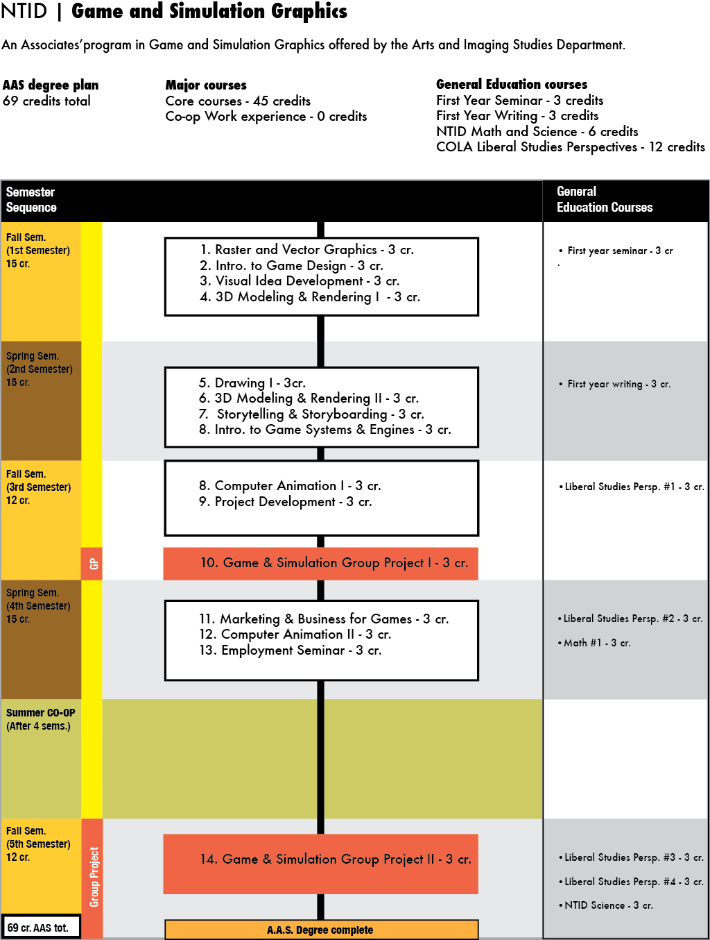

IV. Describe new program’s fit with RIT’s Mission and strategic directions

From the RIT Strategic plan, and its mission statement:

“Our mission is to provide technology-based educational tracks for personal and professional development. We rigorously pursue new and emerging career areas. We develop and deliver curricula and advance scholarship relevant to emerging technologies and social conditions.”
The Game and Simulation Graphics program will be a new addition to the NTID education portfolio that will allow students to earn an associates’ degree in new and rapidly growing fields and will lead to opportunities for students to enter baccalaureate degree tracks in other colleges within RIT. The proposed program addresses the new and rapidly growing field of games and simulation graphics. The growth of this area over the last few years in the consumer market has been exponential, and the use of the technologies and products from games and simulation has had an impact on the daily experiences of today’s increasingly computer-literate society. The proposed program will allow our students to have an opportunity to acquire technical skills and knowledge to pursue entry-level careers in the game and simulation graphics area of the Game and Simulation industry, or prepare them for further study at the baccalaureate degree level.

V. Synergy with other programs: describe curricular linkages with other academic programs and associated interdisciplinary connection

Links within the same college (NTID)

The new program will draw on the expertise of faculty in the NTID Arts & Imaging Studies department (AIS) who teach the Graphics, Animation, and Web Design courses.

Links to BFA/BS tracks in other colleges at RIT

After students complete their Associates’ degree in the Game and Simulation Graphics program, they can decide between two options: to enter the workforce, or to pursue further study at the baccalaureate degree level at RIT. There is one college that has a program that is identified as having a good fit with the program outcomes of the Game and Simulation Graphics program. This BFA program is in the 3D Digital Design program in the School of Design at the College of Imaging Arts and Sciences at RIT.

VI. Administrative structure for the new program

The administrative structure of the proposed Game and Simulation Graphics will closely align with the standard administrative structure of the Institute. The AIS chair will have administrative duties related to faculty and budget for the proposed program. There may be an administrative role that is similar to the Lab Science Technology program at NTID that may be created and assigned to a faculty member who will be responsible for overseeing curriculum development, faculty course assignments, managing and tracking student enrollment in the program, and assisting in outreach for the program.

VII. Enrollment management expectations and sustainment

Due to the nature of the college of NTID, traditional overall college enrollment numbers are not proportionate to the other colleges of RIT, therefore the enrollment expectations for the Game and Simulation Graphics program will be in line with historical enrollment for individual NTID departments.

One set of enrollment data from the NTID admissions office shows that the number of prospective students in 2011-2012 who express a primary interest in, but are not qualified to enter the BS/BFA tracks in Film/Animation, Video Game Development, New Media Design and Imaging, and 3D Digital Design were:

Program | 2011 | 2012
Film/Animation BFA (JPHQ) | 23 | 19
Video Game/Development BS (VIGD) | 30 | 27
3D Digital Design (3DDD) (JADQ) | 6 | 12
New Media Design and Imaging (JADW) | 2 | 3

The numbers show that there is a consistent, high level of interest from students who qualify for the associates’ degrees at NTID at RIT. Outside of the pool of students who apply to RIT/NTID, this program will also tap the market of deaf students who might be planning to attend other colleges due to the lack of an existing Game and Simulation Graphics program. The proposed program is an identified growth opportunity for NTID to attract a group of students who might not otherwise attend the college due to the lack of availability of academic programs that are in line with their future career interests.

While the expectation for the Game and Simulation Graphics program will be in line with historical enrollment for individual NTID departments, we anticipate the initial enrollment for the Game and Simulation Graphics program to be 10 students. As the program grows, there will be a projected program enrollment growth maximum of 30 students (of which contains a group of 10 students returning for their last semester after coop due to the five semester structure of the AAS program) enrolled in the program due to the availability of existing faculty, facilities, and working under the current budgetary considerations at this time at NTID.

When considering attrition as a natural occurrence in academic programs, drawing from the enrollment history of the Arts and Imaging Studies department, the AIS has a first-year retention rate of over 70%, and the expectation is that the Game and Simulation Graphics program would be in line with this expectation for retention, while operating with the additional understanding that the program will recruit a different type of student than those who traditionally enter the AIS programs.

VIII. Impact on resources

Enrollment
We anticipate that the Game and Simulation Graphics program will draw students who normally would not attend NTID at RIT due to the absence of a Game and Simulation Graphics program, and will attract qualified associates’ degree–ready students that would not normally be interested in the current offerings by the AIS department. The expected enrollment impact on the AIS department will be minimal, due to the broad scope of programs and skill paths available in the department. Historically, the AIS department enrollment totals have ranged between 120-140 students. In this academic year, the AIS department has approximately 120 students enrolled full-time into the current program offerings. With the estimated beginning enrollment range of 10 students at each year level, the AIS department will be able to handle the new student levels. The student numbers for the overall AIS department is expected to remain stable. As enrollment approaches the historical maximum for the AIS department, a reduction in enrollment for the other programs in the department may be seen.

Faculty and Computer Laboratory resources
There are two areas where the new program would have an impact on the existing AIS department. This impact would be felt be in regards to the sharing of resources within AIS. The first impact will be in computer lab scheduling availability within the AIS department to accommodate the scheduling of the new program’s courses. Since faculty resources will be shared, the faculty assignments made to the new program will also have an impact on faculty availabilities for the current AIS programs. The AIS department is confident that the current resources will accommodate the proposed Game and Simulation Graphics program.

Budgetary Implications
The AIS department along with funds from the college of NTID will provide the budget for the proposed Game and Simulation Graphics program. With the addition of the new program, there will be three areas where costs will impact the department budget. The first area where anticipated budgetary costs are expected is for faculty professional development, where faculty will develop and refine skills focusing in games and simulations. The second and third areas where there will be budgetary considerations are the costs of software and hardware purchases to support the needs of the Game and Simulation Graphics program beyond what is currently offered by the AIS department. With the changes in software licensing moving towards subscription licensing, the cost for software licensing may decrease. The use and costs for professional development, software, and hardware will be shared with the other programs in the AIS department, so the costs associated with these three areas of budgetary considerations will result in minimal to no budgetary implications for the AIS department and the college of NTID.

IX. Conclusion

In summary, The Game and Simulation Graphics program will be an attractive new addition to the NTID education portfolio that will allow students to earn an associates’ degree in the new and rapidly growing field of games and apps graphics. This program will be a complementary addition to the technical education opportunities for students at the associates’ degree level. In the increasing globalization of the work opportunities for students, the Game and Simulation Graphics associates’ degree will provide students exposure and experience to individual and team-based experiences in both the creative and technical areas of game and simulation graphics.

X. Summary of Community Input and Response to Input (This information is
added following the public vetting and prior to review by Provost)
This concept Paper was proposed and developed by the AIS Game and Simulation Graphics committee, based on an idea discussed and proposed to the AIS department by the AIS chair, Kenneth Hoffmann:

Kurt Stoskopf, committee chair, with committee members, Paula Grcevic, Katherine Olsen, and Heather Smith.

Appendix B.

Community feedback from David Schwartz, IGM faculty

As the Undergraduate Program Coordinator of the School of Interactive Games and Media (IGM), I am responding to the “Concept Paper for the proposed NTID Game and Simulation Graphics Program.” The responses, below, summarize the written and verbal contributions, feedback, and support from all IGM faculty and IGM leadership. As such, when I write “we,” I denote this entire group of contributors.
We have deep reservations the proposed program NTID Game and Simulation Graphics Program. Many of the IGM faculty and leadership have spent over a decade researching, developing, and implementing world-class degree programs in Game Design & Development (GDD) and New Media Interactive Development (NMID). Some of us even have such experience developing similar programs at University at Buffalo and Cornell University. Below, we summarize our responses in several key categories.

1. Scope and focus:

The proposal goes to great lengths to frame the proposal in terms of an Arts experience, even linking the potential output stream to the BFA in 3D Digital Design from CIAS (3DDD). However, the goals and rough sketch of the curriculum conflict with that approach. The courses seem to stretch across production, design, software development, art, team management, character development, and engine use. As such, this spread fails to cover the “artistic” side of the industry. We discuss further course-content issues later in this response.

2. Two-year degrees and market analysis.

The proposal lacks a preliminary investigation into potential employers, letters of support from industry, etc. Nevertheless, IGM has extensive experience in this matter and can provide some analysis in this letter. Two year degrees are generally inappropriate for game design and development, even with a graphics focus (as suggested by the proposal). Occasionally, talented students provide exceptions to the rule, but the vast majority of two-year students lack the skills required to perform well in the industry. We have faculty who have spent several years working with the Educators SIG of the International Game Developers Association and reviewed many curricula. Based on their experience and extensive knowledge, we have continually recommended against accepting students from two-year “games” degrees. Our experience with hiring managers and industry experts continues to affirm this stance. For the few two-year students who DO get hired, we have noted that students with this skill level generally fill temporary positions for production emergencies or quality assurance positions. Even for the graduates of these programs that land longer-term positions, they generally “plateau out” without the four-year emphasis on “Learning to Learn.” Note also that many game industry professionals leave the industry in later stages of their careers, and the jobs they move into require a minimum of a four-year degree.

3. Faculty experience.

We have deep concerns about their experience and qualifications on the game-oriented aspects of their proposed program. In particular, “Introduction to Game Design,” “Introduction to Game Systems and Engines,” “Games and Simulations Group Project I,” “Marketing and Business for Games,” and “Games and Simulations Group Project II” suggest nearly identical course topics (and in some cases, entire courses) in IGM. Granted, the NTID proposal and other courses suggest a focus on game GRAPHICS, which of course, reflects courses in CIAS. But, the courses we note above imply technical and domain-specific content of which IGM has renowned expertise. Several of our faculty (myself included) spent years studying the field, attending conferences, engaging with game industry professionals, developing connections with other institutions, and publishing scholarly works BEFORE creating and implementing our GDD degrees. Although the proposed program might have the faculty to cover the art courses, it is unclear if they have the expertise to cover the other experiences in the curriculum. In addition, it is unclear which of their faculty have ties to the industry, and to games and simulation academia to assist their students in appropriate placement after degree conferral.

4. Course content.

Please refer to the list of courses above in Section 3. (We cover more course content in Sections 5-6, below.) In connection with this list, we highlight this portion of the proposal: “The game and simulation industry is moving toward the same model of product creation that graphic design, printing, and web design have been using for many years. These industries use software that abstracts the majority of the coding away from the designer.” Despite this statement and the proposal’s emphasis that the proposed program will “cover the ‘artistic’ side of the game industry,” production tools and game engines STILL require programming and computational problem solving. Note also that “Simulation” speaks to software development, and we do not see adequate representation of such skills. For example, IGM’s sibling programs in CIAS, New Media Interactive Design, and 3DDD, require all of their students to learn programming early in their education. And from my own professional experience as “Industry Liaison,” I can attest that game design interviews require excellence and breadth in programming and scripting. Although some game engines avoid programming (as discussed in Section 6), they severely limit the range of complexity and efficiency of their products, notwithstanding the artistic and technical skill development of the students. Please consider an example entry-level job posting for an environment artist at Obsidian, who sent their HR representative to RIT about two years ago and continues to work with me:
http://www.gameindustrygrunts.com/job/210/junior-environment-artist-at-obsidian-entertainment-at-obsidian-entertainment.
Note that the job requires a four-year degree and requests scripting experience. Although there are certainly counter examples, they tend to offer less desirable jobs from a student-perspective.

5. Game graphics

The language around graphics seems to align more with graphics programming than with art construction. The distinction is important: game graphics usually focuses on the process of game graphics programming, whereas game art and appropriate approaches differ. A simple Amazon book search of “Game Graphics” will demonstrate the terminology problem. For example, if a transfer student applied to IGM, we would need to refer the student to CIAS programs if they had an appropriate portfolio/evaluation material for the application process.

6. Focus on using engines.

Although a number of academic programs focus on the use of engines as a platform, this focus just adds to a core of non-game related curriculum. There is also a “trap” for potential transfer students: mainstream game programs, like IGM’s BS in GDD, would not accept such courses and experiences. Engine technology designed for specific uses do not generalize to other development domains without extensive effort. Are the students using the “plug-and-play” aspects of the engine (i.e., the “use”), or do they develop with (and within) these tools, as they do in IGM? From an industry perspective, the use-or-develop issue limits a potential applicant’s readiness. Although some companies will look at art experience and level design for a specific engine, these skills are below the same level as established tools in other sectors of the media development landscape. The only tool that approaches this level of acceptance is Unity. But, even in that model, graphics development is external to the package, and development requires suitable knowledge of scripting/programming to leverage the extent of the system. IGM’s Game Engines courses involve development, which requires extensive knowledge of programming, data structures, graphics, mathematics, artificial intelligence, and more. But, the general connotation and first-semester placement of the proposal’s game engines and systems course can only imply use and not development.

7. Budgetary Impact:

We do not agree with this assessment. These costs are substantial, as machines must be new enough to run the latest software, software packages, like Unity, 3DSMAX, Maya, Adobe, Microsoft, and many more. They are rather expensive, and having appropriate technical support to maintain the systems often exceeds the skill and ability of general technical services on campus. Just examine the minimum essential budgetary request of IGM compared with the funded resources to understand the required resources are non-trivial and not minimal.

8. Links to other RIT colleges.

The proposed program notes a connection to New Media Interactive Design and 3DDD, which does seem consistent with the claimed emphasis on computer graphics. But, the proposal states “The proposed program is an identified growth opportunity for NTID to attract a group of students who might not otherwise attend the college due to the lack of availability of academic programs that are in line with their future career interests.” Given that RIT already has tremendously successful four-year programs, we suggest that a new “games” program is superfluous, misleading, and potentially harmful. The games field is fiercely competitive, and we believe that we should rely on the existing four-year programs.

9. Student Perception and impact on other programs.

RIT has phenomenal name recognition via IGM, especially because of the word “games” in our title. Making the Princeton Review’s list of top-10 game program for multiple years has afforded RIT a large and outstanding application pool. Although the proposal suggests that students could continue with other BFA programs at RIT, this program is not an entry vector into IGM’s GDD program. Consider the confusion from an applicant’s perspective: “I’m going to RIT for an AAS in games, RIT has a nationally renowned BS in games, and so, the NTID program will get me into IGM.” Simply put, this proposal suggests a bait-and-switch for a technically focused program or career direction. We worry about the AAS generating several disgruntled students that cannot transfer into IGM have few opportunities elsewhere. As stated in Section 8, we have outstanding and already-existing four-year graphics programs that potential students should apply to.
Overall, there are indeed serious issues to contend with concerning the NTID proposal. We thank the reviewers for taking the time to read through our responses.

Appendix C.

Community Feedback from Marla Schweppe, Chair of 3DDD

I have reviewed this program and support it. The program will give NTID
students a chance to explore this field and prepare for application to the 3D
Digital Design program or for entry level jobs. The combined elements in the
program will make it easy to determine if the student has the skills to
pursue further study, which is a benefit to me as the chair of the 3D Digital
Design program. The students will have a solid foundation in the field.

Appendix D.

3DCG Program costs
