Wisdom of Crowds or Mob Mentality
Beaton, Catherine, Vullo, Ronald P.
Rochester Institute of Technology, Rochester N.Y.
Catherine.beaton@rit.edu
rpv@mail.rit.edu

Abstract: Media, the Latin plural of medium, is a provider of information. Humans are a means of storing or delivering information that began with origin of the humanity,. Current media is variety of platforms such as electronic, mass, multi digital, news, broadcast and social media. This paper examines a popular social media platform, Reddit, which self-professes to be the ‘Front Page of the Internet’ as a mode of crowdsourcing.

Keywords: Crowdsourcing, Social Media

Alice E. Marwick (Marwick 2013) states that social media, as a democratic process, has become a tool prioritizing profits and violating user privacy. The violation of privacy is frequently in the news, and users are now growing to understand the lack of privacy when agreeing to use social media platforms. Signing EULAS (End User Licencing Agreements) involves reading a long document, with fine font, and complex language. In December 2013, an in-class survey of 90 computing students revealed that 7 read EULAS before using social media or installing new software.

Social media, whether it is a news site, a weather site, or a social platform such as Facebook, follow user actions and view user data. Figure 1 below, gathered with data from Google Collusion, shows the sources monitoring a mouse click on www.aljazeera.com, an international news site, without a person’s knowledge or informed consent.

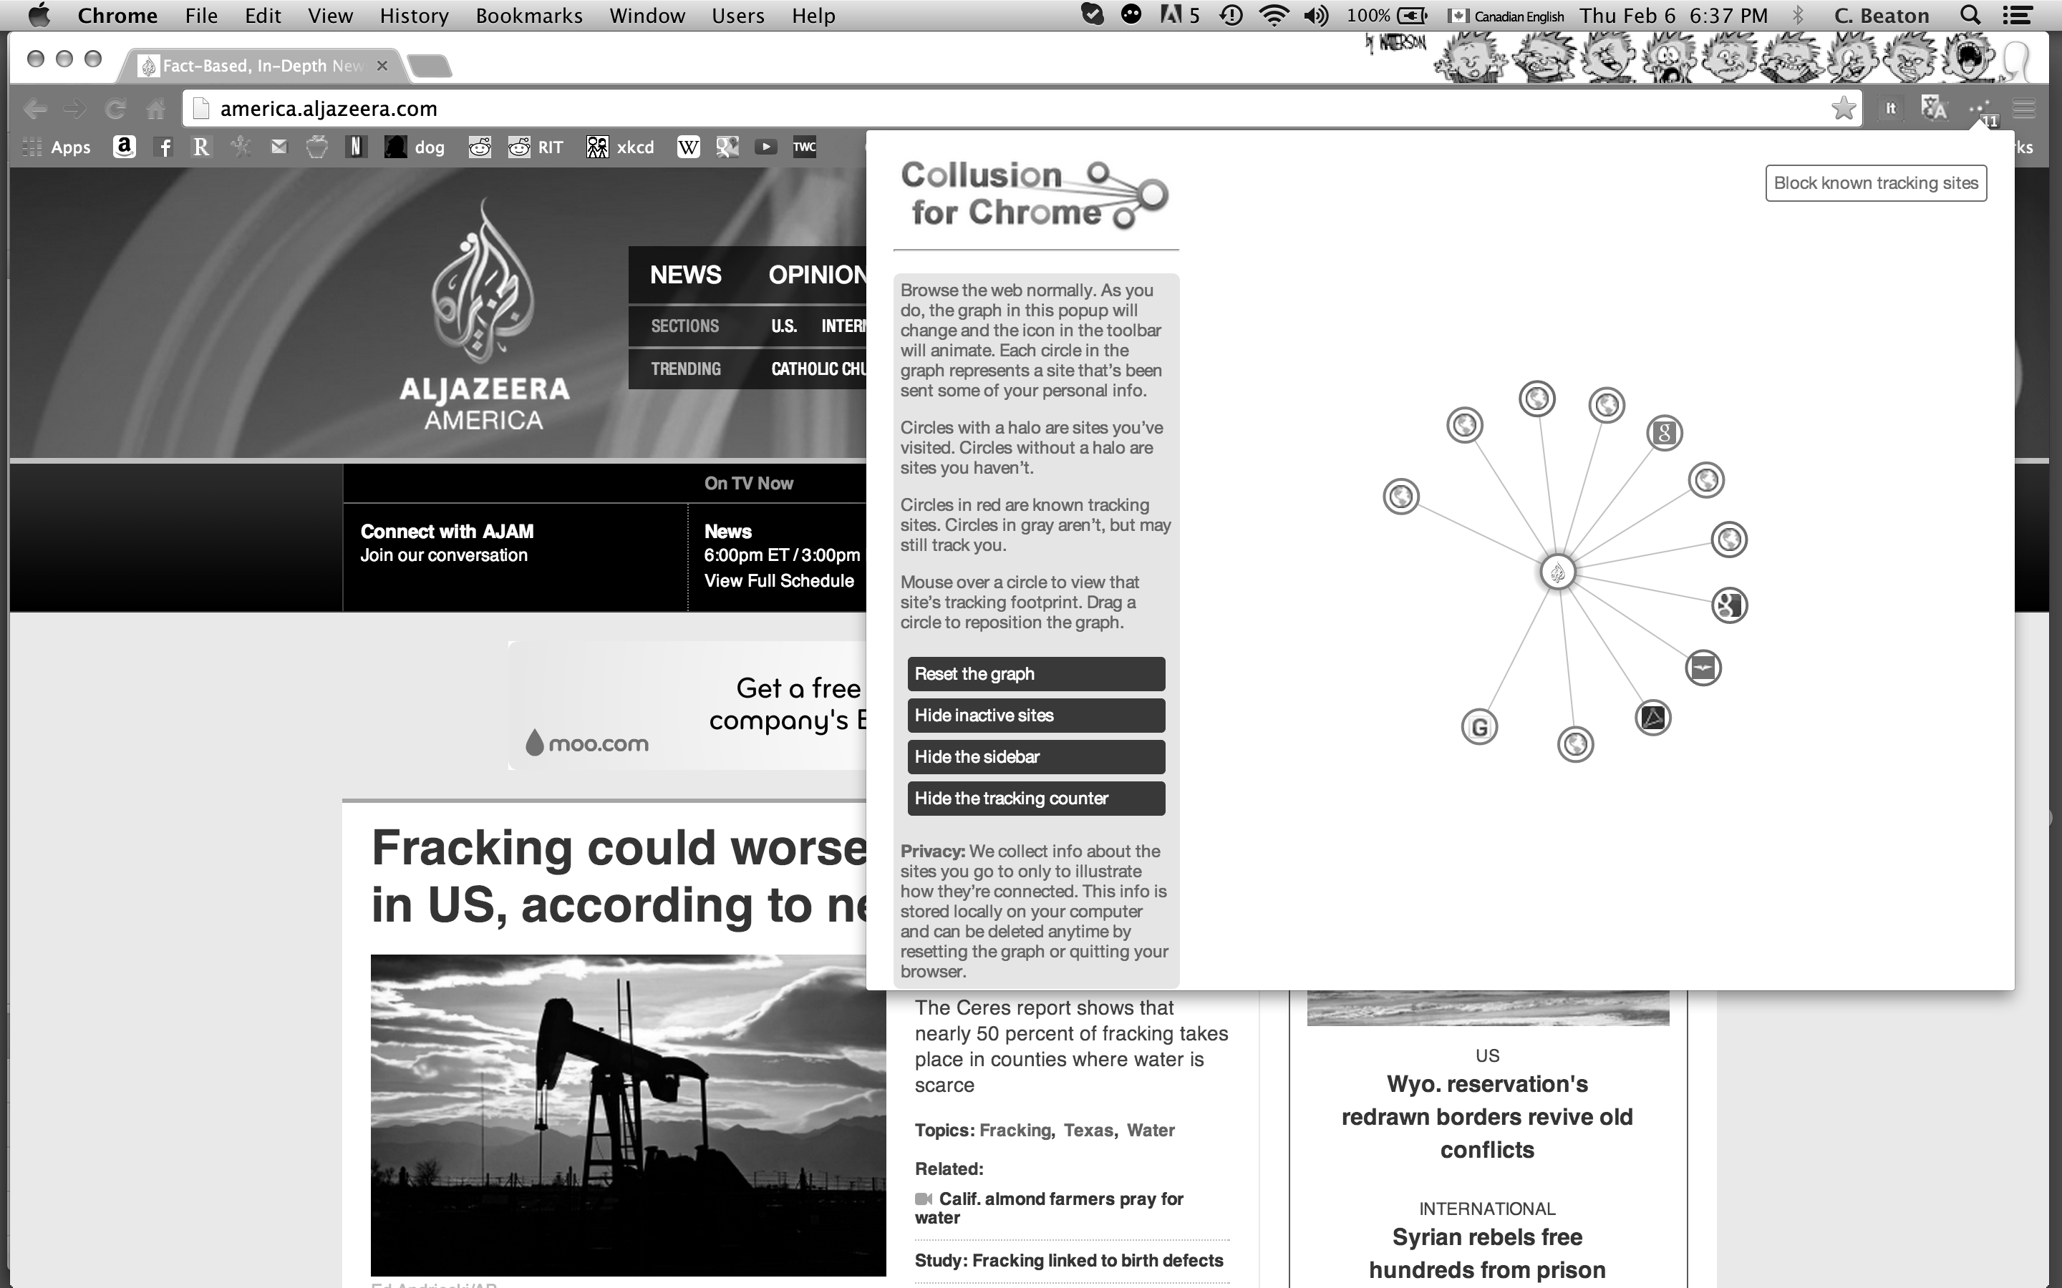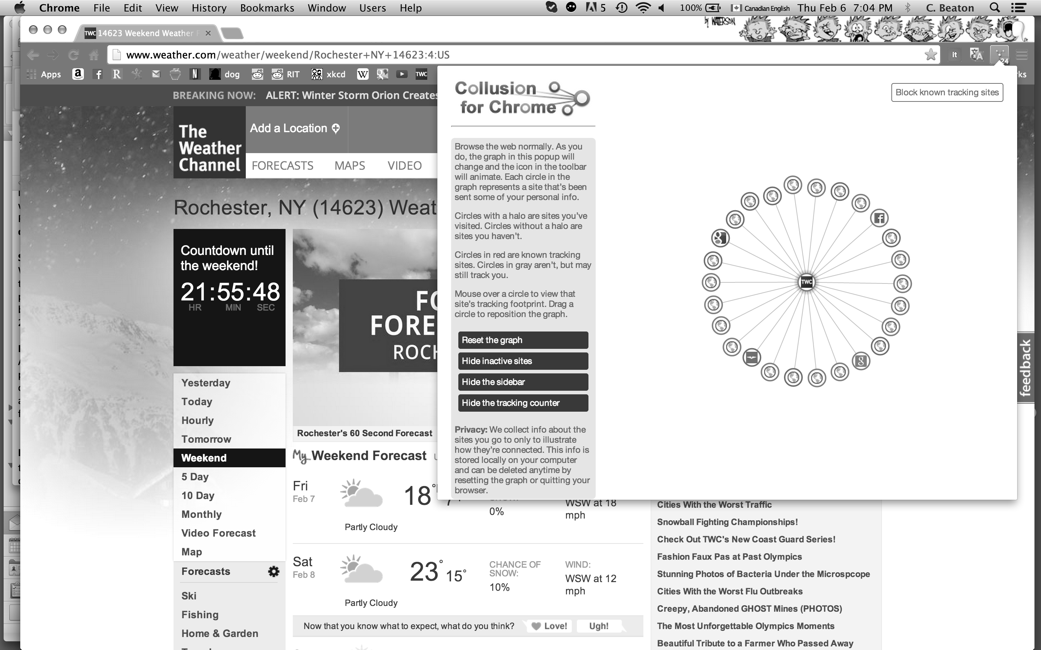
Figure 1: Aljazeera Figure 2: The Weather Channel (TWC)

Users expect to view news, share stories, and leave comments. A user does not expect to have their viewing habits monitored by 12 sources, as the reader loads the web page. Figure 2 demonstrates the 24 sources that monitor a reader’s behavior, upon loading TWC. Figure 3 shows the sources that track users’ behavior on Reddit. The lack of extraneous materials leads for a cleaner, safer, user-friendly environment. It also establishes trust between user and platform.

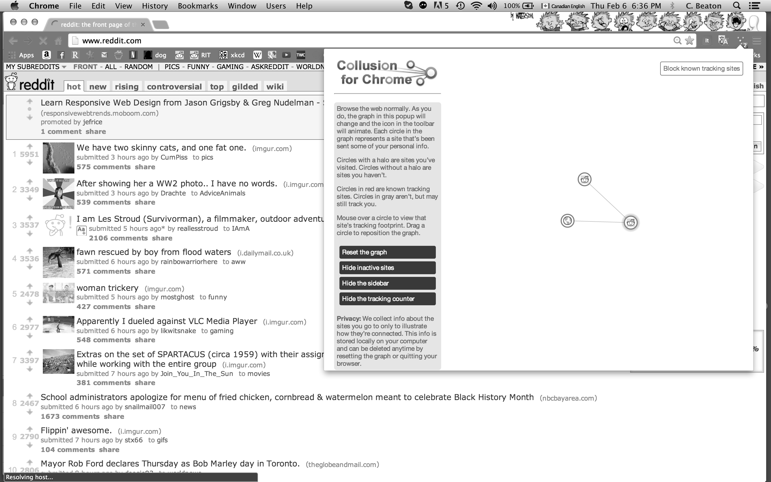
Figure 3: Reddit

Clive Thompson (Thompson 2013) provides statistics for other platforms. According to Thompson, there are 500 million tweets on Twitter, 1 million blogs on Wordpress, and 16 billion words entered on Facebook daily. Twitter allows one user’s perspective to reach his/her followers. Wordpress blogs, permitting user comments are only read by followers or people who stumble across the blog. Facebook allows comments and the post can receive a ‘Like’ represented by a ‘Thumb up’ icon. Posts are limited to followers. Globally, there are 12 billion texts sent daily. The texts are sent to user-specified recipients. Reddit is open to all, and accessible with a self-generated username and password. As an open-source platform, users post news, images and links that has 5.5 billion page views per month, and 113.8 million unique visitors, from 175 countries.

Once registered, a user can ‘upvote’ or ‘downvote’ posts, based on the user’s preference. Anyone can start a community in Reddit, and comments can be left on any Reddit post, or as a thread of message exchanges between the average of 3 million Redditors logged in at any given time. With 7200 active communities, Reddit is a plethora smaller topics, known as subreddits.

With a many-to-many approach of information-sharing, Reddit, like other platforms, has taken advantage of economies of scale and facilitates the sharing of information to the masses. One of the most popular subreddits on Reddit is IAmA( “I am a…” ) where a Redditor posts a subject line, and other redditors ask questions of the IAmA redditor. President Barack Obama hosted this subreddit in 2012, that was upvoted by 14,750 people, and viewed by 5.6 million people. Bill Gates was second in popularity with 8441 upvotes. Upvotes are made by Redditors who like the post.

Reddit has a diverse and frequently vocal population. Redditors draw information from multiple sources to support their individual perspectives, Redditors review the comments and formulate an opinion. With a subreddit such as Obama’s IAmA, the difference between mainstream news and a social media platform is in the real-time nature. Unlike a sound-bite in broadcast news, Reddit interviews become a discussion. Tough questions and kudos are both raised, and participants learn from both the process and the content.

Another subreddit, called Meddit, discusses medical issues. Reddit provides a very clearly phrased disclaimer. A Redditor asked for advice about obtaining insulin for his mother, who had been denied Social Security, Medicare and state care. Within several hours, the Redditor received information about over-the-counter insulin, a savings program for Lantus (a diabetic drug), and a local helpline specific to the Redditor’s community, as well as informing the Redditor that Americans can no longer be denied heath care due to pre-existing conditions such as diabetes. When one Redditor suggested the over-the-counter insulin, another Redditor quickly pointed out that incorrect insulin usage is a recipe for disaster. This is one example of the many instances of Reddit’s information crowd-sourcing.

Crowdsourcing (Howe 2006) was defined as “outsourcing to the crowd.” It is an online problem-solving model, involving feedback and suggestions from those who are interested. Van Ess (Van Ess 2010) says “Crowdsourcing is channeling the experts’ desire to solve a problem and freely share the answer with everyone.” With Reddit, there are many experts who share multiple perspectives, and the most popular suggestions rise to the top. Reddit has become a de facto alternative to journalism; a “collective journalist” demonstrating a willingness to be accountable and to learn from errors.

Within a social web, Rheingold refers to four components of trust that support a successful community. (McKnight 1988) The first level is calculation-based, which is a cost/benefit rationale. “If I participate, what do I gain?’ This level involves a clear decision-making process based on facts. Within the Reddit community, the cost/benefit ratio is reasonable. The cost is the amount of time a person spends in the forums, and the benefit is three-fold: high amusement value, pride of contributing knowledge, and gaining knowledge.

The second level is personal-based trust. Established over a person’s life, people use past experiences to make a decision to trust. Reddit’s anonymity prevents users from knowing each other in the real world, unless they send private messages to exchange personal information. Redditors can examine the past history of comments to gather information about each other, making subjective decisions about trusting the platform and its users.

The third level of trust is based on an instant connection one feels to a person or thing. This pulls into play belief systems, values and a rapport that is established in various subreddits. While the anonymity exists, over time one can get a sense for another Redditor’s style and trustworthiness again, based on past contributions to the community.

The final level of trust is based on a formal structure. Reddit has rules and measures are put into place to protect Redditors. There are collectively determined rules of behavior/norms, modifiable by the community. It is this sense of community that Rheingold first discussed in 1993. His vision of a virtual community was one where people united in a “cross cultural grab bag of written conversations known as IRC Internet Relay Channel.” (Rheingold 1993) Over two decades later, the only change seems to be the platform itself. Instead of IRC, people have a myriad of options for social media interactions.

Successful crowdsourcing entails multiple criteria. (Rheingold 2012) The population must have a collective vision, enough skilled people to sustain the vision, a solid reputation, and shared values. Reddit is a very successful crowdsourcing tool. There is a willingness to act on events due to high interest levels and a desire to problem-solve. The willingness to cooperatively act within groups began at a base level of humanity, when culture determined how people from different backgrounds interacted. Technological changes and the rise of social media have permitted a diverse population a tremendous and very rapid opportunity to effect change. (Boyd et al, 2003) When group boundaries are clearly defined on such a platform as Reddit, good design principles will support change from within the group, full participation, and a system that self-monitors. (Olstrom 1990) As a social media platform, Reddit is philanthropic, educative and controversial. It is the controversies that sometimes pose a problem and raise serious moral issues.

In April 2013, the Boston Marathon was bombed. Reddit set up a subreddit called “FindBostonBombers” and crowdsourced to investigate all evidence available to the public. Visual evidence was examined and analyzed by the community, and conjecture arose. Reddit examined the information and provided an opportunity for interested people to discuss the bombing, and analyze the tragedy. Redditors donated pizzas to the hospitals and police, offered housing and transportation, and set up a relief fund.

The analysis went too far and over-enthusiastic Redditors made unfair allegations. Suffering from a case of groupthink, not enough analysis was given to all possibilities, and Redditors drew a conclusion that had serious moral repercussions. Damage from reporting on unreliable or incomplete information results in a “trial by social media.”

SOPA (Stop Online Piracy Act), was an American government effort to censor the internet. The overwhelming collection action of Reddit led to an internet blackout on Jan 18th 2012, from 8 am – 8 pm. Not long after, other powerful platforms, such as Wikipedia, followed suit. The wisdom of the Reddit mob trickled over into other forms of media. Reddit thoroughly researched and organized actions supported by the collective.

The moral responsibility of media is clear: be sure before accusing/identifying. But in the desire to be ‘first,’ both mainstream news and social media platforms err. Mainstream news reporters are professionals and have a greater obligation to be sure of their information. Social media platforms become a venue for ‘volunteer sleuths.’ Being socially responsible, the Reddit community learned from the misidentification of the Boston Bomber and new guidelines were suggested for future situations. The general manager of Reddit issued a public apology.

Reddit teamed up with The Atlantic, a news platform in Washington, D.C. to set up “Ask Washington Anything,” which is similar to Reddit’s IAmA subreddit, but done by video. Politicians are interviewed using the top ten user-generated questions from the IAmA subreddit. This format avoids the traditional talking points, and people from around the globe have an opportunity to pose questions, and see politics in a different light. Reddit serves as a social platform providing opportunities for social change, problem-solving and news-sharing with interpretations from a range of Redditors.

Zuckerman states, “…we need to paint a broad, global picture so that we can anticipate threats, seize opportunities, and make connections.” (Zuckerman, 2013)The collective power of crowdsourcing can be proactive in seizing opportunities and problem-solving. It also has a responsibility to ensure accuracy through community review, like the Reddit platform. Unlike the one-way presentation of information through news media, the internet is a ball of multi-coloured yarn. Diverse, dense, intertwined, and can unraveled by many opinions, establishing connections through collaboration. The connections should be used to harness the wisdom of the crowd, and not foster the mentality of a mob.

References

Boyd, Robert T, Richerson, Peter J., Henrich, Joseph, (2003) Genetic and Cultural Evolution of Cooperation, MIT Press, Mass.
Howe, Jeff, Blog Jeff ( 2006) Available from: <http://crowdsourcing.typepad.com/cs/2006/06/crowdsourcing_a.html>
Marwick, Alice E., (2013) Status Update, Celebrity, Publicity, and Branding in the Social Media Age, Yale University Press, CT
McKnight, D. Harrison, Cullings, Larry L., Chervany, Normal L., (1998) “Initial Trust Formation in New Organizational Relationships”, The Academy of Management Review Vol. 23, No. 3, pp 141-144
Olstrom, Elinor, (1990) Governing the Commons: The Evolution of Institutions for Collective Action, Cambridge University Press, UK
Rheingold, Howard, (2012) Net Smart How to Thrive Online, MIT Press, Mass.
Thompson, Clive, (2013) Smarter Than You Think, Penguin Press, NY
Van Ess, Henk, (2010) “Crowdsourcing: How to Find a Crowd”, Presented at ARD ZDF Akademie, Sept 17th, 2010.
Zuckerman, Ethan, (2013) Rewire, W. W. Norton & Company, Inc., NY

