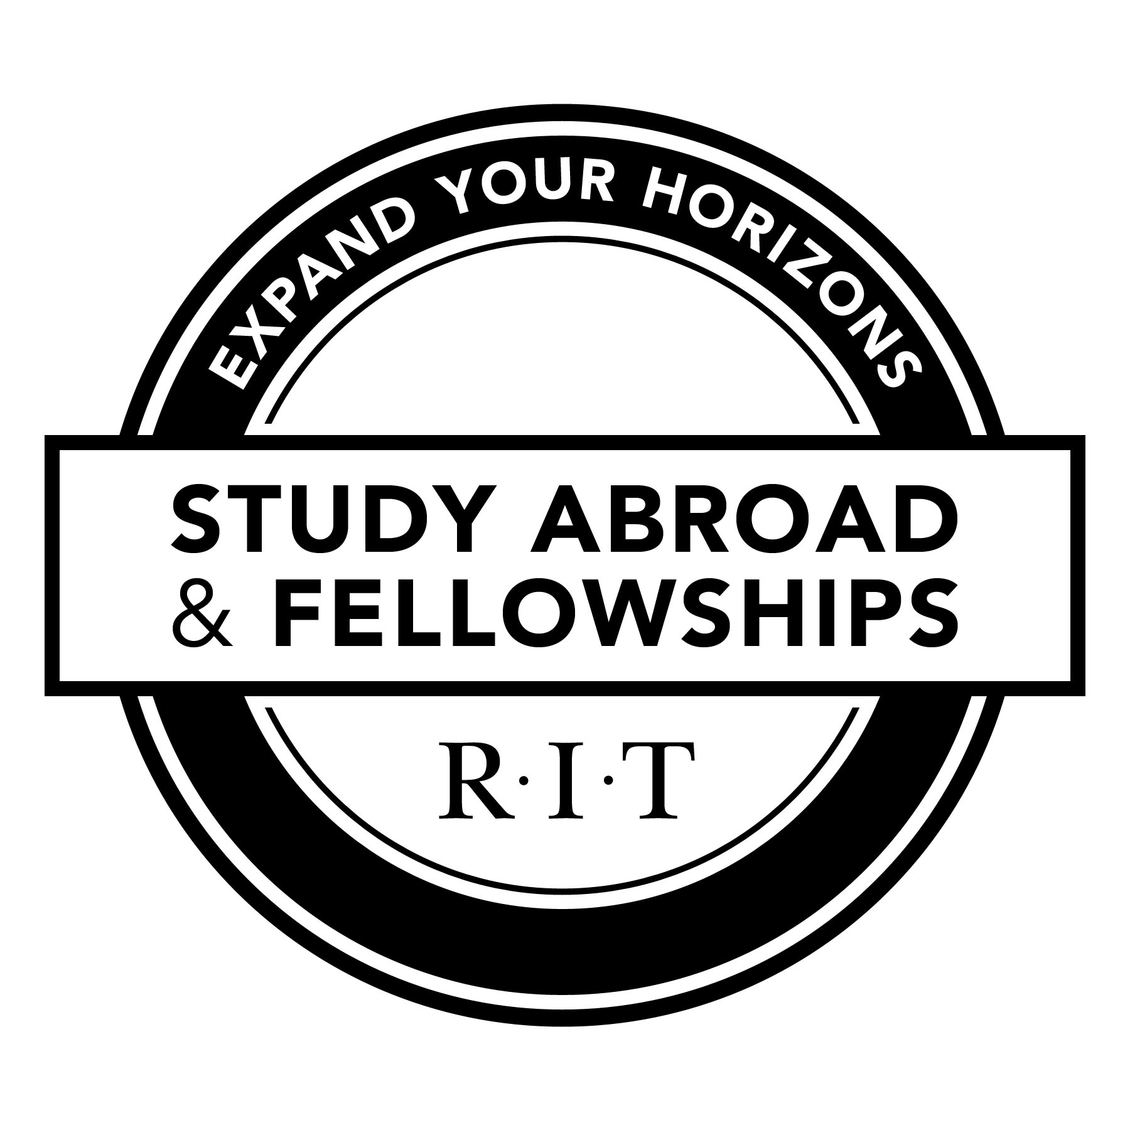
Study Abroad & Fellowships
Faculty-Led Proposal: Phase I

Constellation Commons for Global Learning - Global Village Building 400 Room 2070
P: 585-475-4466 F: 585-475-3222 - http://studyabroad.rit.edu - goabroad@rit.edu

Instructions: Please complete this document and collect approval signature from college Dean or Dean appointed representative. Also, attach a copy of course syllabus and return completed forms to Study Abroad & Fellowships. If you have any questions, please contact Study Abroad & Fellowships.
1. Administrative Information
Are you:
  - Creating a new program
  - Renewing a previously established program
Program Title: This is a permanent title and cannot be changed once it has been added to the SA database
Location(s) (City, Country):
Name of Faculty Director(s): Person actually taking students overseas
Name of Former Faculty Director(s): If this is a renewed program and if different from above
RIT College: | RIT College SA Liaison:
Dates of Program: | Primary Term:  Check all that apply
Language(s) of Instruction: | - Fall Semester  - Spring Semester |  | - Intersession  - Spring Break  - Summer
RIT Courses Offered:
Name |  | Number of RIT Semester Credits

2. Student Information
3. Rationale
Anticipated Number of Participants: |  | Minimum Number of Participants Preferred:
Required Minimum Year Level: | Required College/Major(s):  If none, write ‘none’
Required Prerequisites:
In none, write ‘none’
Required Language & Level:

What is the academic rationale for conducting this program abroad?
Are you aware of current RIT links (faculty, alumni, institutional partnerships, etc.) with the proposed program location? If so, please discuss.
Explain how the specific location(s) will enhance the learning goals for the program.
Is there any conflict or overlap with existing RIT sponsored programs abroad?
What evidence is there of student demand/need for this program?
Explain how the program location(s) was chosen and evaluated, and how the site(s) will be incorporated into the course pedagogy.
Describe how the program will assist students in developing cross-cultural competencies.
4. Student Learning & Development

Describe the teaching facilities within which students will learn, and what type of instruction will occur, especially in the case where no traditional teaching facilities are part of the program.
Describe which excursions will be included, if any, and how they will provide a relevant contribution (academic or cultural) to the program.
Describe how the program provides opportunities that encourage a student’s personal and professional development (e.g. leadership skills, service orientation, maturity, tolerance for ambiguity, growth in cultural awareness).
Describe the co-curricular learning outcomes of the program, how they will be achieved, and the means of assessment.
If applicable, how will the program provide language development appropriate to the mission of the program?
Describe how the students’ international experiences might be integrated into their program plan or general education curriculum upon return to campus.

To be completed by college Dean or Dean appointed representative ONLY
Date Received: |  | Approval:  Yes No
Date Approved: |  | Date Forwarded to Study Abroad & Fellowships:
Number of Minimum Participants Required:
Approved by:
Name (Please Print):
Signature:
Title:
Additional Notes:

