Apple Install Instructions:
- Visit https://console.us2.crashplan.com/login/#/login
- Login with your usernam@rit.edu account
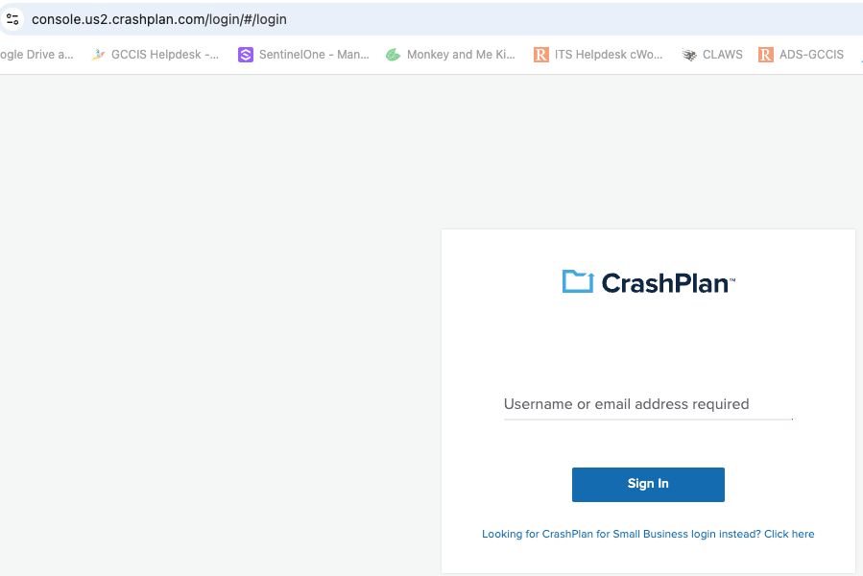
- Login with your full RIT login and select Single Sign On login
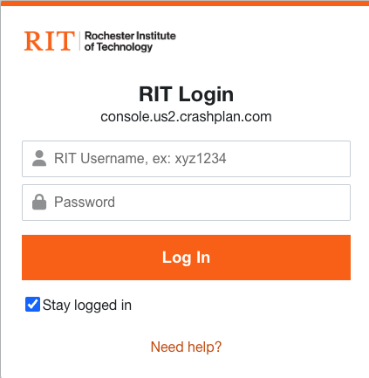
- From the Crashplan control panel, select Administration
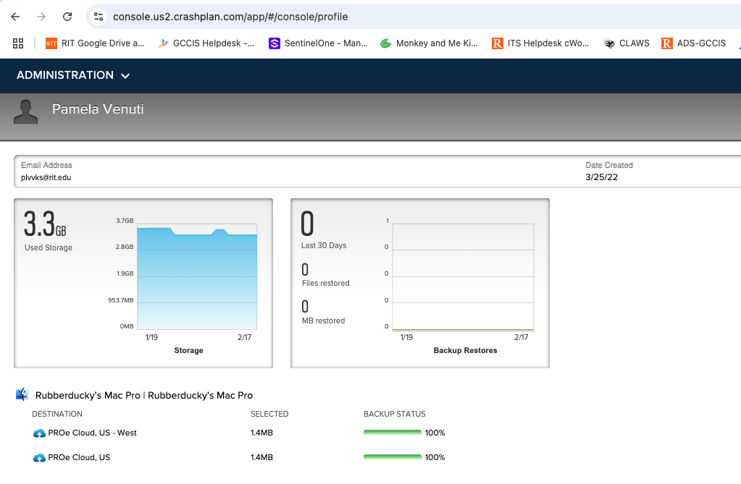
- From the Administration drop down menu, click on Downloads for a complete list of Crashplan clients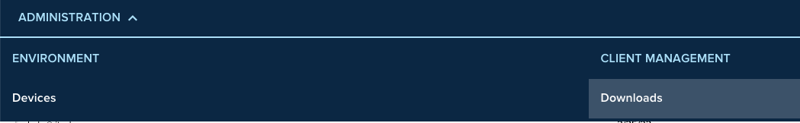
- Click on Blue arrow under Download Apps. Then click on Download Now, for latest Mac installer version. The client will download to your computer.
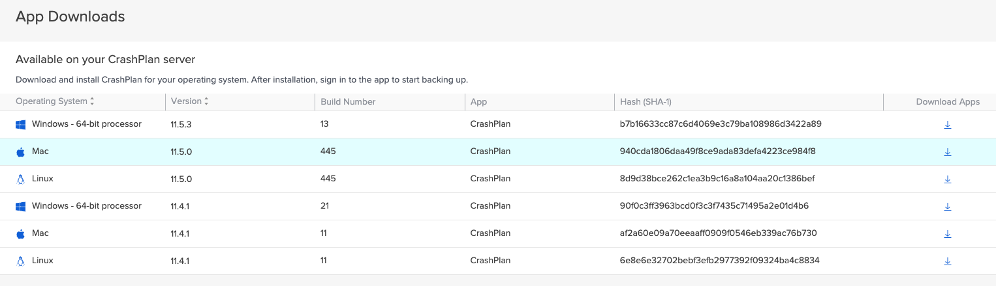
- Double click on Install Crashplan icon
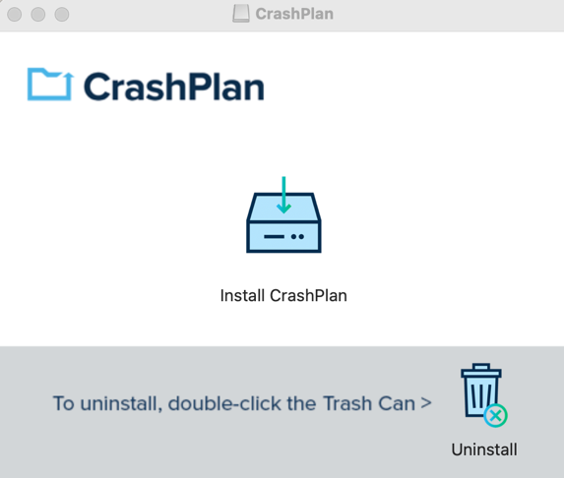
- Allow Installer would like to access files in your desktop folder

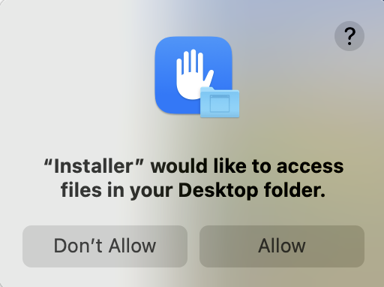

- Click continue from Install Crashplan screen
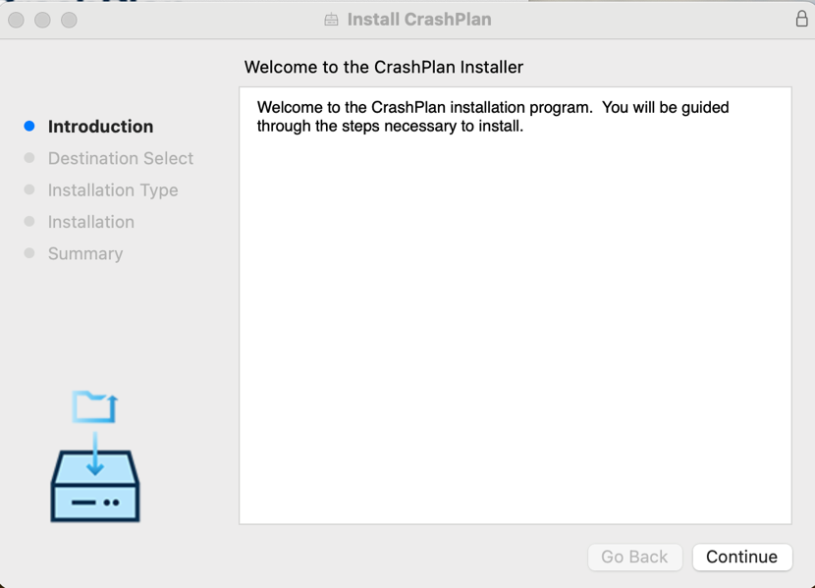
- Select Install for me only and click Continue
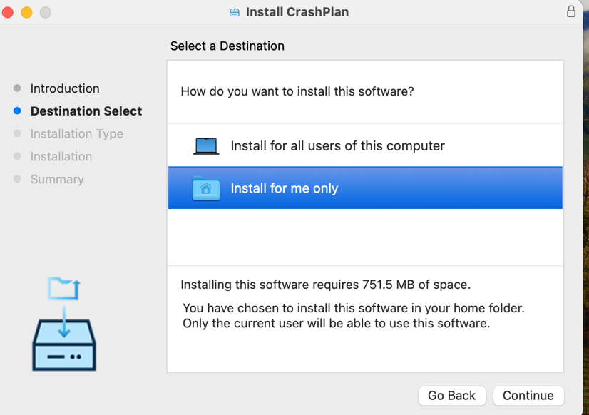
- Click Install
- When complete, click Close
- The next screen will ask you to login to Crashplan. Enter your full RIT username@rit.edu
- You will be directed to your browser to sign into your RIT account from a standard RIT login page. Once logged in you will be informed that you can close the browser.

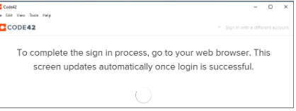
- Once the app is sign in, you should see the backup process starting. Sometimes there is a delay of 2-3 minutes

- Please verify that you are backing up to the proper servers: Proe Cloud, US and Proe Cloud, US-West as seen below
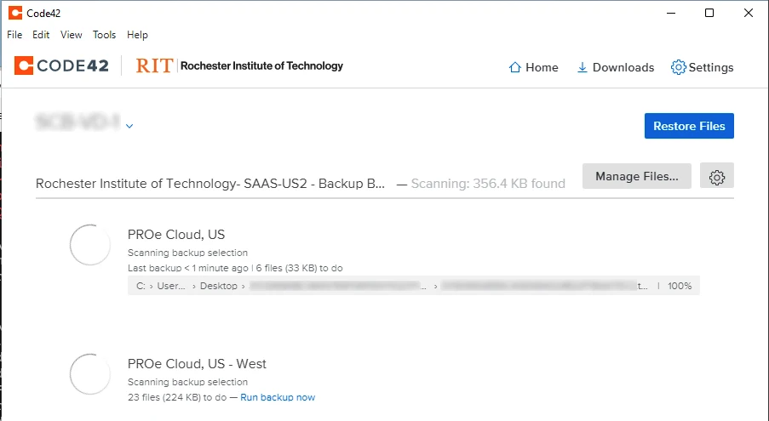
- You may now close the app. Your machine is now being backed up.

