Directions to Complete Academic Progress Report 17

Before you Begin
Make sure you have access to the following:
- Your program PLOAP (available via ROAR Site in SharePoint)
- Last year’s Progress Report 16 (also in ROAR Site in SharePoint)
- Relevant student learning outcomes data
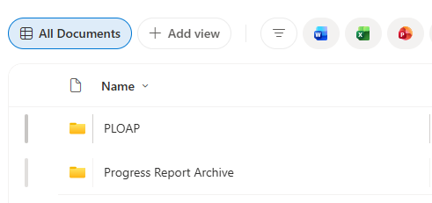

Access the Report
Progress Report 17 link was emailed to all completers; the report will be submitted via a SharePoint form.
- You may be prompted to log in to SharePoint using your RIT credentials and Duo factor authentication
- A Word version of the report was included in the email to completers and is available on the EEA website under Resources and Samples. This version is provided only for drafting your responses. To complete your report, you must submit the SharePoint form

Collaborating with Others
If you are completing the report with other faculty member(s):
- Use the Word version of the report to collaborate
- Once finalized, one person can submit the completed form using the SharePoint link

Saving Your Progress
If you need to pause and return later:
- Complete the five required questions (1, 2, 3, 4, 25)
- Scroll to question 25 and select “No- save a draft”
- Click “Submit” to receive an email with a link to edit your report later
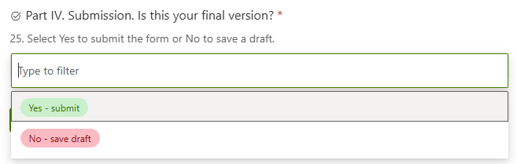

Internal Program Review
Programs may conduct an internal review before submission. Coordinate with your SLOAC representative for additional deadlines and to determine the optimal way to share and review report draft.

Submit the Report
When you are ready to submit your report for review:
- Scroll to question 25 and select “Yes- submit my report for review”
- Click “Submit” and receive an email with a copy of your report

Submitting Multiple Reports
- Start and save a draft for each report before beginning another report

For questions, contact Leah Bradley at lmbdfp@rit.edu, Kate Scahill at kscdfp@rit.edu or Kielynne Banker at kxbdfp@rit.edu

