Institutional Effectiveness (IE)
Administrative Unit Planning Guide

www.rit.edu/outcomes

Table of Contents
Institutional Effectiveness Overview 1
Getting Started or Refreshing an IE Map 2
Institutional Effectiveness: Aligning to RIT’s Vision, Mission and Strategic Plan 2
Institutional Effectiveness Map Core Elements
- Clearly Define Your Charge/Mission 2
- Develop Measureable Administrative Unit Outcomes/Objectives 3
- Identify Data Sources, Unit Activities, and Methods of Measurement 4
- Set Benchmarks or Standards 5
- Identify the Timeline and Person(s) Responsible 6
- Use Results to Inform and Guide Continuous Improvement 6
Assessment Management System – Managing Your IE Map 7
IE Progress Report and Timeline for Administrative Units 7
Appendix A. Institutional Effectiveness Map Template 9
Appendix B. RIT Strategic Plan 2018-2025, Greatness Through Difference 10
Appendix C. Action Verbs for Outcomes/Objectives Statements 11
Glossary 12

©2023. Rochester Institute of Technology, U.S.A. All rights reserved
Institutional Effectiveness Overview
Institutional effectiveness is the systematic and ongoing process of planning, making informed decisions, and allocating resources by collecting, assessing, and acting on data to determine how well the institution is achieving its mission and purposes.
The overarching institutional effectiveness question is: “How well are we achieving our mission and goals?” The assessment of institutional effectiveness essentially involves a documented comparison of institutional performance to institutional purpose.
RIT’s institutional effectiveness processes and practices are designed to:
- Demonstrate how effectively administrative units support RIT’s vision, mission and Strategic Plan 2018-2025, Greatness Through Difference
- Demonstrate use of administrative unit assessment results to inform and guide continuous improvement (enhancing operations, planning, guiding decision making, allocating resources, etc.)
- Provide evidence of systematic processes (meaningful and sustainable) for continuous quality improvement.
Institutional Effectiveness at RIT is characterized by six core elements:
- Achieving a clearly defined mission/charge
- Developing measurable outcomes/objectives that align to the mission of the institution/division
- Identifying data sources or activities for assessment of those outcomes/objectives
- Setting benchmarks to help assess achievement of the outcomes/objectives
- Identifying the timeline and person(s) responsible for data collection/reporting
- Using the results of evaluations and assessments to guide decisions and changes to improve programs and services and inform planning, budgeting, and resource allocation
The Institutional Effectiveness Map (IE Map) was designed as a planning tool to organize administrative unit information related to the core elements of institutional effectiveness (refer to Appendix A). Administrative units develop their Institutional Effectiveness Maps (assessment plans) using existing university, division, or department strategic plans, scorecards, etc. The Office of Educational Effectiveness Assessment provides support and works with administrative units to complete their IE Maps.

Getting Started or Refreshing an IE Map
Tips to get you started: Your IE Map should…
- Organize and guide collection of administrative unit information to showcase how the administrative unit core business practices support institutional effectiveness and align to RIT’s Strategic Plan, its four dimensions and goals as well as RIT’s Inclusive Excellence Framework.
- Identify and highlight administrative unit services and programs which significantly and deliberately contribute to RIT institutional initiatives.
- Be meaningful, manageable and sustainable to support the assessment of varying levels of unit activities to promote continuous improvement.
Institutional Effectiveness: Aligning to RIT’s Vision, Mission and Strategic Plan
An institution’s strategic plan operationalizes its vision and mission to the campus community and its stakeholders. The RIT Strategic Plan 2018-2025, Greatness Through Difference, (refer to Appendix B) serves as a blueprint for the university through 2025 and is founded on four intersecting dimensions.
Dimension One: People - Where Creativity Begins
Dimension Two: Programs - Innovating Across the University
Dimension Three: Places - Facilitating Creativity
Dimension Four: Partnerships - Extending Our Reach and Serving the World
Institutional Effectiveness Map Core Elements
- Clearly Define Your Charge/Mission
An administrative unit’s charge or mission is a broad statement of purpose identifying its services, programs, and contributions to the institution. The statement should be brief, approximately three to five sentences, and reflect the unit’s role within the division and/or institution, its mission and goals, and how it supports primary stakeholders. Existing unit, division, and institution statements should be reviewed as part of this process to determine their relevance and to enhance or revise them as needed.
A mission statement should:
- Address aspects of the institutional vision or mission into which the unit and its activities “fit.”
- Identify and describe stakeholders, those primary groups of individuals to whom the unit provides services and/or those who benefit from the services (e.g. students, faculty, staff, parents, employers, community organizations etc.).
- Include key services provided by the unit to support institutional mission, vision, and the learning environment. Be sure to list only those services within the reporting unit over which you have control or influence.

- Develop Measureable Administrative Unit Outcomes/Objectives
Division and Administrative Unit Mission Statement Examples:
The Division of Diversity & Inclusion works collaboratively with academic and administrative units to provide a holistic range of services that enhance access and success for historically underrepresented students, faculty and staff, support education and scholarship, and ensure a welcoming, inclusive, vibrant and accessible environment for everyone.
The Controller’s Office utilizes efficient, effective and innovative processes that: 1) protect and enhance the university's financial resources; 2) provide reliable information to all stakeholders for decision-making; 3) deliver a wide range of services to the university community; and, 4) meet regulatory requirements.

An outcome or objective (used interchangeably) is a concise statement that provides a specific, detailed description of a desired quality or expectation of key functions, operations, and services within an administrative unit. Statements typically begin with an action verb and are associated with an observable, measurable, results-oriented action. Refer to examples in Appendix C.
Review current outcomes/objectives and revise as needed. For those just beginning the process, consider describing those services and key unit functions that most directly support and contribute to institutional, division, and administrative unit missions.
Administrative Unit Outcome/Objective Examples:
Improve the security of confidential/personal employee data by strengthening HR access controls on employee data
Increase enrollment of Native American/Alaskan Native undergraduate and graduate students
Provide an effective intentional advising model to meet the academic needs of all students
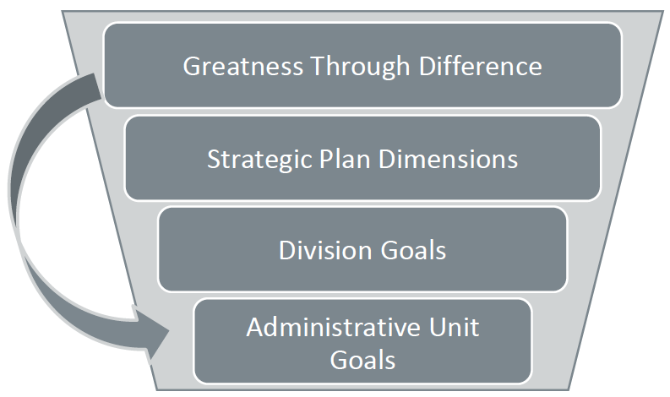Division Goals
Division goals serve as a bridge between the institution’s vision and mission and an administrative unit’s mission and corresponding outcomes/objectives. Division goals are more concrete concepts, narrowed and focused to the division’s primary purpose(s). Explicit goals help a division focus, structure, and guide strategic planning and alignment to institution goals/plans.
Division goal statements describe overarching long-term, divisional planning and capture the intended purposes and accomplishments of the division. Administrative units align their goals and outcomes to the division goals, which are consistent with university initiatives.
Administrative Unit Division Goal Example:
Finance & Administration Division Goals
- Deliver innovative solutions that benefit our stakeholders
- Attract and retain the best workforce
- Ensure fiscal accountability and stewardship of university resources
- Create a culture of exceptional customer service

- Identify Data Sources, Unit Activities, and Methods of Measurement
Each administrative unit should have a corresponding data source or activity from which information will be gathered and measured to provide evidence of meeting or achieving its outcomes/objectives. Data sources can be either qualitative or quantitative and should “fit” outcome/objective as a measure of effectiveness. Data sources will vary by field and can range from student and alumni surveys to focus groups, enrollment and attendance data, number of events and submissions, revenue, and services offered and corresponding response time by a unit.
The selection of data sources should also maximize resources, be useful and cost effective. Review current unit practices for gathering information on services, programs, and activities.
Tips to get you started: Data Sources
- What methods does the unit use to collect information? Are there gaps?
- Are current data sources directly related and aligned to measure the unit’s outcomes/objectives?
- What other information does the unit need to gather in order to determine whether the unit is achieving its outcomes/objectives?

Methods of Measurement
Methods of measurement should serve as reliable, accurate measures of unit outcomes/objectives and provide evidence about its operations, performance, and achievements. Identify methods for which data may already exist. There also may be opportunities to use one method to measure more than one unit outcome/objective.
Direct Methods of Assessing Administrative Unit Processes assess demand, quality, efficiency, and effectiveness. This may include completion and/or productivity of service and efficiency of individual points of service.

Indirect Methods of Assessing Administrative Unit Processes assess student or stakeholder perception of services, programs, and activities.
Examples of Direct Methods of Measurement:
Program Attendance
Number of Students Receiving Service
Revenue (% Alumni Giving, Annual Fund)
Indicators (Applications/Admission Yield)
Post-Graduation Employment and/or Graduate School
[Adapted from University of Central Florida Administrative Assessment Handbook, 2005 and Suskie, L. (2009). Assessing Student Learning: A Common Sense Guide (2nd ed.). San Francisco: Jossey-Bass.]

Examples of Indirect Methods of Measurement:
Student ratings of their experiences, knowledge, skills, and reflections on the associated unit services, program, or activities
Student, alumni, faculty, employee/employer satisfaction through surveys, exit interviews, or focus groups
[Adapted from University of Central Florida Administrative Assessment Handbook, 2005 and Suskie, L. (2009). Assessing Student Learning: A Common Sense Guide (2nd ed.). San Francisco: Jossey-Bass.]
- Set Benchmarks or Targets
Benchmarks (external comparison) or targets (internally developed) determine what the acceptable level of achievement or success is for each unit outcome/objective. Setting benchmarks is a multiple step process to help explain how well the administrative unit is performing.
Tips to get you started: Benchmarks and Targets
- Conduct research and identify external benchmarks from sources using appropriate professional associations or standards and peer programs.
- Review pre-existing internal targets (annual reports, divisional expectations).
- Involve others in the standards-setting process; work with division and unit leadership and staff members.

Once benchmarks have been set, administrative units then measure and determine performance based on the established success metric. Benchmarking is a continuous process. Once units have measured performance in comparison with the initial benchmark, adjustments or modifications can be made based on an analysis of results. A benchmark or target (usually a %) is required for each administrative unit outcome/objective on the Institutional Effectiveness Map.
[Suskie, L. (2009). Assessing Student Learning: A Common Sense Guide (2nd ed.). San Francisco: Jossey-Bass.]
- Identify the Timeline and Person(s) Responsible
Benchmark/Target Examples:
Objective/Outcome: Students will report a positive experience playing intramural sports.
Data Source: Outcome based assessment surveys were performed in intramurals each semester (fall and spring).
Benchmark: 90% of respondents will agree or strongly agree each semester (Q.2 on survey: “My overall experience playing intramurals this semester was positive.” Strongly Agree/Agree).
Objective/Outcome: Deliver exceptional client service and support to Employer Partners during bi- annual Career Fair.
Data Source: Fall 2018 Career Fair Employer Partners Survey
Benchmark: Survey Benchmarks (based on Spring 2018 results): Dietary Options: 91% Student Preparedness and Self-Introduction: 65%
Consider how the administrative unit will collect institutional data on an established cycle. When is the best time of year to collect and measure data? Be selective, strategic, and realistic. Develop a cycle that will match competing demands, internal requirements, and external commitments.
In general, it is recommended that a unit assess two or three outcomes/objectives on an annual basis. A staggered approach over a period of time (e.g. two year cycle) maximizes unit resources and capacity. Be sure to identify the individual responsible for data collection and/or analysis.
- Use Results to Inform and Guide Continuous Improvement
Results: Assessment findings can distinguish patterns of consistency, provide evidence of performance, and identify gaps in services, programs, and activities. Select the most appropriate rating category in the administrative unit’s assessment management system’s workspace based on the findings.
Not Met – Unit has not met benchmark or made progress to achieve the Outcome/Objective
Approaching – Unit has not met benchmark, however it has made significant progress toward achieving the Outcome/Objective
Met – Unit has achieved its Outcome/Objective
Exceeded – Unit has exceeded the benchmark or target for its intended Outcome/Objective
Action: A primary goal of assessment is to support continuous, quality improvement processes by uncovering and addressing issues. A challenging aspect of assessment is “closing the loop,” using the data to inform and reflect upon current practice and facilitate change.
- Identify what, if any, next steps or actions will be taken as a result of the assessment findings.
- Use results to confirm alignment with RIT’s institutional initiatives, guide discussions, validate outcomes, or improve administrative unit performance.
- If appropriate, administrative units can share their findings through division newsletters, internal processes, annual reports, and website postings summarizing relevant results.
Institutional effectiveness deliberately engages an institution of higher learning in systematic self-examination. The Institutional Effectiveness Map is designed to be used as a planning tool for administrative units.
It provides the structure for continuous improvement processes, and it facilitates reflective practice and strategic planning across RIT in an effort to create a positive experience for students, and a productive work environment for faculty and staff.
Assessment Management System - Managing your IE Map
RIT provides administrative units with a resource to create and archive their IE Maps electronically, using an Assessment Management System (AMS) called Taskstream by Watermark. Taskstream by Watermark is an online web-based system providing a communication and resource hub for all of the institution's outcomes assessment and continuous improvement initiatives. The AMS facilitates the documentation and demonstration of the contributions that each of the University's academic programs and administrative units makes towards achieving the goals of the institution as a whole in terms of institutional effectiveness and continuous improvement. The system features assessment plan creation and review, mapping to goals (e.g., university, divisional), tracking and archiving findings, and different access levels for multiple users. Following an initial training session, administrative units are given their own “workspace,” a place where their IE Map can be managed electronically.
The Office of Educational Effectiveness Assessment provides ongoing assistance in the management of IE Maps in Taskstream by Watermark. Available training sessions include:
- Introductory session on various Taskstream features
- Refresher course based on the System Overview training
- Customized topics to meet your needs
- New and Advanced Features
For more information, see the Assessment Management System section of the Educational Effectiveness Assessment website, or contact the AMS Coordinator.
IE Progress Report and Timeline for Administrative Units
As part of its commitment to integrated strategic planning, RIT’s University Assessment Council (UAC) developed a reporting tool and process to highlight how administrative units contribute to institutional effectiveness. This tool, the Institutional Effectiveness Progress Report (IEPR), provides the opportunity to demonstrate how each administrative unit is supporting the university’s mission and goals and uses data to drive improvement processes on an annual basis. The following timeline provides guidance in supporting administrative unit’s IE and annual progress report processes.

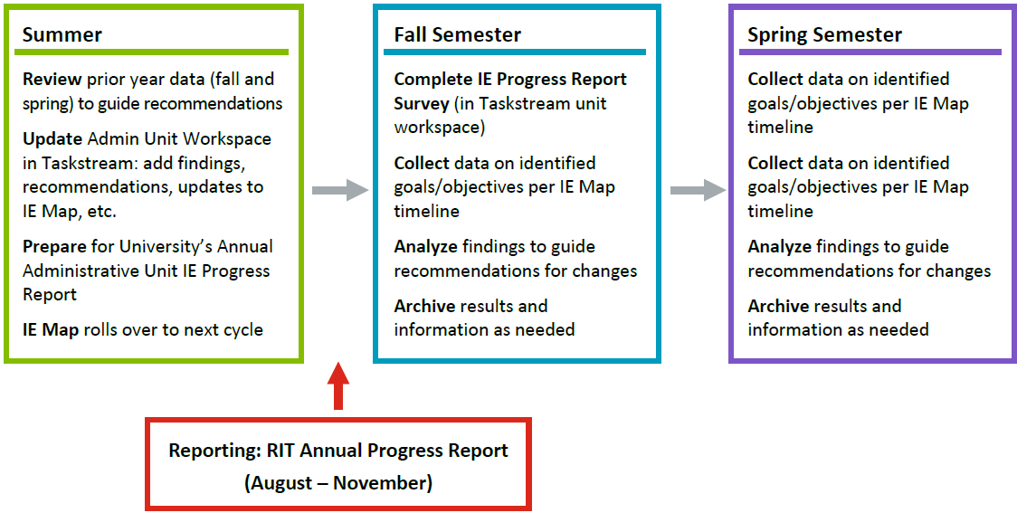
Need Assistance? Contact the Office of Educational Effectiveness Assessment
The Office of Educational Effectiveness Assessment is dedicated to engaging the RIT community around a common purpose: understanding and improving student learning. Assessment is a process, grounded in the institutional values set forth in the mission statement, and focused primarily on supporting quality learning and promoting excellence in education practices. We collaborate with the campus community to establish meaningful, manageable, and sustainable outcomes assessment practices.

EEA Office: 585.475.4138
Email: lmbdfp@rit.edu
Appendix A. Institutional Effectiveness Map Template
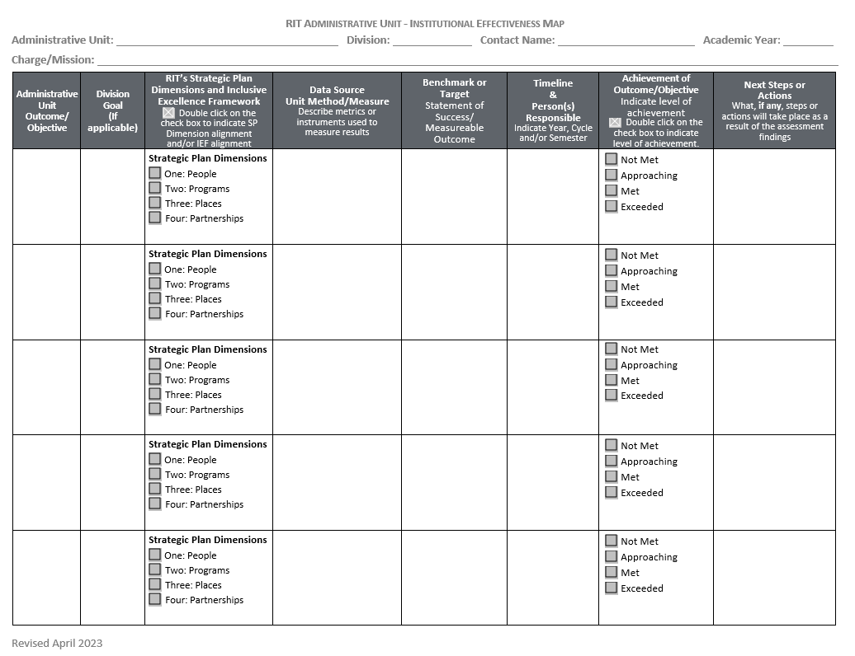

Appendix B. RIT Strategic Plan 2018-2025, Greatness Through Difference,
Vision and Mission
We shape the future and improve the world through creativity and innovation. As an engaged, intellectually curious, and socially conscious community, we leverage the power of technology, the arts, and design for the greater good.
Dimensions (Goals)
Dimension One: People – Where Creativity Begins
- Enroll and support a diverse mix of increasingly creative, multi-talented students
- Continue to diversify the undergraduate student population by gender, race, and nationality
- Improve graduation rates across all demographics
- Continue to attract and retain world-class faculty committed to elevating RIT’s collective excellence
- Continue to diversify the faculty and administration by gender, race, and nationality
- Hire, promote, and retain an increasingly diverse and outstanding staff
- Design and implement RIT for Life, a campus-wide culture that embraces all alumni as full members of the RIT community
Dimension Two: Programs – Innovating Across the University
- Restructure undergraduate degree requirements to ensure students have room to pursue broader curricular experiences, experiential learning, and 21st-century competencies
- Design and integrate unique curricular experiences at the intersection of RIT’s programs in technology, the arts, and design
- Develop the leading performing arts program in the nation for non-majors, making sure to capitalize upon NTID’s strong history in the performing arts
- Increase research, scholarship, and artistic activity by developing nationally prominent research areas and centers, increasing the number of doctoral degrees awarded, and developing new Ph.D. programs
- Continue to build a strategic, sustainable, and high quality online program portfolio
- Determine and work toward the plan for the optimal size of the university and its colleges
- Develop a sustainable long-term business model that enables us to undertake new initiatives
- Develop and implement an enterprise risk management plan that identifies and prioritizes those risks with the greatest potential to impair the university’s ability to meet its strategic objectives
- Create a distinctive RIT brand and develop a supporting content marketing strategy that makes use of all relevant media
Dimension Three: Places – Facilitating Creativity
- Develop a master plan that addresses current and future space needs of the Rochester campus
- Pursue the design, construction, and renovation of facilities that support the core activities of creativity, design, and innovation
- Pursue construction and/or renovation of facilities that support the research enterprise and graduate students
Dimension Four: Partnerships – Extending Our Reach and Serving the World
- Through the Rochester Regional Health-RIT Alliance, identify and develop collaborative research and degree programs in health sciences and technologies
- Establish new and strengthen existing community partnerships with schools and cultural institutions
- Partner with regional economic development agencies to catalyze and support the local start-up community
- Explore opportunities for establishing on-the-ground RIT program facilities in the U.S., outside of Rochester.
- Increase NTID’s presence throughout the university and strengthen its position as a national and international model of inclusive excellence and accessibility
- Develop our international partnerships using a strategic decision-making process

Appendix C. Action Verbs for Outcomes/Objectives Statements
Administer  Address  Advise  Allocate  Assess  Balance  Budget  Calculate  Collaborate  Communicate  Conduct  Coordinate  Counsel | Coach  Demonstrate  Develop  Diagnose  Direct  Ensure  Establish  Evaluate  Explain  Expedite  Facilitate  Forecast  Generate | Guide  Increase  Institute  Instruct  Interview  Introduce  Investigate  Implement  Improve  Illustrate  Interpret  Manage  Market | Monitor  Organize  Perform  Plan  Prepare  Process  Produce  Promote  Provide  Research  Strengthen  Support  Systematize

Glossary
Administrative Unit
An administrative unit represents an office, department, or program within one of the RIT divisions which offer services, support, programs, or outreach to the RIT community.
Institutional Effectiveness
The systematic and ongoing process of planning, making informed decisions, and allocating resources by systematically collecting, assessing, and acting on data relative to how well the institution is achieving its mission and purposes. The overarching question is: how well are we achieving our mission and goals? Assessment of institutional effectiveness essentially involves a systematic, explicit, and documented comparison of institutional performance to institutional purpose.
Benchmark
Specific standards against which Units gauge success in achieving an outcome. Benchmarks or targets determine the acceptable level of achievement/measure of success for each unit outcome/objective. Defining acceptability or unacceptability will depend upon the importance of the outcome/objective and type of measure (direct or indirect).
Charge/Mission
A broad statement of purpose which identifies a Unit’s services, programs, and contributions to the institution.
Direct Methods of Assessing Administrative Unit Processes
Direct methods assess demand, quality, efficiency, and effectiveness. These may include completion and/or productivity of service and efficiency of individual points of service or quality of programs.
Program Evaluation
The systematic collection of information about the activities, characteristics, and results of programs to make judgements about the program, improve or further develop program effectiveness, inform decision making and/or increase understanding (Patton, 2008)
Goal
Goals state what programs and services are designed to achieve. Goal statements describe overarching long-term, divisional planning, and capture intended purpose and accomplishments. Statements are typically broad and theoretical, and are consistent with university initiatives.
Indirect Methods of Assessing Administrative Unit Processes
Indirect methods assess student or stakeholder satisfaction with services, programs, and activities. Level and degree of satisfaction are less clear.
Institutional Effectiveness
The systematic and ongoing process of planning, making informed decisions, and allocating resources by collecting, assessing, and acting on data relative to how well the institution is achieving its mission and purposes. The overarching institutional effectiveness question is, how well are we achieving our mission and goals? The assessment of institutional effectiveness essentially involves a methodical, explicit, and documented comparison of institutional performance to institutional purpose.
Outcomes or Objectives
The terms: outcomes and objectives are used interchangeably. An outcome/objective is a concise statement which provides a specific, detailed description of a desired quality or expectation of key functions, operations, and services within an administrative unit. Statements often begin with a verb and are then associated with an observable, measurable results-oriented action.

