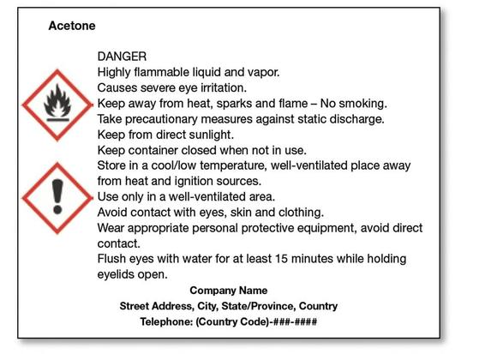

**Label Example**

Product Identifier

Signal Word

Hazard Statement(s)

Pictogram(s)

Precautionary Statement(s)

Name, Address, Telephone