3D Printing Activity 6-8: Matching 3D Printers & Materials

Knowing the different types of 3D Printers and materials used to print, are important to understand how 3D printers are able to print any part someone comes up with. Since different printers and materials are used to make different types of objects. Match the description of the printer to the correct printer. Then match the description of the material to the picture of the material.

Matching 3D Printers:

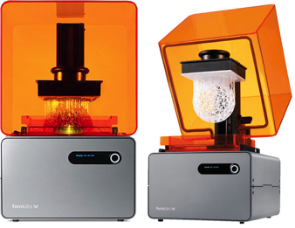
The SLS Printers use Powder Bed and a Laser in order to print the part.

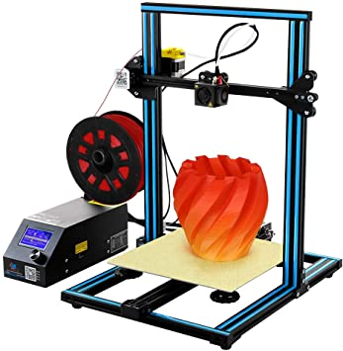
The SLA Printer is unique because it prints the part from Top-Down versus a Bottom-Up process.

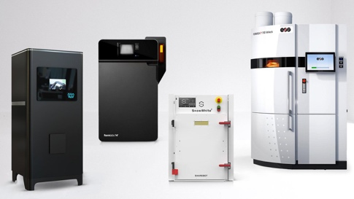
The FDM Printer is widely used in a variety of applications and uses a Bottom-Up process to print the part.

This material is exceptionally durable, heat resistant and impact resistant. It is also temperature resistant which is great for printing parts that will be used outdoors.
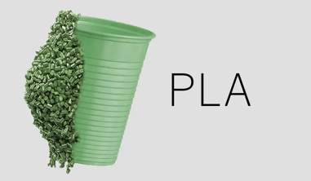

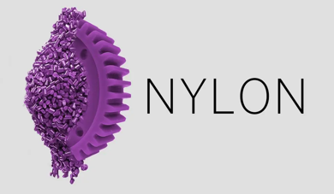
This material is made out of corn or sugarcane making it biodegradable and the most environmentally friendly material for 3D printing.

This material is very flexible and widely used in the plastic industry. It is also very strong and durable.

