3D Printing Activity K-5: Matching 3D Printed Part to Job

Lots of different jobs utilize 3D printing to make parts to test and to use, not just engineers! Draw arrows to match the 3D printed part with the job of the person who uses the 3D printer.

Matching 3D Printed Part to Job:

Racecar Engineer 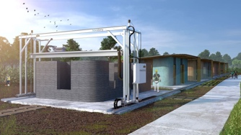

Doctor 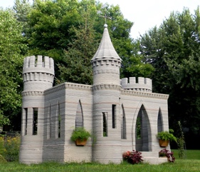

Office Designer 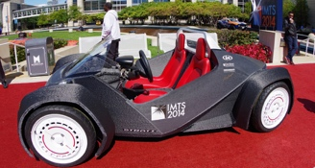
Architect 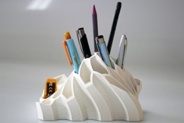
Construction Worker 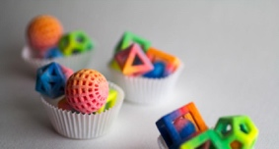
Toy Designer 