3D Printing Activity K-5: 3D Printer Basics

Industrial Engineers use 3D Printing to make their ideas come to life! You can make anything with a 3D printer no matter how detailed. Now, let’s name the parts of the 3D printer using the words from the word bank, and then use your imagination to draw your own part that you want to 3D print!

Step 1 – Name the parts of a 3D Printer:
Safety Box Extruder Base/Platform Part Material

Safety Box

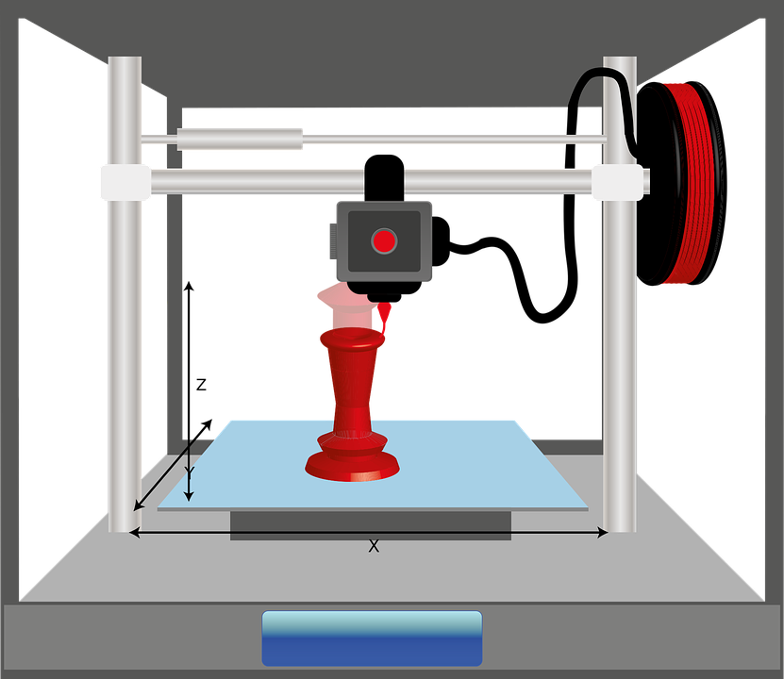
Extruder
Part
Material
Base/Platform

Step 2 – Use your Imagination to Draw Something to 3D print:
Draw your part on the platform or base of the 3D printer where the blue arrow is pointing.

