Manufacturing Module: Machine Learning Worksheet

Step 2: Fill in your answers for each character

 | 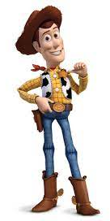 | 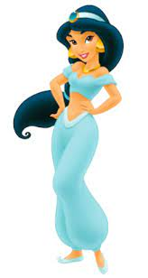 | 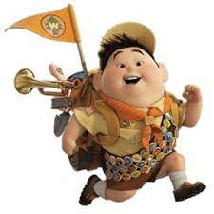
Name
Hair Color (brown or black)
Hair Length (long or short)
Hat (yes or no)
Shirt color (yellow or blue)
Pants color (blue or brown)
Earrings (yes or no)

Step 3: Compare the answers of your characters to the mystery character based on the amount of answer they have in common, called the similarity score.

Name
Hair Color (brown or black) |  |  |  | Brown
Hair Length (long or short) |  |  |  | Short
Hat (yes or no) |  |  |  | Yes
Shirt color (yellow or blue) |  |  |  | Yellow
Pants color (blue or brown) |  |  |  | Blue
Earrings (yes or no) |  |  |  | No
Similarity Score |  |  |  | X

