Procore Standard Operating Procedures
(AE)



Welcome to Procore!
Procore Link: Procore
Upon being invited to Procore for the first time, you will be prompted to set up a password. Once you have set up a password you will be sent to the RIT Portfolio page where you will be able to see all the projects you have been invited to.

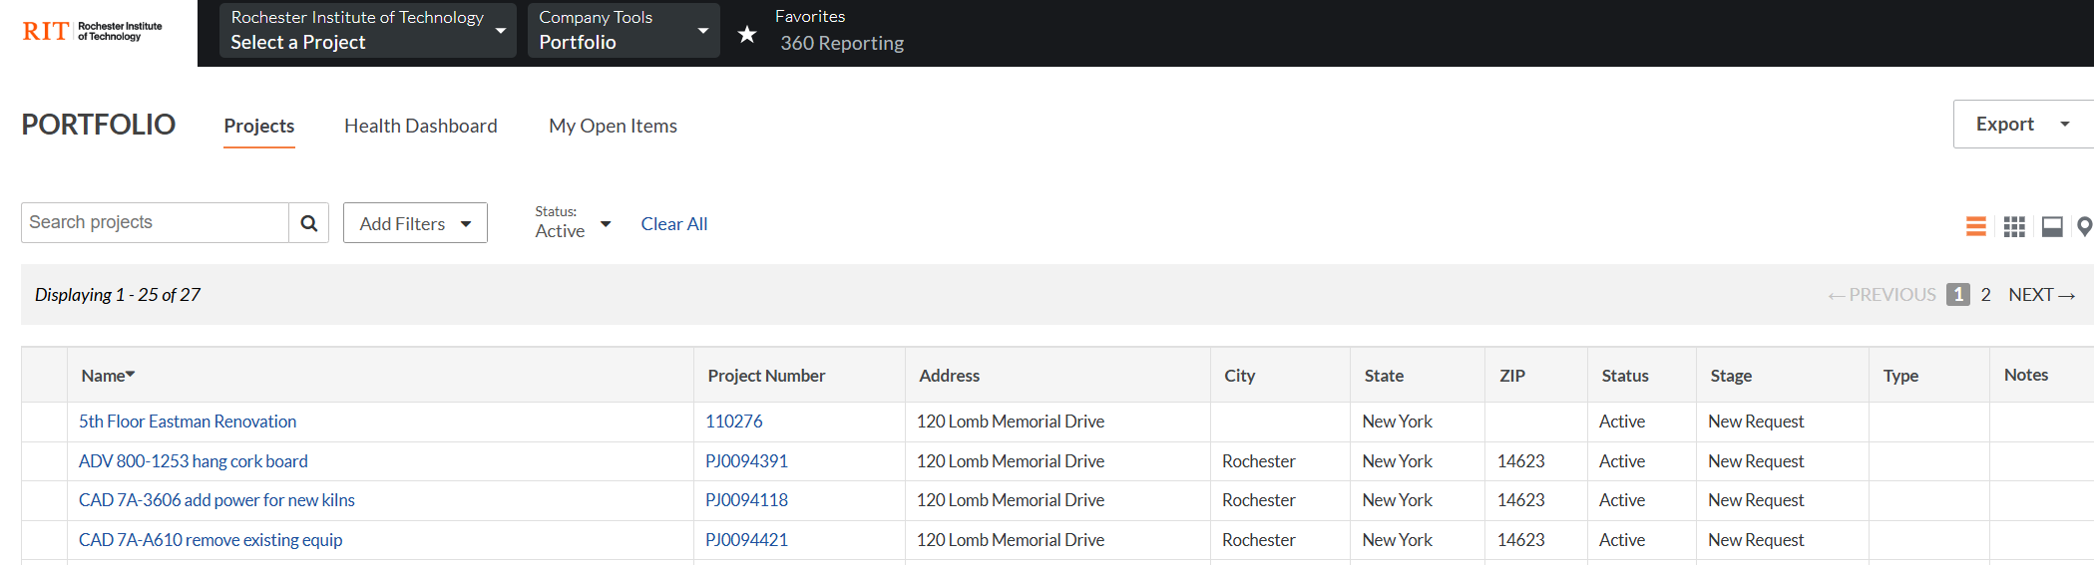

Project Tools Menu
To navigate within any project, you will want to open up your Project Tools Menu located at the top of every page once you are within a project.
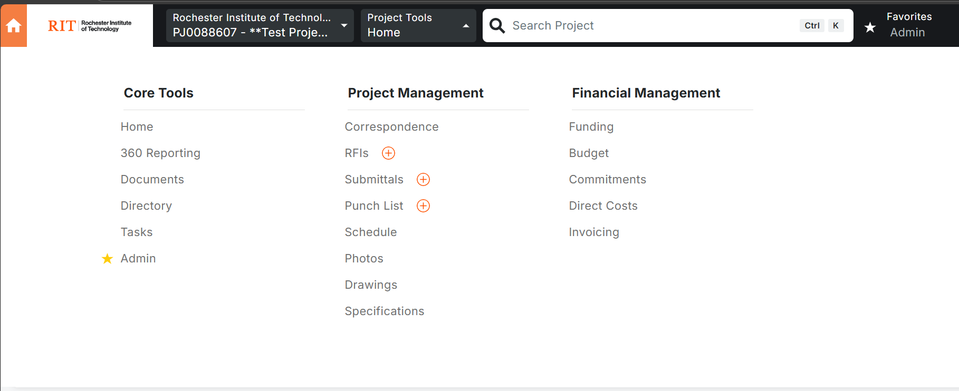

A/E Expectations in Procore
- Upload all finalized Bulletins/ ASI (Correspondence Tool)
- Upload completed punch list items
- Upload drawings throughout the project
- Upload all specifications related to the project
- Upload milestone CAD files to the Documents Tool
- Upload any other relevant documents to the Procore Documents Tool
- Upload pictures to the Photos tool (optional)

Updates to Procore should be provided on a monthly basis at the minimum or at the discretion of the RIT PM

Project Management Tools

Documents (RIT PM/ AE)
The AE firm is responsible for uploading all relevant project documentation. Every project has a default file structure, and files should be uploaded to their respective folders. If you are unsure where to upload a file, reach out to your RIT PM or RIT DM.

Procore Videos
Project Documents - Procore

Correspondence(Bulletin) (RIT PM/ AE)
The Correspondence Tool is where we are housing our Change Bulletins (ASI, RBs). The AE firm will use the Bulletin form to upload finalized Bulletins. If the Bulletin impacts any drawings, they should also be updated in the Drawings Tool.

Punch List (RIT PM / GC / RIT DM / AE)
The Punch List tool is designed for the AE firm to upload a completed punch list for record keeping purposes. It can also be used by the RIT PM to keep track of items that are not on the official Punch List. When the AE firm is ready to upload their completed punch list they should perform the following steps.

- Once the Punch List tool has been opened, click on the Create button in the top-right corner (AE Task)
- Add the following title -> “Completed Punch List” (AE Task)
- Upload the punch list as an attachment (AE Task)
- Select the RIT PM as the “Final Approver” (AE Task)
- Click the “Save” button in the bottom right corner (AE Task)
- An email will be sent to the RIT PM, when received, the RIT PM should click the “View in Procore” button (RIT PM Task)
- Once the RIT PM has verified submission of the completed punch list they should click the “Close Punch Item” button in the top right corner (RIT PM Task)

Photos (RIT PM / AE)
The Photos tool is an optional tool for either the RIT PM or the AE firm to upload project related photos. To upload photos to a project, follow these steps.

- Once the Photos tool has been opened, click on the Albums tab (RIT PM Task or AE Task)
- Click on the “Create Album” button in the top right corner and name your new album (RIT PM Task or AE Task)
- Click the “Upload” button in the top right corner (RIT PM Task or AE Task)
- Click and drag your photos into the appropriate box and click “Upload Photos” (RIT PM Task or AE Task)

Drawings (AE)
The Drawings tool is where the AE firm will upload their drawing sets throughout the project. This also includes any updated drawings issued with accepted change bulletins. There are different Drawing Area folders depending on the type of set that needs to be uploaded.

Upload Drawings
- Once the Drawings tool has been opened, select the appropriate Drawing Area (AE Task)
- Click the “Upload” button (AE Task)
- Fill out the following fields (AE Task)
  - Attach a drawing file
  - Name the drawing set by typing in the name and pressing “Create Set”
  - Click Advanced Options -> enter in the Revision if there is one notated on the drawing set. For example Revision 4 may be the first revision that is being uploaded into Procore but it’s important to enter in the 4 in this field.
- Click “Process” and wait for the drawings to finish uploading (AE Task)
- Click “Review” (AE Task)
- All sheets should now be reviewed to make sure they have the appropriate Drawing No and Drawing title. As you update the Drawing No it will offer suggestions. Select the suggestions if they are correct and a pop up will appear asking if you would like to update subsequent drawing numbers. You will want to select Yes and Procore will attempt fix the mistakes it made. (AE Task)
- Continue to do this until all drawings are appropriately labeled (AE Task)
- Click the “Confirm All” button (AE Task)
- Then click the “Publish” button and then “Publish & Distribute All” (AE Task)
- To then notify the RIT PM and the RIT DM, click the select all check mark and click on Email (AE Task)
- Select from the drop down the RIT PM and the RIT DM (AE Task)
- The RIT PM and RIT DM will receive an email from Procore with links to all of the drawings (RIT PM Task or RIT DM Task)

Procore Videos/ Documentation
Upload Drawings - Procore
Review and Confirm Drawings - Procore
Mark Up a Drawing - Procore

Specifications (AE)
The Specifications tool is where the AE will upload their specs for the project. Any specification changes noted in a change bulletin should also be uploaded. To do so they will need to perform the following steps.

- Once the Specifications tool has been opened, click the “Upload” button in the top right corner (AE Task)
- Upload the specification file, name the set, select the format and click “Process” (AE Task)
- Once the file has been uploaded, click the “Review” button (AE Task)
- The document should be reviewed that all Numbers and Titles are in the appropriate spot. Once that has been reviewed, the “Publish All” button can be pressed (AE Task)

