Procore Standard Operating Procedures
(GC)



Welcome to Procore!
Procore Link: Procore
Upon being invited to Procore for the first time, you will be prompted to set up a password. Once you have set up a password you will be sent to the RIT Portfolio page where you will be able to see all the projects you have been invited to.

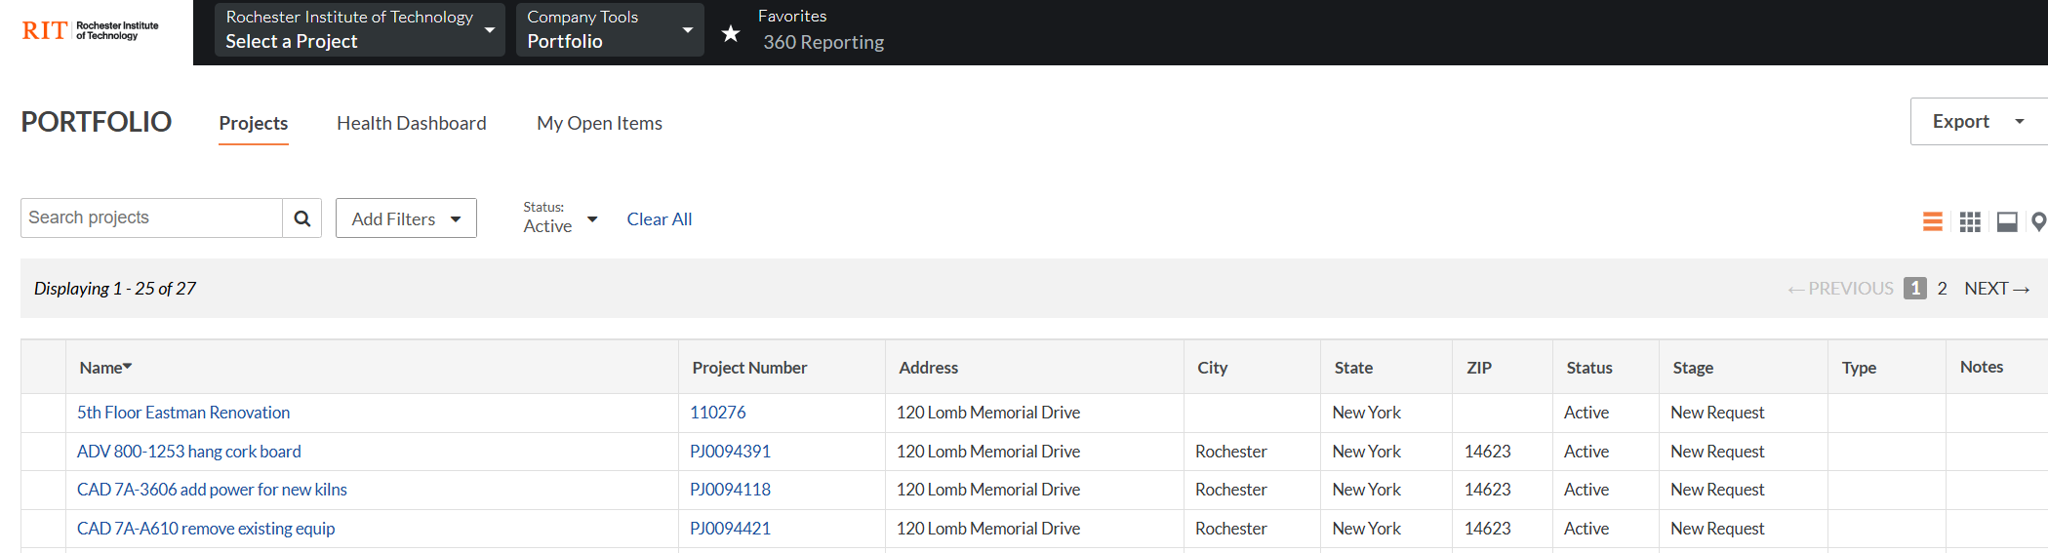

Project Tools Menu
Once you open up a project, you will want to click on the “Project Tools” button at the top of the page. This is how you will navigate through the different tools within the project.

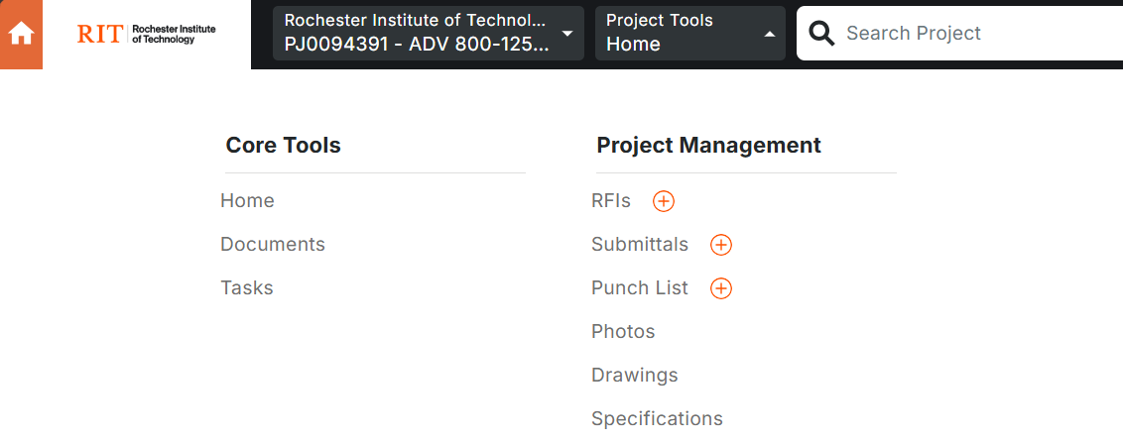

GC Expectations in Procore
- Engage with the Bulletin (Correspondence Tool) to be kept aware of project changes. This will only be used if the project is designed by an RIT DM (Design Manager)
- Use the RFI tool to either upload completed RFIs when working with A/E firms or to work through RFIs with an internal RIT DM
- Use the Submittals tool to either upload completed/ approved Submittals after they have been reviewed by an A/E firm or to enter in submittals through the tool if the project is designed internally by an RIT DM
- The GC may be required to review and close out punch list items submitted by RIT
- Upload Change Order Logs to the documents tool (01 Communications > Change Order Log)
- Upload any other relevant documents to the Procore Documents tool
- Upload pictures to the Photos tool (optional)

Updates to Procore should be provided on a monthly basis at the minimum or at the discretion of the RIT PM
Project Management Tools

Documents (RIT PM/ GC)
The GC is responsible for uploading all relevant project documentation. Every project has a default file structure, and files should be uploaded to their respective folders. If you are unsure where to upload a file, reach out to your RIT Project Manager.

Procore Videos
Project Documents - Procore

Correspondence (Bulletin) (GC / RIT DM)
The Correspondence Tool is where we are housing our Bulletins. If the project is being designed by the RIT Planning and Design department, they will use the Bulletins to engage with the GC about any design related project changes. The GC will get emailed upon any entries into the Bulletin.

RFIs (GC / RIT DM)
The RFI Tool will be used in two possible ways:
- The GC will use the RFI Tool to engage with the RIT DM if the project is internally designed
- The GC will upload the completed/ answered RFIs into the tool and close it out if there is an external AE firm on the project
Scenario A
- Once in the RFI tool, click the Create button in the top right corner (GC Task)
- Fill out the New RFI form (GC Task)
  - Subject -> A good title for the RFI
  - Question -> This can provide some more detail or be as simple as “See attachment”
  - Attachments -> A PDF copy of the completed RFI
  - Number -> This will be auto populated and does not need to be edited
  - Due Date -> This will be auto populated and does not need to be edited
  - RFI Manager -> This will be auto-populated and does not need to be edited
  - Assignees -> The RIT DM assigned to the project
  - Private -> This should be left unchecked
- Click the Create as Open button in the bottom right corner (GC Task)
- An email will be sent to the RIT DM, when received, they should click the “View Online” link (RIT DM Task)
- Once the DM Designer has reviewed the RFI they should click the “Add Response” button, provide a response and click the “Add” button (RIT DM Task)
- Then click the “Mark Official” checkbox and click the “Close RFI” button (RIT DM Task)

Scenario B
- Once in the RFI tool, click the Create button in the top right corner (GC Task)
- Fill out the New RFI form (GC Task)
  - Subject -> A good title for the RFI
  - Question -> This can provide some more detail or be as simple as “See attachment”
  - Attachments -> A PDF copy of the answered RFI
  - Number -> This will be auto populated and does not need to be edited
  - Due Date -> This will be auto populated and does not need to be edited
  - RFI Manager -> This will be auto-populated and does not need to be edited
  - Assignees -> Select the GC themselves
  - Private -> This should be left unchecked
- Click the “Create as Open” button in the bottom right corner (GC Task)
- Click the “Close RFI” button (GC Task)

Submittals (GC / RIT DM)
The Submittals Tool will be used in two possible ways:
- The GC will use the Submittals Tool to engage with the RIT DM if the project is internally designed
- The GC will upload the completed/approved Submittals into the tool and close it out if there is an external AE firm on the project. Only include approved submittals.
Scenario A
- Once the Submittal tool has been opened, click on the Create button in the top-right hand corner and select Submittal (GC Task)
- There are many fields on the Submittal form however ONLY the following need to be filled out (GC Task)
  - Title -> A short description of the submittal that is being entered
  - Attachments -> Upload the submittal to be reviewed
  - Submittal Workflow -> Select the RIT DM as the approver
- Click the “Create and Send Emails” button in the bottom right-hand corner (GC Task)
- An email will be sent to the RIT DM, when received, the RIT DM should click the “View Online” link (RIT DM Task)
- Click the “Respond” button (RIT DM Task)
- Click Next, Update the response to “Reviewed”, click “Preview” and then click “Respond” (RIT DM Task)
- Click the “Close & Distribute” button in the top right corner (RIT DM Task)
- Add a person for distribution, update the Status, select the Workflow Response and click the “Distribute” button (RIT DM Task)

Scenario B
- Once the Submittal tool has been opened, click on the Create button in the top-right hand corner and select Submittal (GC Task)
- There are many fields on the Submittal form however ONLY the following need to be filled out (GC Task)
  - Title -> A short description of the submittal that is being entered
  - Status -> Change to Closed
  - Attachments -> Upload the approved submittal
- Click the “Create” button in the bottom right-hand corner (GC Task)

Punch List (RIT PM / GC / RIT DM)
The Punchlist tool may be used by RIT especially if RIT designed the project. The following steps will be used to track open punch list items.

- Once the Punch List tool has been opened, click on the Create button in the top-right corner (RIT PM Task or RIT DM Task)
- Add a title (RIT PM Task or RIT DM Task)
- Keep yourself as the “Punch Item Manager” and “Final Approver” (RIT PM Task or RIT DM Task)
- Add the GC as the “Assignee” (RIT PM Task or RIT DM Task)
- Click the “Save” button in the bottom right corner (RIT PM Task or RIT DM Task)
- An email will be sent to the GC, when received, the GC should click the “View in Procore” button (GC Task)
- Once the GC has completed the punch list item they should click the “Close Punch Item” button in the top right corner (GC Task)

Photos (RIT PM / GC)
The Photos tool is used at the discretion of the RIT PM. The GC can upload project related photos using the following steps:

- Once the Photos tool has been opened, click on the Albums tab (RIT PM Task or GC Task)
- Click on the “Create Album” button in the top right corner and name your new album (RIT PM Task or GC Task)
- Click the “Upload” button in the top right corner (RIT PM Task or GC Task)
- Click and drag your photos into the appropriate box and click “Upload Photos” (RIT PM Task or GC Task)

Drawings
The Drawings tool is where the GC can review the projects drawings that are uploaded throughout the project. There are different Drawing Area folders depending on the type of set that needs to be reviewed.

Procore Videos/ Documentation
Upload Drawings - Procore
Review and Confirm Drawings - Procore
Mark Up a Drawing - Procore

Specifications
The Specifications tool is where the AE will upload their specs for the project. The GC can review the specifications within this tool as needed.

