Rochester Psychology Internship Consortium

Intern Handbook

Updated: July 1, 2025

Consortium Partners: Hillside Children’s Center, Ontario County Mental Health, Rochester Institute of Technology, Rochester Regional Health, Rochester Psychological Assessment & Testing, University of Rochester Medical Center Strong Recovery

Table of Contents
Aim 3
Accreditation Status 3
APPIC Membership Status 3
Overview 3
Competencies 4
Structure of the program 5
Training Sites 5
Training Faculty 9
Supervision 10
Research 10
Application Process and Selection Criteria 11
Stipend, Benefits, and Resources 12
Vacation 13
Parent Leave 13
Absences 13
Intern Expectations 13
Tracking Internship Hours 14
Evaluation, Retention, and Termination Policy 14
Intern Records 15
Evaluation Forms 15
Grievance Procedures 24
Telesupervision Policy 25
Artificial Intelligence Policy 27
Acknowledgment of Receipt of Handbook 27

Aim
The aim of the Rochester Psychology Internship Consortium is to provide a supervised, intensive, experiential learning opportunity focused on the delivery of efficient and comprehensive psychological services.

Accreditation Status
The full-time internship is fully accredited by the American Psychological Association (APA Office of Program Consultation and Accreditation).

Questions related to the program’s accreditation status should be directed to the Commission on Accreditation:
Office of Program Consultation and Accreditation
American Psychological Association
750 1st Street, NE, Washington, DC 20002
Phone: (202) 336-5979
Email: apaaccred@apa.org

APPIC Membership Status
The Internship Program is a participating member of APPIC.

Overview
Rochester Psychology Internship Consortium represents a cooperative endeavor between University of Rochester Medical Center (URMC) Strong Recovery, Rochester Institute of Technology (RIT), Rochester Regional Health, Hillside Children’s Center, Coordinated Care Services Inc (CCSI), Rochester Psychological Assessment & Testing (RPAT), and Ontario County Mental Health (OCMH). URMC Strong Recovery functions as a hub for the internship faculty, didactic training, and administrative processes.

This internship year is first and foremost a supervised, intensive, experiential learning opportunity focused on the delivery of psychological services. The program embraces a scientist-practitioner model in which theory and evidence routinely inform professional practice and each intern has the opportunity to pursue a scholarly activity that can center on research, program evaluation, clinical care, or education. The training is competency based. Each intern will have a year-long placement at one of the clinical sites. While in their clinical settings, interns provide supervised behavioral health intervention and assessment services to individuals from diverse backgrounds. Interns across clinical sites have the opportunity to gain experience working with and consulting across a variety of disciplines as a major component of their training program. Experiences may involve collaboration and consultation with various agencies and/or providers within multiple care disciplines and settings.

Our training and education program is dedicated to developing the next generation of leaders in the field using innovative and advanced technologies (e.g, Telehealth and Technology Assisted Interactive Tools for Clients). All interns are provided with didactic and experiential training in the use of telehealth and interactive therapeutic technologies.

A priority is placed on professional development, including assistance to interns in securing opportunities after internship such as post-doctoral fellowships and employment. Our clinical sites have an interest in hiring the next generation of leaders.

Competencies
Rochester Psychology Internship Consortium Competencies are as follows:

Competency 1: Interns will achieve an intermediate to advanced level of competence in Evidence-Based Intervention

Competency 2: Interns will achieve an intermediate to advanced level of competence in Evidence-Based Assessment

Competency 3: Interns will achieve an intermediate to advanced level of competence in Ethical and Legal Standards

Competency 4: Interns will achieve an intermediate to advanced level of competence in Cultural and Individual Diversity

Competency 5: Interns will achieve an intermediate to advanced level of competence in Research

Competency 6: Interns will achieve an intermediate to advanced level of competence in Professional Values, Attitudes, and Behaviors

Competency 7: Interns will achieve an intermediate to advanced level of competence in Interprofessional and Interdisciplinary Consultation

Competency 8: Interns will achieve an intermediate to advanced level of competence in Supervision

Competency 9: Interns will achieve an intermediate to advanced level of competence in Communication and Interpersonal Skills

Competency 10: Interns will achieve an intermediate to advanced level of competence in Telehealth and Interactive Therapeutic Technologies

Competency 11: Interns will achieve an intermediate to advanced level of competence in Clinical Leadership and Career Development within Ambulatory Behavioral Health Settings

Structure of the program
The internship begins on July 1st and concludes on June 30th of each academic year, and provides 2000 hours of training. Interns in this program are referred to as "psychology interns." Interns will complete the internship program over 12 months on a full-time (40 hours/week) basis. Interns are matched to one of the following clinical tracks; Hillside Children’s Center, URMC Rochester Addiction-Forensic Clinical Research, Rochester Regional Health (RRH) Outpatient Behavioral Health (Adult), Rochester Regional Health (RRH) Integrated Care, Rochester Regional Health (RRH) Neuropsychology at the Neuroscience Institute, Rochester Psychological Assessment & Testing (RPAT), or Ontario County Mental Health (OCMH).

Interns spend 4 days a week with their clinical track and 1 day a week at URMC Strong Recovery for additional supervision, didactics, clinical discussions, and scholar activities, unless otherwise specified.

The training curriculum has been designed in accordance with the internship program’s required competencies. Each competency is met through both experiential and didactic training. While in their clinical settings, interns provide supervised behavioral health intervention and/or assessment services to individuals from diverse backgrounds. Intervention may include individual, group, and/or family therapy, and may be provided for children, adolescents and/or adults, depending on the clinical placement. Assessment opportunities are provided at each placement site. Therapy clients, type and number of assessments, consultation work, and research vary depending on the specific site.

Interns across clinical sites have the opportunity to gain experience working with and consulting across a variety of disciplines as a component of their training program, as each track involves collaboration across various systems of care. Experiences may involve collaboration and consultation with various agencies and/or providers within multiple care disciplines and settings.

All interns are provided with didactic and experiential training in the use of telehealth and interactive therapeutic technologies, as these skills are critical for providers in highly underserved areas and are core to the internship training program. Additionally, interns have the opportunity to engage in alternate experiences including training and resource development.

Interns are provided with regular supervision, which focuses on clinical skills development as well as addressing such issues as ethics, diversity, and professionalism. Interns are also provided with training in the effective provision of supervision and given opportunities to practice these skills through simulated supervision exercises and/or provision of supervision to practicum students, undergraduates, or Master’s level interns. All competencies are additionally supported through the provision of relevant didactics provided by content experts.

All interns are expected to conduct research through at least one ongoing “scholar project”, the focus of which is determined collaboratively between the primary supervisors and the intern.

Training Sites
Interns are matched to one of the following clinical tracks; Hillside Children’s Center, URMC Rochester Addiction-Forensic Clinical Research, Rochester Regional Health (RRH) Outpatient Behavioral Health (Adult), Rochester Regional Health (RRH) Integrated Care, Rochester Regional Health (RRH) Neuropsychology at the Neuroscience Institute, Rochester Psychological Assessment & Testing (RPAT), or Ontario County Mental Health (OCMH).

Hillside Children’s Center
The Hillside Children’s Center is a non-profit organization consisting of more than 100 coordinated programs in 41 locations across New York and Maryland which provide comprehensive health, education, and human services for children and families. Interns at this placement site work as part of a multidisciplinary team treating youth placed in residential care from across New York State. Interns are responsible for psychological evaluations, consultation with the treatment team including family and external funders, and delivery of evidence-based group and individual therapy. Interns placed with Hillside will work directly with youth and families who have experienced complex and intergenerational trauma. Evidence-based practices used include dialectical behavior therapy and trauma-focused cognitive behavioral therapy. Interns also have the opportunity to gain experience in the school connected to the residential campus, providing evaluation services and supporting intervention plans for youth placed in residential care. This residential campus has youth with emotional and behavioral disorders as well as dually diagnosed youth (who also have a Developmental Disability). The majority of students in this school have experienced complex and intergenerational trauma.

URMC Rochester Addiction- Forensic Clinical Research at Strong Recovery
Interns in the University of Rochester Medical Center (URMC) Addiction-Forensic Clinical Research Track at Strong Recovery will focus their time on developing expertise in clinical services and translational clinical research. Interns are integrated into a multidisciplinary team of providers, collaborating closely with psychiatrists, substance use counselors, psychologists, and other clinicians. Interns have the opportunity to conduct both individual and group therapy with clients experiencing co-occurring substance use and mental health disorders. Interns conduct psychological and neurocognitive testing to aid in diagnostic clarity and help shape treatment plans tailored to the needs of each client. Clinical activities utilize advanced interactive healthcare technologies to provide evidence based behavioral health care. Interactive technologies include the use of digital assessments, behavior tracking tools, and interactive digital health care intervention platforms (e.g., a User Friendly, Customizable Avatar Assisted CBT Platform [RITch®CBT], 3D Organ Simulation Tools for Motivational Interviewing, Virtual Reality Mindfulness Tools). Under the supervision of a licensed clinical psychologist, interns may complete court-ordered competency to stand trial assessments and mental health evaluations (e.g., Mental Health and Drug Court Evaluations). Research activities also include using the digital tools with wearable biosensor research, biomarker research, and tele-health services. Interns are expected to make substantive contributions to ongoing research projects, including developing and submitting manuscripts for publication using existing data sets, assisting with federally funded randomized controlled trials evaluating the treatments for comorbid substance use disorders and mental health conditions, analyzing dyadic data from couples in alcohol manipulation studies, as well as EMA data assessing the proximal relationships between substance use and aggression.

Rochester Regional Health (RRH) Outpatient Adult
The RRH Adult track will provide trainees with opportunities at outpatient mental health clinics including RRH’s Evelyn Brandon Health Clinic, Greece Behavioral Health Clinic, Rochester Mental Health Clinic, and Genesee Mental Health Clinic. Four interns are placed within clinics treating adult (18+) clients. The psychiatric characteristics of clients treated includes the full diagnostic range of the DSM-5. Interns across clinics have the opportunity to conduct individual therapy, family therapy, and group therapy. Interns will also engage in psychological assessment in order to provide differential diagnoses and recommendations for ongoing treatment/referrals. Interns will learn efficient evaluation and report writing procedures. Interns at RRH work closely with a multi-disciplinary team of licensed social workers, licensed mental health counselors, substance abuse counselors, psychiatric nurse practitioners, and psychiatrists. Interns are assigned to teams of psychiatrists, psychiatric nurse practitioners, and therapists for weekly case discussions and clinical presentations. This track allows interns opportunities to provide consultation on behavioral health leadership projects and complete inpatient consultations and evaluations on an as needed basis. Lastly, interns are provided with leadership opportunities including presentations at staff meetings, best-practice presentations, practicum student supervision, and participation in program development and behavioral health research projects.

Rochester Regional Health (RRH) Integrated Care
The RRH Integrated Care clinical rotation provides trainees with opportunities to engage in the integrated care model of treatment, providing outpatient mental health services to individuals within their primary care, family care, and/or specialty care offices. The embedded setting allows for thorough collaboration with the medical care team of each individual served, providing comprehensive care. The population served is diverse with the opportunity to gain experience in working with our refugee community, individuals struggling with chronic pain, as well as individuals with comorbidities. Interns will have the opportunity to engage in individual therapy, family therapy, and group therapy while also conducting comprehensive evaluations and psychological assessments. Interns will work on a multi-disciplinary team consisting of licensed social workers, licensed mental health counselors, and a psychiatrist, as well as with the medical team and physicians at their sites.

Rochester Regional Health Neuropsychology at Neuroscience Institute
Neuropsychology interns at the RRH Neuroscience Institute receive supervision from a team of postdoctorally trained neuropsychologists. Interns conduct evaluations with a variety of neurological populations, with etiologies including ischemic stroke, cerebral hemorrhage, the spectrum of traumatic brain injuries (mTBI/concussion to severe), anoxic brain injury, brain tumor, metabolic and other encephalopathies, neurodegenerative disease/dementias, autoimmune neurologic disorders (such as multiple sclerosis), psychiatric disorders presenting with primary cognitive symptoms and others. The age of patients served ranges from infant to geriatric. Interns rotate through the inpatient program and all major outpatient clinics. In addition, they participate in didactics reviewing neuroanatomy, clinical disorders, as well as neuroradiology rounds. There are also opportunities for intern involvement in stroke and dementia support groups, as well as opportunities to supervise practicum/extern students. Within the comprehensive inpatient rehabilitation program, interns will assess and treat the widest diversity of ages, neurological conditions, including etiologies noted above as well as traumatic or nontraumatic spinal cord injuries. Interns will learn efficient evaluation and report writing procedures and hone psychotherapy skills within the inpatient setting. Interdisciplinary collaboration and presentations at staff conferences are regular components of the intern’s inpatient rehabilitation experience. The outpatient clinics provide opportunity for more comprehensive neuropsychological assessment with a variety of patient populations. The memory clinic provides neuropsychological evaluation to assist with differential diagnostic clarification including dementia subtypes versus other neurological or psychiatric factors. At the memory clinic, interns will collaborate with our neurology partners, including the opportunity to learn about advanced neuroimagery. In addition, the concussion clinic exposes the intern to the complexities of post-concussion disorder that can often have premorbid and psychological factors that may prolong and exacerbate the symptoms. Furthermore, the general outpatient neuropsychological clinic provides a context for training in comprehensive neuropsychological evaluation and report writing with a wide range of neurological patient populations. Interns may also provide psychotherapy with neurological patients in the outpatient context, addressing emotional adjustment, coping, and existential concerns.

Rochester Psychological Assessment & Testing (RPAT)
Rochester Psychological Assessment and Testing (RPAT) was founded to provide additional psychological assessment and psychotherapy services to the greater Rochester, New York area. RPAT internship track offers the unique opportunity to gain experience working within a multidisciplinary private practice. Interns will receive supervision from RPAT’s team of licensed psychologists who draw from a wide range of training and practice backgrounds. The RPAT clinical and assessment track provides trainees with opportunities to further develop skills in the primary areas of therapeutic intervention and psychological evaluation, along with a number of additional experiences tailored to each intern’s interests. At RPAT, interns conduct evidence-based treatment and psychological assessment in an outpatient office setting. In addition, the internship track provides an opportunity to learn about business practices and considerations when pursuing self-employment and independent practice. Furthermore, interns will have the opportunity to work with both children and adults and may consult with the RPAT team to emphasize either pediatric or adult practice, if desired. Psychological assessment at RPAT includes evaluations for attention-deficit/hyperactivity disorder, autism spectrum disorder, learning and cognitive functioning, court ordered evaluations, adaptive behavior assessment, sex offender risk assessments (if a desired experience), police officer candidate evaluations, and assessment for gender affirming medical and surgical treatment. Psychotherapy interventions are tailored to each individual client and can include a range of cognitive-behavioral, applied behavioral, exposure and response prevention, family systems, and mindfulness/meditation interventions. RPAT serves a wide range of clients with varying presenting concerns and demographics. RPAT provides services for the full diagnostic range of those in need of therapy or assessment; however, cases are driven by the individual needs of our clients. Additionally, interns consult and collaborate with referral sources that include primary care physicians and pediatricians, clinic and community therapists, psychiatrists and nurse practitioners, schools, and various community agencies. The goal of the RPAT internship track is to provide interns with lasting knowledge and experience working with a variety of cases and providing a range of services within an outpatient private practice setting.

Ontario County Mental Health (OCMH)
The Ontario County Mental Health (OCMH) Department is situated in the heart of Western New York, in the Finger Lakes Region. OCMH clinic’s Director of Community Services, Jessica Mitchell, Ph.D., through the Local Government Unit (LGU), is responsible for the distribution of funds (federal, state and/or local dollars), oversight and compliance of programs with State regulations, and the development of local plans for behavioral health services for individuals living with developmental, mental health, and/or substance or alcohol abuse disabilities in the community. OCMH operates a certified outpatient mental health clinic treatment program, licensed by the New York State Office of Mental Health (OMH) through the Mental Health Department. The OCMH clinic serves individuals from ages 5 through adulthood, with a wide-range of psychological conditions or presenting concerns, from depression or anxiety, trauma or co-occurring disorders, to serious mental illness or emotional disturbances. The clinic offers evidence-based practice within the context of a multidisciplinary team approach, including psychiatric/medical providers, social workers, mental health counselors, peers/case workers, and in collaboration with other helping professionals or systems of care to support individuals’ recovery. These include the Departments of Social Services, Public Health and Probation, school districts, primary care offices, Health Homes case management providers, crisis service providers, local hospitals, etc. OCMH’s internship training program includes a broad range of clinical and professional experiences within a rural, community-based setting, which can assist psychology interns in the development of their professional identity as providers of psychological services. Psychology interns will have opportunities to participate in didactic or training opportunities, as well as to develop, integrate, and synthesize their professional skills through a) direct clinical work; b) consultation and involvement in county/community-based committees or programs; and c) provision of psychological testing and evaluations for clients of the clinic and/or court-ordered evaluations. Psychology interns will also have opportunities to offer supervision to social worker or mental health counseling interns, offer in-service or educational training to clinical staff or other county/community partners, as well as opportunities to observe or participate in school-based clinic work or consultation groups depending upon interest.

Training Faculty
URMC
Caroline Easton, PhD, Chief Psychologist, Supervisor
Cory Crane, PhD, Supervisor
Cassandra Berbary, PhD, Intern Training Director, Supervisor
Courtney McKinney, PsyD, Deputy Intern Training Director, Supervisor
Melinda Ann Patterson, PsyD, Neuropsychology Supervisor

Hillside
Christopher Dehon, PhD, Supervisor

Rochester Regional Health
Krista M. Damann, PhD, Supervisor
Tanya R. Grace, PsyD, Supervisor
William N. Schneider, PhD, Supervisor
Garry Spink, PhD, Supervisor

Rochester Psychological Assessment & Testing
Brian Amos, PhD, Supervisor
Nicole Gibson, PhD, Supervisor
Jake Swartwout, PsyD, Supervisor
Kristy Kelley, PsyD, Supervisor

Ontario County Mental Health
Jessica Mitchell, PhD, Supervisor

Additional Training Faculty
Latrease Moore, PhD, Supervisor
Rebecca Zill, PhD, Supervisor
Elizabeth Meeker, PsyD, CCSI Psychologist

Post-Doctoral Associates
Sabrina Gambino, PsyD, Ontario County Mental Health
Victoria Pezzino, PsyD, URMC
Hasad Freitag, PhD, URMC
Eva Tetteyfio, PsyD, URMC

Supervision
All Interns receive at least 4 hours of supervision per week. Interns are provided two hours of individual supervision by a licensed psychologist who oversees the interns’ clinical work at their clinical sites. All interns participate in 1 hour of group supervision through URMC and 1 hour of additional group supervision through their specific track or research.

Research
Interns are trained in the scientist-practitioner model by incorporating scholarship into the internship curriculum. Interns are supported in the development and execution of a year-long scholar project. A scholar project is an independent piece of scholarly work that is independent from dissertation work; it can be completed as part of ongoing research at one of the clinical sites or can be a unique project, developed by an intern and deployed at one or multiple internship sites.

Given the focus on digital technologies, it is asked that interns incorporate digital components into their scholar projects, if possible.

Interns present their scholar project to their cohort, faculty, and community leaders at the end of internship. Interns also present their scholarly work at University of Rochester’s Department of Psychiatry Trainee Poster Day. Scholar projects can be:
- Independent projects unique to interns’ interests and career goals
- Unique approaches to existing work and projects at clinical sites
- Reviews of intersections of digital and mechanical approaches to mental health

Scholar projects cannot be:
- The same project as intern dissertations
In addition to presentations, interns are encouraged to attend and submit to presentations at internal, regional, national, and international conferences. Interns are also encouraged to submit their scholarly work to publication. Should interns choose to submit their work to conferences or publications, there is support available to assist with this process.
Research Support
The internship program includes multiple opportunities for scholarly support and conference attendance. Interns should discuss questions regarding research support and conference attendance with the Training Director. Interns will be assisted with their scholar projects by supervisors and have the opportunity to attend additional research meetings as needed.

Examples of Past Scholar Projects
- Examining Perceptions of Therapeutic Alliance and Treatment Outcomes in a Sample of Substance Using Offenders of IPV
- Network and Regulatory Modeling of Resilience and Risk Factors of Suicidal Ideation in Military Service Members and Veterans
- Utilizing 3-Dimensional Health Tools Within Adolescent Substance Use Treatment
- The Emotion Visual Analog Scale: Development of a Virtual, Interactive, Visual Measure of Emotion Awareness and Intensity
- Finding a Link Between Family Violence and Race in the Homeless Population

Application Process and Selection Criteria
Students interested in applying for the internship program should submit an online application through the APPIC website (www.appic.org). Interviews are conducted via Zoom.

Application due date: December 1st
A complete application consists of the following materials, which are all part of the online AAPI:
- Completed online AAPI
- Cover letter
- Current Curriculum Vitae
- Three Standardized Reference Forms, two of which must be from persons who have directly supervised your clinical work. Please submit no more than three letters
- Official transcripts of all graduate coursework
- Supplementary materials: One full integrated assessment report (please redact appropriately)

All application materials must be received by the APPIC deadline in order to be considered. Applicants who are invited to interview will be notified by email. Interviews will be scheduled in January/February and will occur via Zoom.

The program bases its selection process on the entire application package noted above; however, applicants who have met the following qualifications prior to beginning internship are considered preferred:
- Preferred. Minimum of 400 intervention hours (experience with CBT, MET, DBT, Trauma Focused Interventions
- Preferred. Minimum of 200 assessment hours (experience administering cognitive, neuropsychological, personality measures with experience in integrative Report Writing)
- Preferred. Dissertation proposal defended or data collected/ date set.
- Interest in Telehealth and Interactive Technologies
- Some experience or special interest in working with diverse populations

In addition to the above consortium-wide preferences, sites will consider specific aspects of the applicant’s experience, interests, and training goals in determining an applicant’s potential “fit” with individual clinical training sites. Applicants are encouraged to carefully review the descriptions of the training sites and to highlight areas of perceived fit within their cover letters. In general, the internship program prefers that interns have completed intervention hours that include experience with CBT, MET, DBT, and/or Trauma Focused interventions. In terms of assessment experience, the program looks for experience administering such measures as the WISC, WAIS, WMS, MMPI, and the PAI as well as experience with integrated report writing.

All interns who match must successfully pass a background check as well as obtain any required medical clearances, before beginning their internship. Clinical sites may require site specific clearances, background checks, and/or drug testing. Applicants are advised that the internship requires regular travel between training sites, and thus interns must have consistent access to reliable transportation.

This internship site agrees to abide by the APPIC policy that no person at this training facility will solicit, accept, or use any ranking-related information from any intern applicant. Questions regarding the selection process may be directed to the Internship Training Director, Dr. Cassandra Berbary at cassandra_berbary@urmc.rochester.edu.

Stipend, Benefits, and Resources
Stipends are provided in the amount of $36,500. The program reports stipends utilizing Form 1099. Interns are eligible to enroll in student health coverage. Interns will be provided with office space, computers, and access to IT and administrative support.

As an intern, you are responsible for the following:
- Laptop and Charger:
  - You must return the laptop and charger at the end of your internship. Laptops must be returned no later than June 22, 2026.
  - You are responsible for any damages to the laptop and charger.
- iPads, Pens, and Testing Materials:
  - You are responsible for signing out and returning iPads, pens, and all testing materials in your possession.
Please handle all equipment with care and ensure that all items are returned in good condition.

Vacation
Interns are expected to follow the holiday/vacation calendar for their individual clinical site. The following days are paid holidays for all interns:
- New Year’s Day
- Memorial Day
- Independence Day
- Labor Day
- Thanksgiving Day
- Christmas Day

Interns are given an additional 15 days of vacation and/or professional development time. All vacation time must be approved by your primary site supervisor as well as the Training Director. When an intern plans to take vacation or professional development time, they are required to submit a formal request to their site supervisor, training director, and project coordinator via e-mail. Interns are expected to secure coverage for any internship responsibilities prior to any vacation days. Interns should submit written vacation requests with as much advance notice as possible (no less than 2 weeks) so that backup arrangements can be made. Every effort will be made to accommodate vacation requests, unless business circumstances do not permit.

No more than 1 week (5 days) of vacation time may be used within the last month of internship.

Parent Leave
Paid parent leave is offered for up to 6 weeks. Given the uniqueness of the one-year appointment of the internship program, combined with the requirement of 2000 hours, every effort is made to assist interns wishing to take parental leave to still meet the requirements of the internship program without having to extend their time. In order to meet the 2000 hours requirement for internship completion, interns may need to dedicate additional hours either before or after the parent leave. If an intern does not meet the 2000 hours requirement, an intern's time may need to be extended to satisfy the hours requirements of the internship program.

Absences
Interns are provided 5 sick days. It is the intern's responsibility to ensure that supervisors are informed when illness or injury results in absence from internship. Interns are required to notify their site supervisor, training director, and project coordinator via e-mail. Should interns be absent from for more than three consecutive days, interns are required to provide a physician note indicating the nature of the illness and approval to resume internship responsibilities.

Intern Expectations
With regard to intern behavior and performance during the training year, the general expectations of the internship program are that the intern will:
- Adhere to the APA Ethical Principles of Psychologists and Code of Conduct (https://www.apa.org/ethics/code)
- Operate within the bounds of the laws and regulations of the New York state
- Adhere to the policies and procedures of the consortium
- Adhere to the policies and procedures of intern’s assigned track

Tracking Internship Hours
Interns are required to accurately track their hours daily, including direct client contact, supervision, didactic training, and administrative duties. Logs should be maintained using approved tracking systems such as Time2Track or other programs required by doctoral programs, though Excel is also acceptable. Interns must review their recorded hours with their primary supervisor at the internship evaluation time points. A final record of internship hours must be submitted by the end of June.

Evaluation, Retention, and Termination Policy
Formal evaluations are completed 3 times a year, during the year and serve as a review of progress on training goals and core competencies. To progress in the program and to successfully complete the program, Interns must demonstrate minimum levels of achievement across all required elements. Evaluations are conducted using a standard rating form, which includes comment spaces where supervisors include specific written feedback regarding the Interns’ performance and progress. Supervisors will review these evaluations with the Interns and provide an opportunity for discussion if the Intern has questions or concerns about the feedback. Interns will be asked to verify in writing that they have received and reviewed the evaluation with their supervisor.

A minimum level of achievement at the 1st and 2nd evaluation time points are defined as a rating of “3” (Intermediate Competence) for each element. The rating scale for each evaluation is a 5-point Likert scale. If an Intern receives a score less than 3 on any element, or if supervisors have reason to be concerned about the Intern’s performance or progress, the program’s Due Process procedures will be initiated. The Due Process guidelines can be found in this Handbook. A minimum level of achievement at the 3rd evaluation time point (end of the training year) is defined as a rating of “4” (Proficient Competence) for each element. Meeting the minimum level of achievement at the end of the year includes having; 1) the ability to independently function in a broad range of clinical and professional activities; 2) the ability to generalize skills and knowledge to new situations; 3) the ability to self-assess when to seek additional training, supervision or consultation.

Additionally, Interns are expected to complete 2000 hours of training during the internship year. Meeting the hours requirement and obtaining minimum levels of achievement on evaluations demonstrates that the Intern has progressed satisfactorily through and completed the internship program. Evaluations will be maintained by the Training Director and will be accessible to the Intern for future review if requested. Feedback to the Interns’ home doctoral program is provided at the 2nd evaluation time point and at the culmination of the internship year. Doctoral programs are contacted within one month following the end of the internship year and informed that the Intern has successfully completed the program.

If successful completion of the program comes into question at any point during the internship year, or if an Intern enters into the formal review step of the due process procedures due to a grievance by a supervisor or an inadequate rating on an evaluation, the home doctoral program will also be contacted. This contact is intended to ensure that the home doctoral program is kept engaged in order to support an intern who may be having difficulties during the internship year. The home doctoral program is notified of any further action that may be taken by the internship program as a result of the due process procedures, up to and including termination from the Program. See the Due Process procedures for more information about the process of and conditions for termination.

Intern Records
Copies of all intern competency evaluations, certificates of completion, copy of the intern’s training experience (i.e. training handbook) and any Due Process documents- are maintained by the internship program indefinitely. These records are securely stored in electronic files. The handbook for each training year is maintained in electronic format. A separate electronic file is maintained for grievances.

Evaluation Forms
(Please Note: Copies of the evaluation forms are included here for information purposes only. The actual forms should be completed via evaluation survey links.)
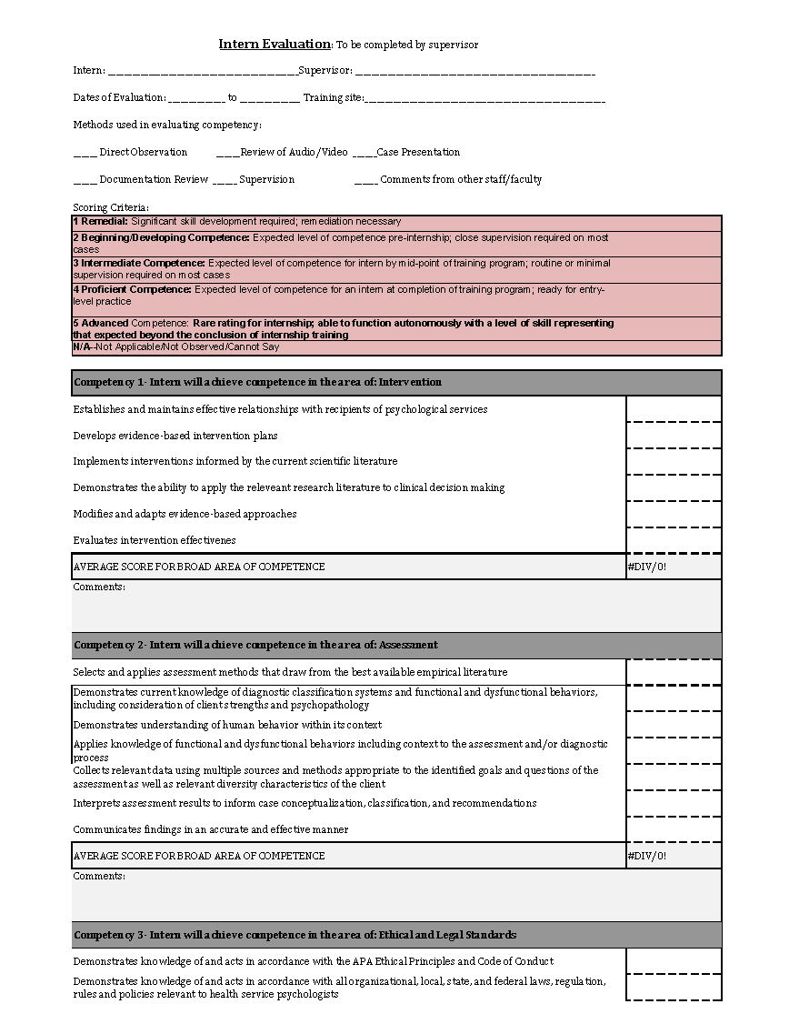

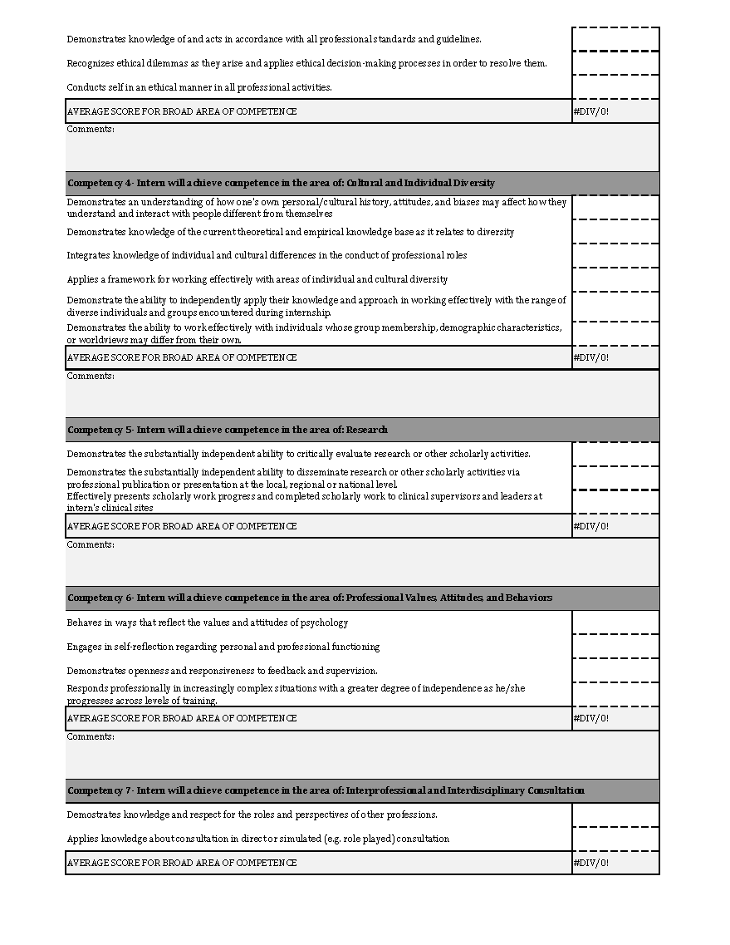

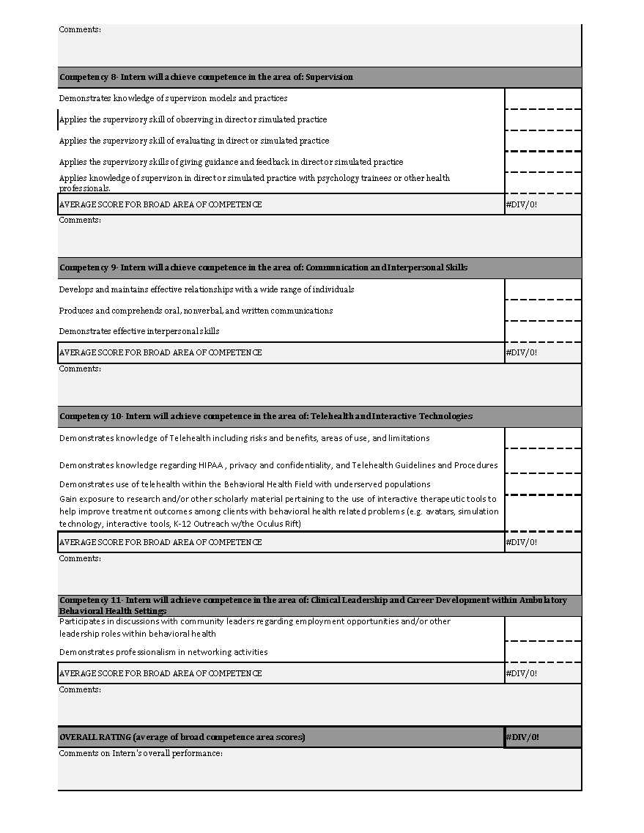

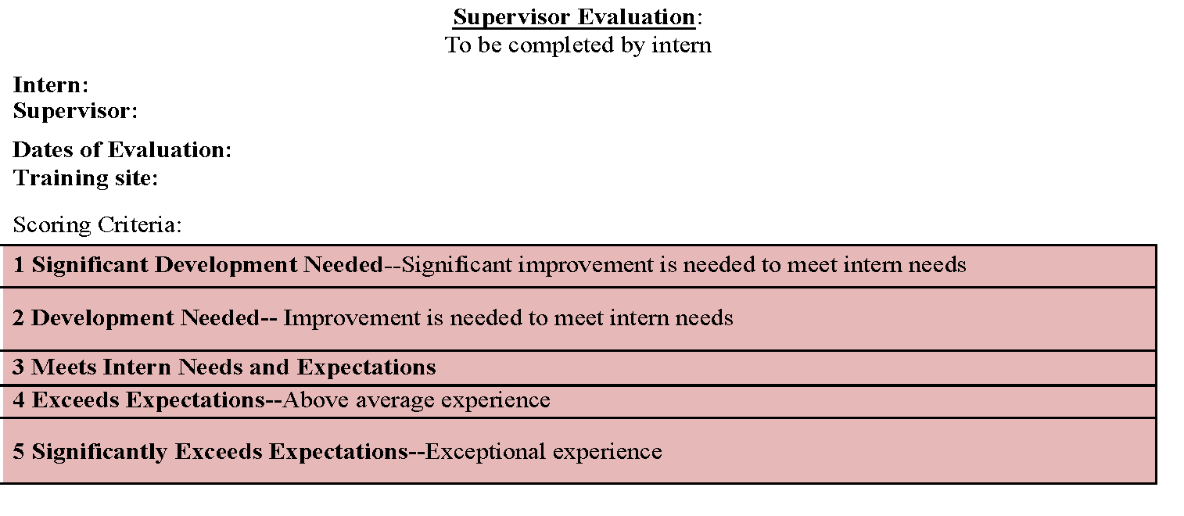
NOTE: Any score below a 3 on any item will result in corrective action as deemed appropriate by the Training Committee in order to improve the intern's supervisory experience.
General Characteristics of Supervisor
Is accessible for discussion, questions, etc
Schedules supervision meetings and is available at the scheduled time
Allots sufficient time for supervision
Keeps sufficiently informed of case(s)
Is interested in and committed to supervision
Sets clear objectives and responsibilities throughout supervised experience
Is up-to-date in understanding of clinical populations and issues
Presents as a positive role model
Maintains appropriate interpersonal boundaries with patients and supervisees
Provides constructive and timely feedback on supervisee's performance
Encourages appropriate degree of independence
Demonstrates concern for and interest in supervisee's progress, problems, and ideas
Communicates effectively with supervisee
Interacts respectfully with supervisee
Maintains clear and reasonable expectations for supervisee
Provides a level of case-based supervision appropriate to supervisee's training needs
Supports the intern's successful completion of the internship program
Comments:
Development of Clinical Skills
Assists in coherent conceptualization of clinical work
Assists in translation of conceptualization into techniques and procedures
Is effective in providing training in behavioral health intervention
Is effective in providing training in assessment and diagnosis
Is effective in providing training in interdisciplinary collaboration and consultation
Is effective in helping to develop short-term and long-range goals for patients
Promotes clinical practices in accordance with ethical and legal standards
Promotes intern's general acquisition of knowledge, skills, and competencies
Comments:
Summary
Overall rating of supervision with this supervisor
Describe how the supervisor contributed to your learning:
Describe how supervision or the training experience could be enhanced:
Any other suggestions/feedback for your supervisor?

Intern Signature Date

Supervisor Signature Date

Due Process Procedures

Due Process Procedures are implemented in situations in which a supervisor or other faculty member raises a concern about the functioning of a psychology intern. These procedures are a protection of intern rights and are implemented in order to afford the intern with every reasonable opportunity to remediate problems and to receive support and assistance. These procedures are not intended to be punitive.

Definition of a Problem
For purposes of this document, a problem is defined broadly as an interference in professional functioning which is reflected in one or more of the following ways: 1) an inability and/or unwillingness to acquire and integrate professional standards into one's repertoire of professional behavior; 2) an inability to acquire professional skills in order to reach an acceptable level of competency; and/or 3) an inability to control personal stress, and/or excessive emotional reactions which interfere with professional functioning.
Administrative Hierarchy and Definitions
The internship program’s Due Process procedure occurs in a step-wise fashion, involving greater levels of intervention as a problem increases in persistence, complexity, or level of disruption to the training program. Faculty roles included herein are defined as follows:
Supervisor: Any faculty member or training psychologist who provides direct supervision or teaching to an intern.
Training Director (TD): The supervisor who functions as the director of training. The training director leads the internship Training Committee and oversees the training program.
Informal Review
When a supervisor believes that an intern’s behavior is becoming problematic, the first step in addressing the issue is to raise the issue with the intern directly and as soon as feasible in an attempt to informally resolve the problem. This may include increased supervision, didactic training, and/or structured readings. This process is documented in writing and discussed with the Training Director, but will not become part of the intern’s professional file.
Formal Review
If an intern’s problem behavior persists following an attempt to resolve the issue informally, or if an intern receives a rating below the minimum level of achievement on a supervisory evaluation, a formal review process is initiated. A minimum level of achievement at the 1st and 2nd evaluation time points is defined as a rating of “3” (Intermediate Competence) for each element. A minimum level of achievement at the 3rd evaluation time point (end of the training year) is defined as a rating of “4” (Proficient Competence) for each element. The decision to move from informal to formal procedures is frequently based upon professional judgment. The following guidelines are used to support this determination:

- The intern does not acknowledge, understand, or address the problem when it is identified;
- The problem is not merely a reflection of a skill deficit which can be rectified by the scheduled sequence of clinical or didactic training;
- The quality of services delivered by the intern is sufficiently negatively affected;
- The problem is not restricted to one area of professional functioning;
- A disproportionate amount of attention by training personnel is required;
- The trainee's behavior does not change as a function of feedback, and/or time;
- The problematic behavior has potential for ethical or legal ramifications if not addressed;
- The intern's behavior negatively impacts the public view of the agency;
- The problematic behavior negatively impacts the intern cohort;
- The problematic behavior has the potential to cause harm to a patient; and/or,
- The problematic behavior violates appropriate interpersonal communication with agency staff.

The decision to move to a formal review process is made by the Training Committee. If a formal review is initiated, the following process will occur:
- The supervisor will meet with the Training Director (TD) and intern within 10 working days to discuss the problem and determine what action needs to be taken to address the issue. If the TD is the intern’s direct supervisor, an additional member of the Training Committee will be included in the meeting.
- The intern will have the opportunity to provide a written statement related to his/her response to the problem. This response must be submitted to the Training Director within 3 working days of the meeting in step A.
- After discussing the problem and the intern's response, the supervisor and TD may:
  - Issue an "Acknowledgement Notice" (issued within 5 working days of the meeting described in A)which formally acknowledges:
    - that the faculty is aware of and concerned with the problem;
    - that the problem has been brought to the attention of the intern;
    - that the problem is not significant enough to warrant further remedial action at this time.
  - Determine that the intern requires a remediation plan. A remediation plan includes actively and systematically monitoring, for a specific length of time, the degree to which the intern addresses, changes and/or otherwise improves the problematic behavior or skill deficit. The length of the remediation period will depend upon the nature of the problem and will be determined by the intern’s supervisor and the TD. A written remediation plan is shared with the intern and the Director of Clinical Training at the intern’s graduate institution and includes:
    - the actual behaviors or skills associated with the problem;
    - the specific recommendations for rectifying the problem;
    - the time frame during which the problem is expected to be ameliorated; and,
    - the procedures designed to ascertain whether the problem has been appropriately rectified.
This statement will be issued within 10 working days of the meeting in step A. At the end of this remediation period, the TD will provide a written statement indicating whether or not the problem has been remediated. This statement will become part of the intern’s permanent file.
  - In special cases, the intern may be allowed to switch supervisors within the internship program. This option would be applicable in situations in which it is believed that the intern’s difficulties are the result of a poor “fit” between the intern and supervisor and that the intern could be successful in a different supervisory relationship. This option would require a meeting of a review panel convened by the Training Director and consisting of him/herself, the intern’s primary supervisor, and at least two other members of the Training Committee or supportive faculty. Additional parties who are knowledgeable about the intern’s abilities may be involved in order to inform decision making. This meeting, if deemed necessary by the Training Director, will be convened within 10 working days of the original meeting discussed in step A.
- If the problem is not rectified through the above processes, or if the problem represents gross misconduct or ethical violations that have the potential to cause harm, the intern’s placement within the internship may be terminated. The decision to terminate an intern’s placement would be made by the entire Training Committee and would represent a discontinuation of participation by the intern within every aspect of the training program. The Training Committee would make this determination during a meeting convened within 10 working days of the original meeting discussed in step A, or during the regularly-scheduled weekly Training Committee meeting, whichever occurs first. The TD may decide to temporarily suspend an intern’s clinical activities during this period prior to a final decision being made, if warranted. In the event of dismissal, APPIC, APA, and the intern’s Director of Training at the intern’s home doctoral program would be contacted.

Appeals Process
If the intern wishes to challenge the decisions made, they may request an Appeals Hearing. This request must be made in writing- an email will suffice- to the TD within 5 working days of notification regarding the decision made in step C or D above. If requested, the Appeals Hearing will be conducted by a review panel convened by the TD and consisting of the TD, the intern’s primary supervisor, and at least two members of the Training Committee. If the TD is the intern’s primary supervisor, an additional member of the Training Committee will be included. The intern may request a specific member of the Training Committee to serve on the review panel. A representative from the intern’s doctoral program may also attend as a support person for the intern, if requested. The Appeals Hearing will be held within 10 working days of the intern’s request. The review panel will review all written materials and have an opportunity to interview the parties involved or any other individuals with relevant information. The review panel may uphold the decisions made previously or may modify them. The review panel has final discretion regarding the outcome.

Notifying the Sponsoring Doctoral Program
If either the Acknowledgment Notice or the remediation action occurs, the TD will inform the intern's sponsoring university within 5 working days, indicating the nature of the inadequate rating, the rationale for the action, and the action taken by the faculty. The intern shall receive a copy of the letter to the sponsoring university.

Once the Acknowledgment Notice or remediation is issued by the TD, it is expected that the status of the problem or inadequate rating will be reviewed no later than the next formal evaluation period or, in the case of remediation, no later than the time limits identified in the probation statement. If the problem has been rectified to the satisfaction of the faculty and the intern, the sponsoring university and other appropriate individuals will be informed and no further action will be taken.

Grievance Procedures

Grievance Procedures are implemented in situations in which a psychology intern raises a concern about a supervisor or other faculty member, staff member, trainee, or the internship training program. These guidelines are intended to provide the psychology intern with a means to resolve perceived conflicts. Interns who pursue grievances in good faith will not experience any adverse professional consequences. For situations in which an intern raises a grievance the following steps will occur:

Informal Review
First, the intern should raise the issue as soon as feasible with the involved supervisor, staff member, other trainee, or TD in an effort to resolve the problem informally. In some cases, the TD or another Training Committee member may wish to meet with the intern and the individual involved in order to provide consultation related to the issue. The goal of the meeting will be to develop a plan of action to resolve the matter informally. The plan of action will include:
a) the behavior or problem associated with the grievance;
b) the specific steps to rectify the problem; and,
c) a designated time at which the parties will meet again to ascertain whether the problem has been appropriately rectified.

Formal Review
If the matter cannot be satisfactorily resolved using informal means, the intern may submit a formal grievance in writing to the TD. If the TD is the object of the grievance, the grievance should be submitted to another member of the Training Committee. A response to the intern will be provided in writing within 10 working days.

A review of the formal grievance will be conducted by a review panel convened by the TD and consisting of the TD, the Deputy TD, and at least two members of the Training Committee. If the TD or Deputy TD are the object of the grievance, an additional member of the Training Committee will be included. The review panel will review all written materials and have an opportunity to interview the parties involved or any other individuals with relevant information. The intern will be informed that such a review is occurring and given the opportunity to provide the panel with any information regarding the problematic situation(s). The review panel has final discretion regarding the outcome. The TD or other Training Committee member will document the process and outcome of the meeting.
If the review panel determines that a grievance against a staff member cannot be resolved internally or is not appropriate to be resolved internally, then the issue will be turned over to agency administrators in order to address the grievance per institutional policies.

Telesupervision Policy
Rochester Psychology Internship Consortium adheres to the telesupervision requirements issued by the APA Commission on Accreditation (APA CoA) through its Standards of Accreditation for Health Service Psychology [Standard II.C.3.] and corresponding Implementing Regulation [C-15 I.] The program requires a minimum of 4 hours of supervision per week, including both individual and group supervision; however, additional supervision may be provided. The distribution of supervision via telesupervision and in-person supervision is as follows:
- Group Supervision: A maximum of 2 hours per week of group supervision will be provided via telesupervision. One hour of group supervision is typically conducted in-person; however, this may be shifted to telesupervision when needed (see below).
- Individual Supervision: A maximum of 2 hours per week of individual supervision may be conducted via telesupervision. One hour of individual supervision is typically conducted in-person; however, this may be shifted to telesupervision when needed (see below).

Telesupervision is used when both interns and supervisors are unable to meet in person, such as during inclement weather, scheduling conflicts, or other circumstances that prevent in-person meetings. It may also be used when remote supervision is deemed appropriate based on the clinical context. Clinical training via telesupervision ensures that interns have continued support during their clinical work, even if face-to-face supervision is temporarily unavailable. The decision to switch between telesupervision and in-person supervision will be made on a case-by-case basis. Factors such as the intern’s technical difficulties, the quality of supervision, clinical needs, and any signs of supervisory rupture will be considered when determining whether to transition between the two formats.

Telesupervision is utilized to ensure flexible, accessible supervision while maintaining the highest standard of training and support. Telesupervision is utilized in the program to enhance accessibility and efficiency, especially for interns who are geographically dispersed across various training sites. The flexibility of telesupervision allows interns to receive high-quality supervision without the limitations of distance or scheduling conflicts. It also reflects the growing integration of telehealth services in behavioral healthcare, providing interns with direct experience in utilizing telecommunication tools as part of their professional development. Telesupervision is consistent with the program’s overall training aims and outcomes by promoting access to behavioral healthcare, including telehealth practices, and by fostering the development of competencies in utilizing technology for therapeutic services. By incorporating telesupervision, the program aligns with its goals to prepare interns for contemporary clinical practice, which increasingly involves telehealth and remote supervision models.

The program engages in regular self-assessment to evaluate trainee outcomes and satisfaction with telesupervision compared to in-person supervision. This is done through intern surveys where interns are asked to provide feedback on the effectiveness of telesupervision, including their satisfaction with communication, quality of interaction, and overall learning experience. The feedback is reviewed by program administrators to determine whether adjustments are necessary to enhance the telesupervision process.

All interns are provided with a laptop with a camera, access to HIPAA-compliant telehealth/telesupervision tool (Zoom, Microsoft teams, and/or Webex), and all clinical sites provide secure internet connections. Telesupervision is provided to interns who have access to necessary technology, including a secure internet connection, a webcam, and a private location to engage in supervision. Interns on a remediation plan may participate in telesupervision only if they demonstrate sufficient progress toward meeting program performance expectations and competencies including self-direction, timely communication, technological proficiency, and the ability to engage in reflective practice as determined by supervisor evaluations.

All telesupervision occurs over a secure network (e.g., the system/network includes encryption) using real-time videoconferencing technology. Supervision sessions using this technology are never recorded, thus protecting the privacy and confidentiality of all trainees and clients. Both interns and supervisors receive training on how to use these technologies effectively at the start of the internship year. This training includes instruction on troubleshooting, maintaining confidentiality, and ensuring the technology meets the program’s quality requirements. The program provides training and ongoing support to interns and supervisors to ensure they are prepared to utilize telesupervision.

At the onset of the internship, supervisors and interns engage in an initial in-person or virtual meeting to establish a professional supervisory relationship. This relationship is grounded in mutual respect, clear expectations, and an understanding of how supervision will be conducted (either in-person or via telesupervision). This foundational meeting ensures that both parties are comfortable with the technology and can effectively communicate. The program ensures that the supervisory relationship is maintained through regular check-ins, clear communication, and open feedback. Supervisors actively monitor the relationship for any issues, such as communication breakdowns, lack of engagement, or dissatisfaction with the supervision format. If a rupture occurs, the supervisor and intern will address it promptly and include the TD if needed, to restore the integrity of the supervisory relationship.

For all clinical cases discussed during telesupervision, full professional responsibility remains with the intern’s supervisor, and any crises or other time-sensitive issues are reported to that supervisor immediately. Interns are provided contact information for all supervisors including email and phone numbers, so crises and time-sensitive information can be reported as necessary. Non-scheduled consultation and crisis coverage are managed by ensuring that interns have immediate access to their supervisor via email or phone for urgent matters. Supervisors are also available for real-time consultations during telesupervision, and interns are encouraged to reach out as needed for support during crises or time-sensitive issues. Interns also have consistent access to additional on-site supervisors and/or clinical management personnel at all times, in order to ensure a high level of in-person support.

The program adheres to strict privacy and confidentiality standards. All telesupervision occurs via encrypted videoconferencing technology to protect the privacy of both trainees and clients. Supervisors and interns are instructed on maintaining confidentiality in the virtual environment, including using secure locations for meetings and safeguarding any electronic records. Supervision sessions using this technology are never recorded, thus protecting the privacy and confidentiality of all trainees and clients.

The program ensures that telesupervision is accessible to all interns, including those with disabilities or other specific needs. Interns are supported in overcoming any technical barriers and are provided with the necessary resources to ensure they can fully participate in telesupervision. The program is committed to addressing issues of diversity, equity, and inclusion by promoting culturally competent practices in virtual environments, ensuring that all interns have an equal opportunity to succeed in their training.

Artificial Intelligence Policy
Interns are expected to develop and hone clinical skills without relying on AI technology. By upholding this policy, the internship consortium is committed to fostering the growth and development of intern through hands-on experience and direct engagement with clients and supervisors. Our policy emphasizes the importance of maintaining patient confidentiality, obtaining informed consent, and upholding professional integrity. AI tools may be utilized for non-clinical work; however, they should always be discussed with a supervisor and should be accompanied by human oversight.

Please sign this acknowledgment page and return to the Training Director.

Acknowledgment of Receipt of Handbook

I acknowledge that I have received and reviewed the Rochester Psychology Internship Consortium’s Intern Handbook, including APA’s Ethical Principles of Psychologists and Code of Conduct, Due Process, and Grievance Procedures. I agree to abide by all policies and procedures found in the Handbook, and have been provided with a copy to keep in my files.

_____________________________________
Signature

_____________________________________
Print Name

_____________________________________
Date

