FACULTY OFFER PROCESS
- Move the Candidate to Offer
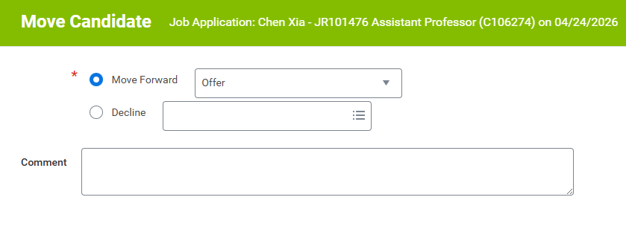
- Once the Candidate Moves to Offer, the next step is for the Hiring Manager or HR Partner(s) to enter the Offer Details. This task will go to both of those roles. So anyone with those roles for the Job Requisition/Supervisory Organization will receive the Task. Any one of those people can take action on the task, but as soon as one completes it, it moves on (task will go away for those that didn’t do anything). You can always see where the task is from the Candidate Record under Job Application Details by clicking on the number under “Awaiting”
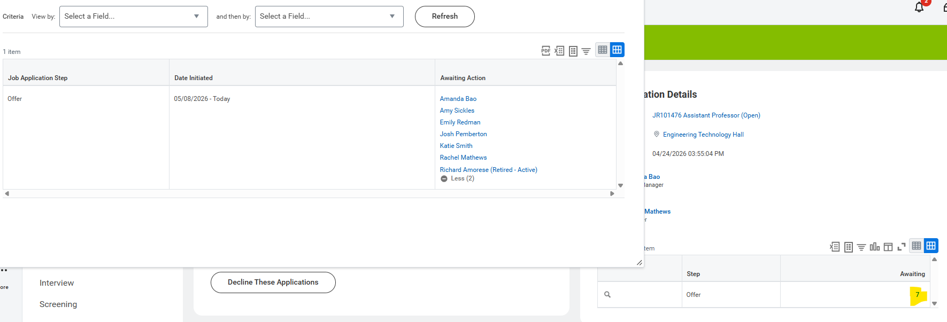
- For this example, I went in as Rachel Mathews (she is an HR Partner on the Supervisory Organization so received the task)
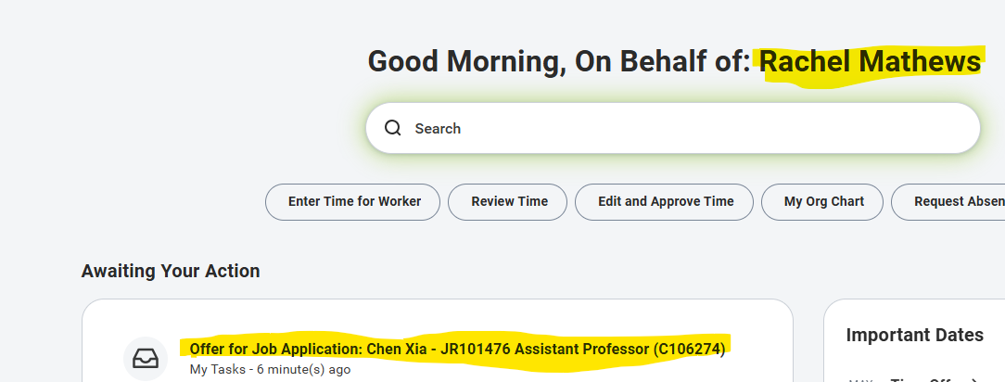
- Offer Details are entered from the Task. There are a couple steps so need to complete each page and select “Next”
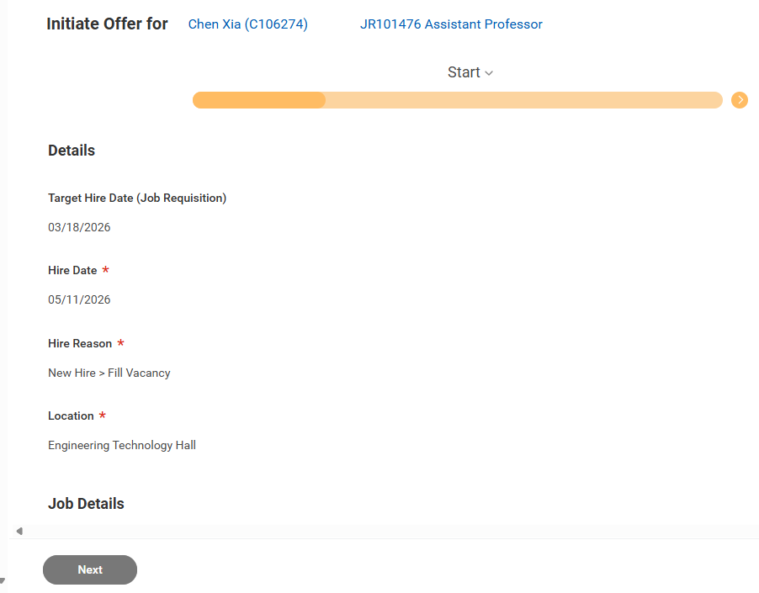
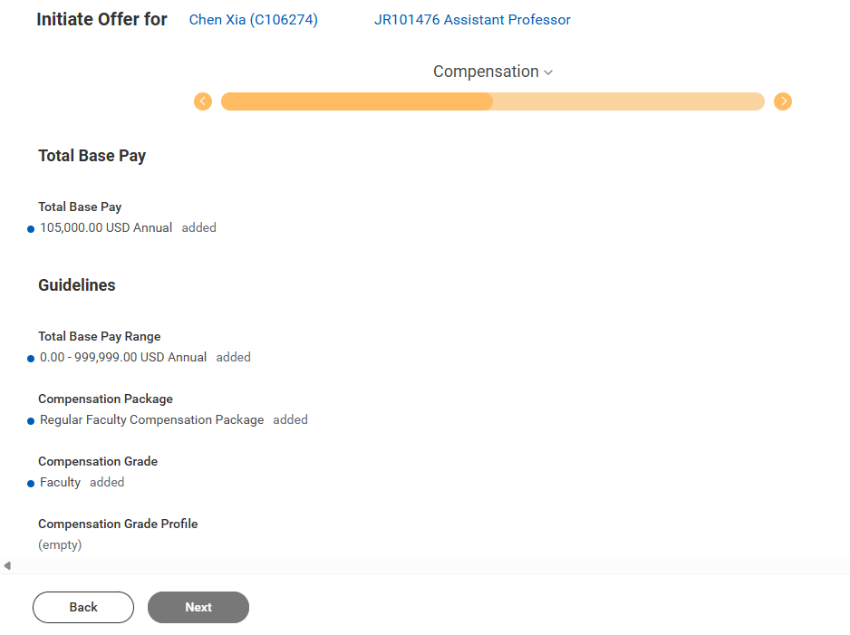
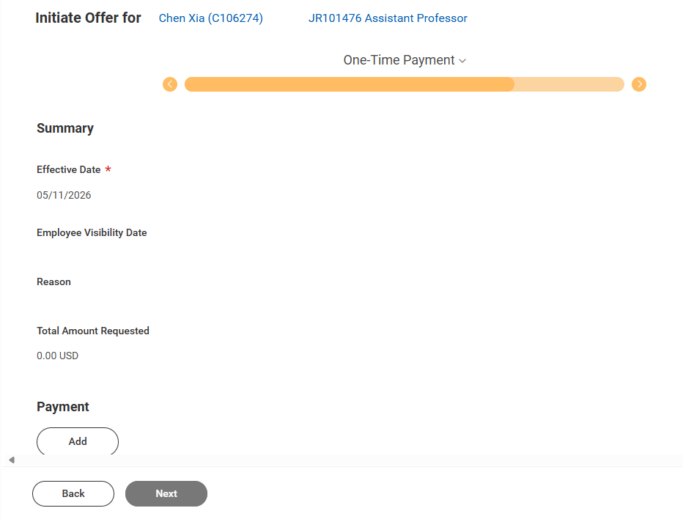
Once the 3 pages are completed, will see the review of all Offer Details and have the option to Submit or Save for Later.
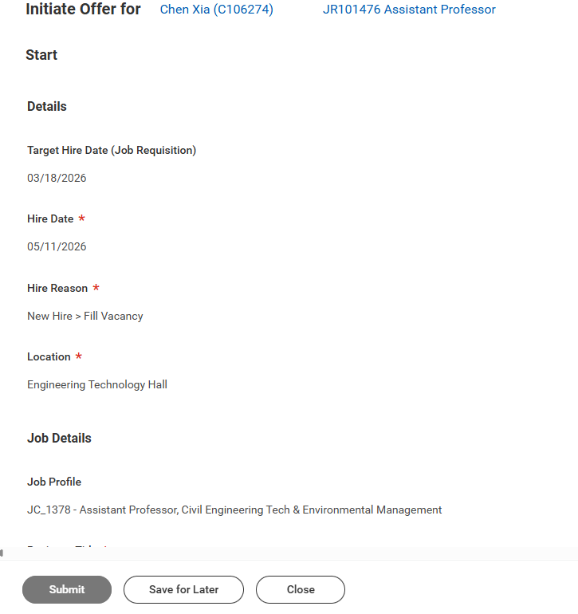
- Click on Submit which generates the next Task to Enter Offer Additional Details (this task again goes to the Hiring Manager and all HR Partner(s))
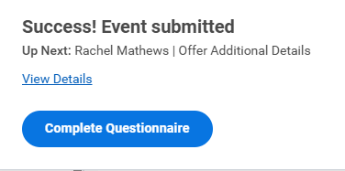
- Once the Offer Additional Details are completed can Submit
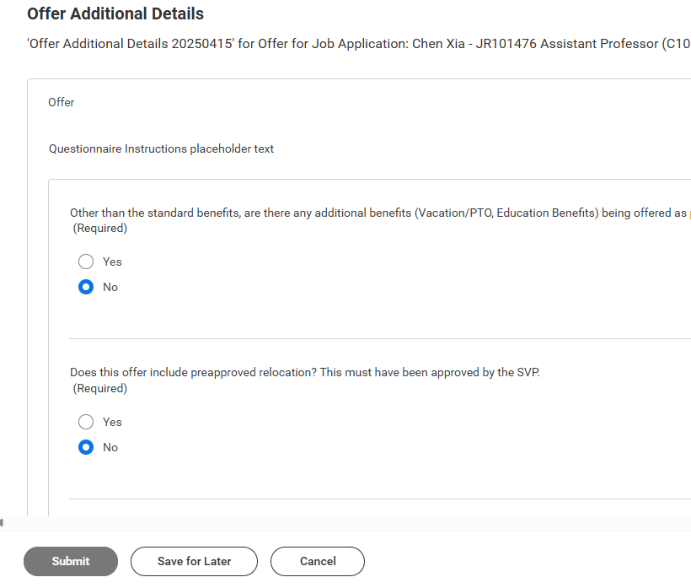
- The Offer Details and Additional Details then go through all the Review and Approval steps which can look a little different based on faculty vs. staff.
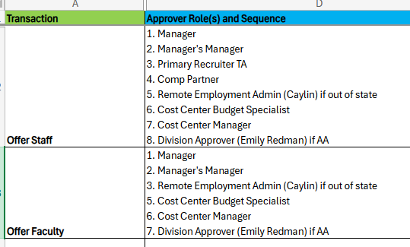
**Please note, all these steps are done before the offer template is generated. This is just gathering and approving all the details that will go in the Offer Letter. Approvers will be able to Send Back during this part of the process and they can select at which point they want to send back to based on what has already taken place. Here is an example from the Cost Center Manager and Send Back
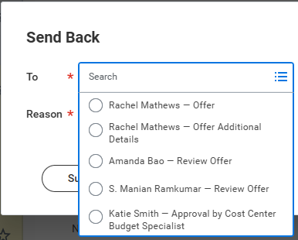
- Once the Offer Details and Offer Additional Details are fully approved, the next step is for the Hiring Manager or HR Partner(s) to complete the Offer Letter template which generates the actual offer letter. This task will go to both of those roles as some of the other steps did before.

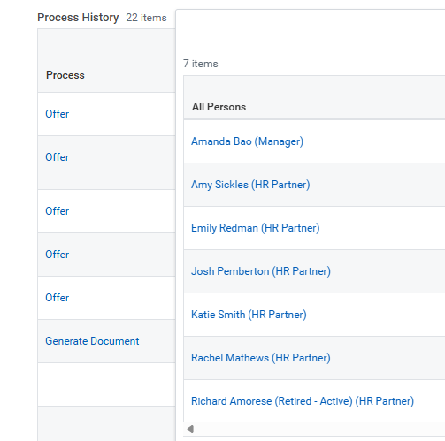
- I will again complete this task as Rachel Mathews
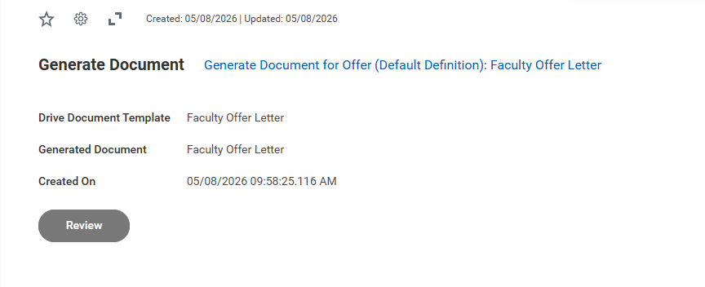
- Click on Review to open and modify the template
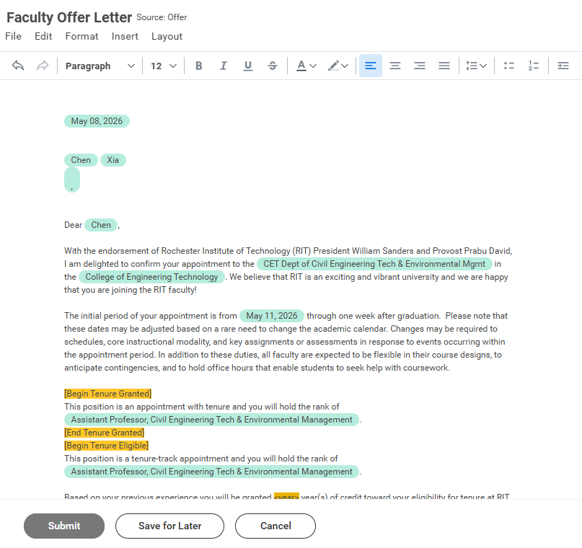
- Once changes are complete, click on Submit
- Generated Offer Letter will now go to the Recruiting Signature Authority which is the Dean who can either Sign or “Don’t Accept”
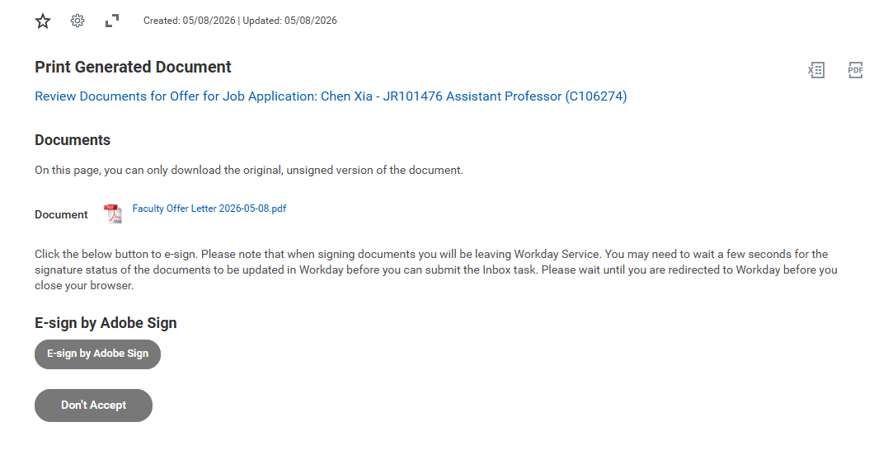
If “Don’t Accept” is selected, a Reason is required and can then select OK which sends it back to the HR Partners who can then determine where in the process it should go next.
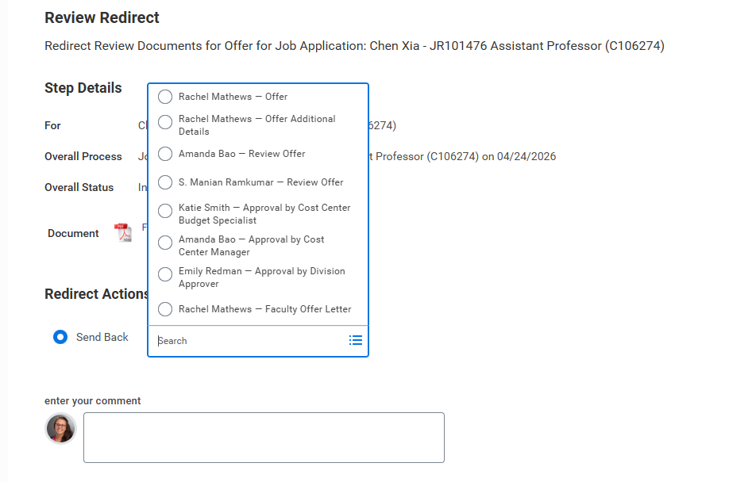
Here is where you can pick the specific steps/approvals in the process that have been completed so far to send back to.
- Offer = Initial Details (including Hire Date etc.) – Step 4 above
- Offer Additional Details (Comp, Work Location etc.) – Step 6 above
- Review Offer – Review Steps after both Offer and Additional Details were completed
- Approvals
- Faculty Offer Letter – Letter Template Generation – Step 10 above

- Recruiting Signature Authority can Select E-sign by Adobe Sign which will then send the generated Offer Letter to the Candidate

