NTID Guidelines for Offering Independent Study Opportunities

Overview
Sometimes, a student will benefit from exposure to material not included in an academic course that is regularly offered. In these instances, a student can seek individualized learning for credit with guidance from a faculty member. Such an arrangement is referred to as “independent study.” RIT policy D03.0 Registration outlines the general framework for how students enroll in and undertake an independent study course:

https://www.rit.edu/policies/d030#v-independent-study-undergraduate-and-graduate

Within NTID, most academic programs have at least one independent study course and these have been created with the following course numbers:
- Associate: 199 (e.g., NLST-199 Independent Study: LST)
- Bachelor: 399 (e.g., INTP-399 Independent Study: ASL-English Interpretation)
- Graduate: 799 (e.g., MSSE-799 Independent Study: MSSE)

The general parameters that pertain to an independent study course are:
- They allow individual students to learn about and to explore content that is not otherwise available to them through an existing course.
- They will be developed and based on student interest and demand and faculty interest and availability.
- They are usually taken on an elective basis.
- They require the development of a signed contract that outlines various parameters of the independent study experience. This contract is stored as part of the student’s permanent RIT record.

When deciding whether to offer an independent study experience, a chairperson and instructor should consider whether enrolling the student in an established traditional course with similar content, creating a special topics course for a group of students, or enrolling the student in a research course are better options. Special topics and research courses are offered using different course numbers than independent study arrangements use.

Process for Creating and Documenting an Independent Study Experience
Once a student, faculty sponsor, and chairperson conclude that implementing an independent study course is appropriate for a student’s circumstances, there are specific steps necessary to document the purpose of the independent study project and to enroll the student in the course. The first step is for the faculty sponsor and student to agree on the terms of the independent study project and to document the parameters on the NTID independent study contract form, which can be found online:

https://www.rit.edu/ntid/president/academic-affairs/curriculum#guidelines-and-forms

Click on “Course Actions” to find the independent study contract form (see yellow highlighted item 5 in the list):

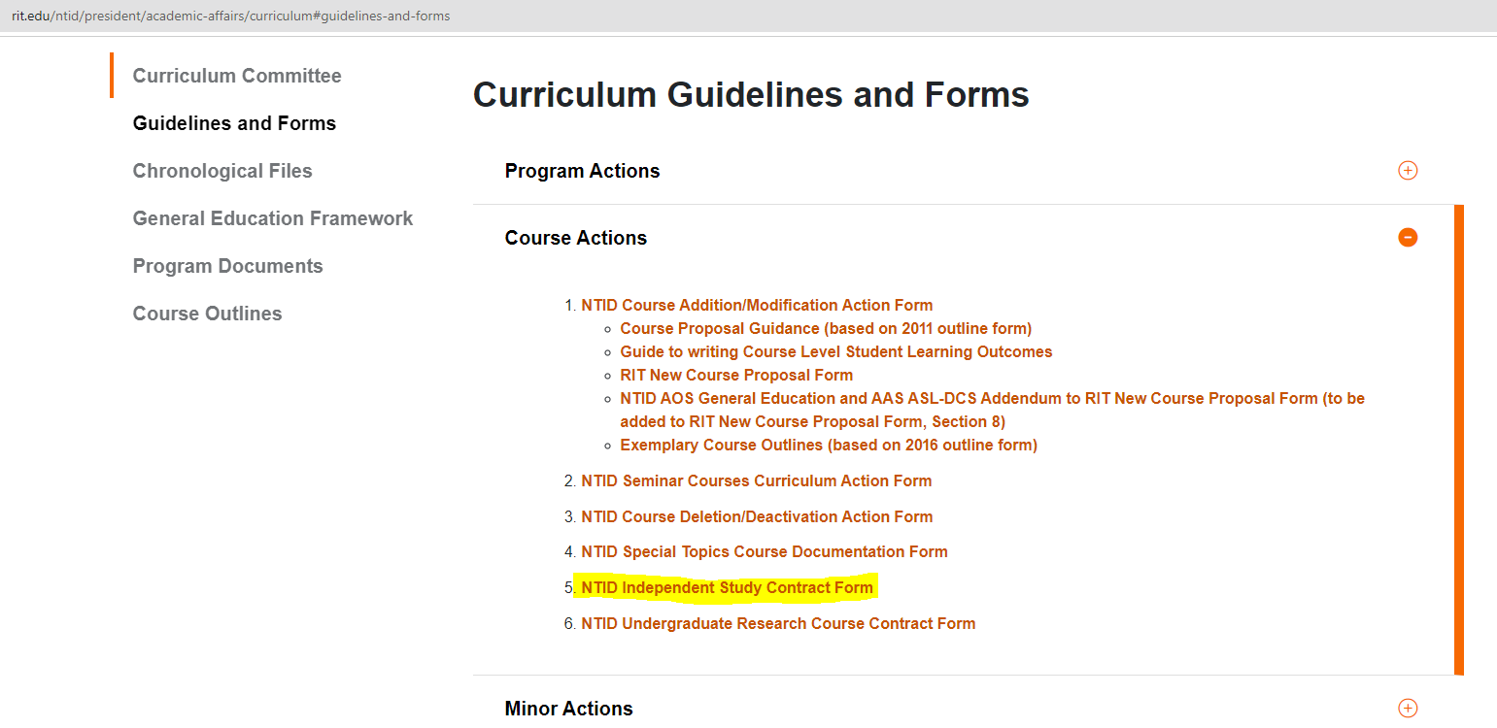

The student and instructor then fill out the information (student name, university ID, faculty sponsor, course code and number, advisor/counselor, etc.) at the top of the form:

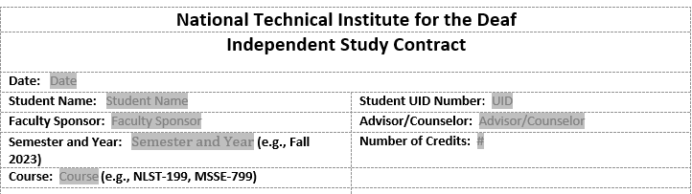

The instructor, consulting with the student, will determine the Objectives, Activities, and Method of Evaluation and will document them in these sections of the form. Lastly, the student, faculty sponsor, and chairperson must sign the form.

Once the independent study form has been completed and signed, the chairperson will send it to the NTID Scheduling Officer who will review it to ensure all information is correct. The Scheduling Officer will then create the course section in SIS (Student Information System), enroll the student, and send the contract form to the Registrar’s Office so that it can be added to the student’s record in OnBase. If any issues arise, either the Registrar’s Office or the Scheduling Officer will follow up.

