Responding to the Climate Crisis:
Is the Whole World deaf?

Andrew Manning
University of East Anglia, Norwich, UK

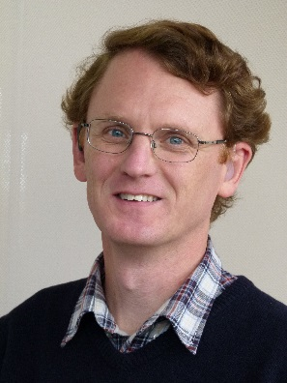

Abstract:
Climate change is the most important issue of our times and has been called an “existential threat” to the human race. But it doesn’t feel like that because it is a long-term, slow process. This only makes it even more important that we don’t ignore it, and that we do something about it. The first step is to understand what “climate change” really means, by looking at the science, not social media. In this talk, I will discuss what causes climate change, the evidence that it is happening, and predictions for the future. Many of the facts can be scary, but by taking action there is hope.
I will also discuss my own research to better understand carbon dioxide (CO₂), which is, by far, the most important greenhouse gas causing man-made climate change. Despite this importance there are large gaps in our scientific knowledge of the carbon cycle. From a personal perspective, I will discuss the changing environment climate scientists find themselves in, with respect to their engagement with policy-makers, the media, climate denialists, and the general public.
My Background:
I was born and raised in New Zealand, where I obtained a Bachelor of Engineering degree from the University of Canterbury in 1990, before moving to the USA where I obtained my Ph.D. at the Scripps Institution of Oceanography in 2001. During my Ph.D. I set up atmospheric oxygen measurements in New Zealand, which is now the longest record of continuous oxygen measurements in the world. After the USA, I moved to Germany and worked at the Max Planck Institute for Biogeochemistry, where I was leader of the “Tall Towers Group”, establishing greenhouse gas measurements in Germany, Poland and Siberia. Since 2006, I have been in England, at the School of Environmental Sciences, University of East Anglia (UEA). At UEA, I established the “Carbon Related Atmospheric Measurement (CRAM) Laboratory”, and I teach the next generation of students about the urgency, importance and intricacies of climate change.
I have been profoundly deaf since I was one year old, but I attended mainstream schools and so sadly I never learned NZSL. I did, however, take ASL classes during my Ph.D., where I was also very lucky to meet Carol Padden, Tom Humphries and Rain Bosworth. I am particularly proud of my deaf sister, Victoria Manning, who, as well as being a Gallaudet alumnus, has been a very strong advocate for deaf and disabled rights in New Zealand. Victoria currently works for the New Zealand Department of Health, championing access and rights for all disabled people.

