SCHOOL OF CHEMISTRY AND MATERIALS SCIENCE

Chemical Analysis Laboratory
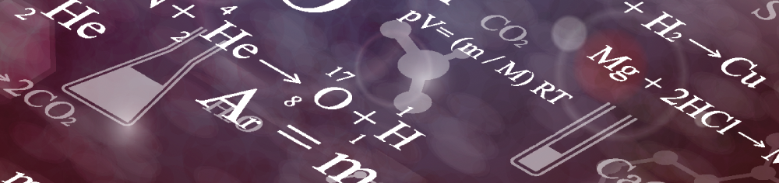

Services
* Discounts may apply for 10 or more samples.
** Additional charges may apply for extensive sample preparation or data interpretation. Please call for a quote.
Instrument | Model | Cost Per Sample* | Other Associated Costs**
Atomic Absorption | - Perkin-Elmer Aanalyst 800 with Graphite Furnace  - Perkin-Elmer Aanalyst 100 | $50 | $5 per element sample
Fluorimeter | - Horiba Jobin Yvon Fluoromax-4  - Perkin-Elmer LS-55 | $50
Infrared Spectrophotometers | - Biorad Excalibur with ATR and Diffuse Reflectance Capabilities  - Shimadzu IR Prestige-21 with ATR/li> | $50
HPLC | - HP 1100 with UV-VIS, Diode Array, RI Detection, and GPC Capabilities  - Shimadzu Prominence with UV-VIS Detector | $75
NMR | - Bruker Avance III 500 capable of measuring carbon, hydrogen, and fluorine  - Bruker Avance DRX 300 capable of measuring carbon, hydrogen, and fluorine. Note: Other Nuclei with spin can also be determined. Call for a quote. | $75
UV-VIS | - HP 8543 Diode Array  - PerkinElmer Lamda 25  - Shimadzu UV-2501PC – High Resolution  - HP 8453 Diode Array | $50
DSC | - TA 2010 with cold temperature capabilities  - PerkinElmer Diamond with cold temperature capabilities | $70
TGA | - TA 2050  - TA Q500 | $70
DMA | - Seiko DMS110 with cold temperature capabilities  - Perkin Elmer DMA 8000  - Seiko DMS200 with cold temperature capabilities | $80
GC-MS | - HP 6890/5973 GC/MS | $80
Rheometry | - TA AR 2000 Rheometer | $75
LC/MS/MS | - Applied Biosystems Q Trap | $80
Melt Flow | - Tinius Olsen MF Index | $75

