Rochester INSTITUTE OF TECHNOLOGY
Minor Program proposal form

B. Thomas Golisano College of Computing and Information Sciences

Information Sciences and Technologies
Name of Minor: Geographic Information Systems (GIS)

Brief Description of the Minor to be used in University Publications:

The Geographic Information Systems (GIS) minor provides students with experience in concepts, technology and applications related to computer-based mapping, spatial databases, and geographic analysis and problem solving. The minor features two tracks – a GIS development track for students interested in GIS software development and a GIS analysis track for students interested in utilizing GIS as a strong methodological base within their major degree of study. Required courses provide core GIS foundations applicable to a variety of multidisciplinary elective courses students can chose from to match their research, post-graduate or career GIS interests.

1.0 Minor Program Approvals
 | Approval request date: | Approval granted date:
Academic Unit Curriculum Committee | 12/4/12 | 2/13/13
College Curriculum Committee | 4/19/13 | 5/3/13
Inter-College Curriculum Committee | 5/6/13 | 5/8/13

2.0 Rationale:
Modern Geographic Information System (GIS) and related technologies such as mobile mapping applications and web-based geographic visualization environments continue to expand in societal use. The evolution of GIS technology has, in turn, created a proliferation of myriad GIS application domains such as emergency response, transportation modeling, urban and community planning and digital humanities and is creating opportunities for the training and education of the next generation of technicians and scientists from multiple disciplines that can analyze geographic information. Furthermore, the variety, computing power and development potential of GIS is creating opportunities for the training and education of the next generation of software developers and information scientists that can fuse (a) underlying scientific principles of geographic information and representation with (b) advanced software development technical skills for (c) facilitating the processes of advanced science and spatially-oriented problem solving and application development. For example, custom developed GIS software is essential to support scientific inquiry into complex problems such as understanding how people are vulnerable to the effects of climate change.

This minor is open to all RIT students who are interested in learning about and gaining practical experience with GIS. To accommodate diverse student GIS interests and matching GIS industry trends, the minor has two tracks. The GIS development (GIS-D) track is primarily intended for (although not exclusive to) computing major students that wish to advance their technical and scientific investigation skills and/or pursue careers as GIS developers with the customization and development of GIS software via advanced skill levels in technical areas such as programming. The GIS analyst (GIS-A) track is primarily intended for (although not exclusive to) non-computing major students that wish to advance their technical and scientific investigation skills with GIS and where GIS constitutes a strong methodological base within their major degree of study. Given the strong technical focus of GCCIS students in general and the synergy we have observed in our teaching that is created when these technical background are utilized for GIS development, we believe students pursing the GIS-D track of this minor will be very successful. Given the diversity and increase of non-GCCIS students enrolled in Introduction to Geospatial Technologies (ISTE-382), we believe the GIS-A track of this minor will be very successful.

How is this set of academic courses related?
All students completing this minor will have solid foundations in basic principles of geographic information (scale, coordinate systems, spatial indexing), spatial database structures and handling, spatial modeling, cartography, introductory GIS programming and desktop GIS software operation. Students pursuing the GIS-D track will develop skills such as advanced GIS programming, advanced GIS application development practice and new, emerging areas of GIS development. Students pursuing the GIS-A track will develop skills such as spatial analysis, and learn how to design, implement and present results from a GIS-oriented research project.

3.0 Multidisciplinary involvement:

If this is a multidisciplinary minor spanning two or more academic units, list the units and their role in offering and managing this minor.
GCCIS-IST will manage the minor. The proposed minor includes courses from COLA-English, COS-Center for Imaging Science and CAST-Civil Engineering Technology, Environmental Management and Safety. Each of these units have granted permission to include elective courses from their respective course offerings in the GIS minor. None of these units will be responsible for managing this minor.

4.0 Students ineligible to pursue this minor:
The purpose of the minor is both to broaden a student's college education and deepen it in an area outside the student’s major program. A minor may be related to and complement a student’s major, or it may be in a completely different academic/professional area. It is the responsibility of the academic unit proposing a minor and the unit’s curriculum committee to indicate any home programs for which the minor is not a broadening experience.

Please list below any home programs whose students will not be allowed to pursue this minor, provide the reasoning, and indicate if this exclusion has been discussed with the affected programs:
The proposed minor is open to all RIT majors and no students will be excluded.

5.0 Minor Program Structure, Sequence and Course Offering Schedule:
Describe the structure of the proposed minor and list all courses, their anticipated offering schedule, and any prerequisites.
- All minors must contain at least fifteen semester credit hours;
- Minors may be discipline-based or interdisciplinary;
- In most cases, minors shall consist of a minimum of two upper division courses (300 or above) to provide reasonable breadth and depth within the minor;
- As per New York State requirements, courses within the minor must be offered with sufficient frequency to allow students to complete the minor within the same time frame allowed for the completion of the baccalaureate degree;
- Provide a program mask showing how students will complete the minor.

Narrative of Minor Program Structure:
The minor consists of five courses of three credits each. All students must take GCCIS-ISTE-382 (Introduction to Geospatial Technologies), followed by GCCIS-ISTE-384 (Introduction to Geographic Information Systems). Beyond these two required classes (which can be taken in one academic year), students can choose three electives to complete the minor. A recommended (but not required) three course elective sequence for students interested in the GIS-D track is GCCIS-ISTE-386 (GIS Programming), GCCIS-ISTE-482 (Geospatial Data Analysis) and GCCIS-ISTE-484(Thematic Cartography and Geovisualization). ISTE-386 can be taken concurrently with GCCIS-ISTE -484. A recommended (but not required) three course elective sequence for students interested in the GIS-A track is GCCIS-ISTE-482 (Geospatial Data Analysis), ISTE-230 (Introduction to Database and Data Modeling) and GCCIS-ISTE-483- Information Science and Technology Research. ISTE-230 can be taken concurrently with GCCIS-ISTE -482. The minor also includes non-GCCIS electives that include COLA-ENGL-422 (Maps, Spaces and Places), COS-IMGS-431 (Environmental Applications of Remote Sensing) and CAST-CVET-160 (Surveying). The minor will require a minimum of three semesters to complete.

Course Number & Title | SCH | Required | Optional | Fall | Spring | Annual/Bi annual | Prerequisites
GCCIS-ISTE-382: Introduction to Geospatial Technologies | 3 | Yes | No | Yes | No | Annual | None
GCCIS-ISTE-384: Introduction to Geographic Information Systems | 3 | Yes | No | No | Yes | Annual | GCCIS-ISTE-382
GCCIS-ISTE-482: Geospatial Data Analysis | 3 | No | Yes | Yes | No | Annual | GCCIS-ISTE-384
GCCIS-ISTE-386: GIS Programming | 3 | No | Yes | Yes | No | Annual | GCCIS-ISTE-384, ISTE-100 or ISTE-120 or similar
GCCIS-ISTE-484: Thematic Cartography and Geovisualization | 3 | No | Yes | No | Yes | Annual | GCCIS-ISTE-386
GCCIS-ISTE-230: Introduction to Database and Data Modeling | 3 | No | Yes | Yes | Yes | Biannual | GCCIS-ISTE-384
GCCIS-ISTE-483: Information Science and Technology Research | 3 | No | Yes | No | Yes | Annual | Fourth year standing
COLA-ENGL-422: Maps, Spaces and Places | 3 | No | Yes | Yes | No | Annual | None
COS-IMGS-431 Environmental Applications of Remote Sensing | 3 | No | Yes | Yes | No | Annual | ENVS-250 or GCCIS-ISTE-384 and permission of instructor
CAST-CVET 160 – Surveying CVET 161 (Surveying Lab) | 4 | No | Yes | Yes | No | Annual | None

Total credit hours: 15

Figure 1 graphically outlines the minor’s program mask.

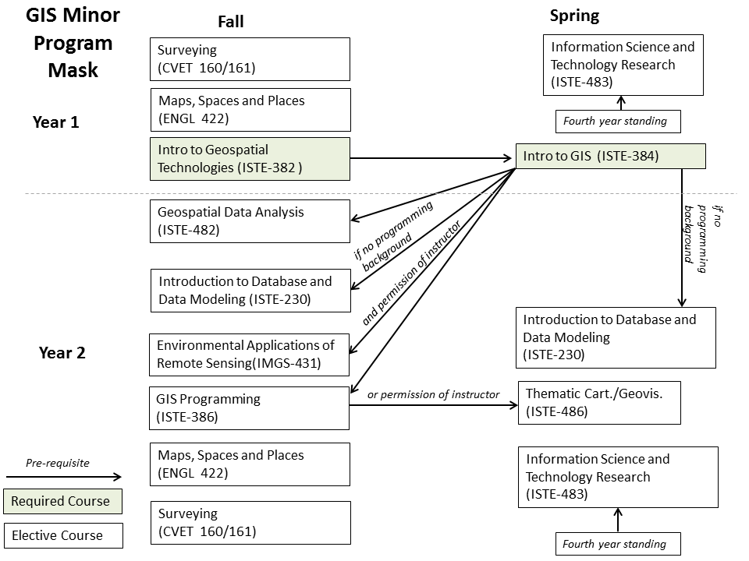
Figure 1: GIS Minor program mask.

Table 1 outlines recommended elective courses for completing the GIS-D and GIS-A tracks. However, these tracks are not exclusive and students can choose any three electives. The two required courses for the minor (ISTE-382 and ISTE-384) are not included in Table 1.

Table 1: Recommended Track Elective Courses for advising purposes.
GIS-D Track | GIS-A Track
GCCIS-ISTE-482: Geospatial Data Analysis | GCCIS-ISTE-482: Geospatial Data Analysis
GCCIS-ISTE-386: GIS Programming | GCCIS-ISTE-230: Introduction to Database and Data Modeling
GCCIS-ISTE-484: Thematic Cartography and Geovisualization | GCCIS-ISTE-483: Information Science and Technology Research
 | COS-IMGS-431 Environmental Applications of Remote Sensing
 | COLA-ENGL-422 – 01: Maps, Spaces and Places
 | CAST-CVET 160/161 – Surveying

Please include below course descriptions for all courses in the proposed minor.

6.0 Course Descriptions as they appear in the course catalog:

Course - ISTE-382: Introduction to Geospatial Technologies
This course provides a survey of the underlying concepts from the discipline of Geography and subsequent technologies used to represent and understand the earth, collectively referred to as Geospatial Technologies (GTs). Students will gain hands-on experience with GTs, including Global Positioning Systems (GPSs), Geographic Information Systems (GISs), remote sensing, Virtual Globes, and Web mapping mashups Students also will develop basic geographic thinking, reasoning, problem solving and literacy skills.
Class 3, Credit 3 (F)

Course - ISTE-384: Introduction to Geographic Information Systems
This course introduces students to Geographic Information Systems (GIS). Course lectures, reading assignments, and practical lab experiences will cover a mix of conceptual, practical and technical GIS topics. Topics include GIS data models, basic cartography, geodatabases, spatial data acquisition and creation, spatial analysis, and GIS software operation. Class 3, Credit 3 (Sp)

Course - ISTE-482: Geospatial Data Analysis
This course is an introduction to the theory and techniques used for spatial analysis of complex, geographically referenced data. Topics include and spatial data analysis and statistical techniques for a variety of problem types that span a broad spectrum of disciplines. In-class and out-of-class assignments will develop students’ spatial data analysis skills. Class 3, Credit 3 (F)

Course - ISTE-386: Geographic Information Systems (GIS) Programming
Any serious interest in Geographic Information System (GIS) beyond the “out-of-the-box” capabilities of standard commercial GIS software such as ESRI’s ArcGIS platform requires knowledge of how to program a GIS. Knowledge of how to program a GIS extends the capabilities and possibilities of GIS in numerous scientific, technical, and applied dimensions not possible with “out-of-the-box” GIS capabilities. This course is targeted to students with a serious interest in GIS who wish to apply previously learned object oriented programming concepts within the context of Geographic Information System (GIS) application development across a variety of environments.
(a course in programming, Intro to GIS or permission of instructor) Class 3, Credit 3 (F)

Course - ISTE-484: Thematic Cartography and Geographic Visualization
This course examines concepts and techniques associated with dynamic map construction, usage, and assessment. Specific topics include thematic cartography, geographic information visualization, sources of dynamic geographic information, developing animated and interactive maps, mapping mashup development, using maps as a means to support group work, usability of dynamic maps, and current geovisualization research areas. Development of a visualization prototype in an area related to thematic cartography and geographic visualization are required. (one course in a high level programming language).
Class 3, Credit 3 (Sp)

Course - ISTE-230: Introduction to Database and Data Modeling
A presentation of the fundamental concepts and theories used in organizing and structuring data. Coverage includes the data modeling process, basic relational model, normalization theory, relational algebra, and mapping a data model into a database schema. Structured Query Language is used to illustrate the translation of a data model to physical data organization. Modeling and programming assignments will be required. (One course in object-oriented programming or Intro to GIS) Class 3, Credit 3 (F, Sp, Su)

Course -ISTE-483: - Information Science and Technology Research
This course is for students enrolled in the BS IT degree program and minors to demonstrate competence in concepts, techniques and applications via a semester-length research project developed in conjunction with a faculty member and based on the student’s degree concentration or minor. With instructor guidance, students will learn how to formulate a research question, choose relevant methods to answer the question, execute the project and present results in a public forum.
(fourth year standing) Class 3, Lab 0, Credit 3 (Sp)

Course: COLA-ENGL-422 – 01: Maps, Spaces and Places
The course takes as its premise that spatial thinking is critically important, particularly in science, engineering, mathematics and technology the STEM disciplines. Spatial thinking also informs our ability to understand many areas of 21st century culture. The diverse writers, critics and filmmakers represented in this course are rethinking space as a dynamic context for the making of history and for different organizations of social and communal life. The study begins with a meditation on the language of maps and mapmaking, and how they work, exploring the idea that to present a useful and truthful picture, an accurate map must tell lies. The course develops into an exploration of the ways, particularly in texts, that mapmaking and power mutually reinforce various kinds of social authority, and the ways we begin to think about race, class, gender and sexuality, in terms of the natural authority asserted in space. Class 3, Credit 3 (F)

Course: COS-IMGS-431 Environmental Applications of Remote Sensing
This course offers an introduction to remote sensing systems and a selection of environmental applications of remote sensing. The basic properties of electromagnetic radiation, its interaction with the atmosphere and earth surfaces (e.g., vegetation, minerals, water, etc.), and the interpretation of these interactions are dealt with in the first half of the course. This is followed by a description of airborne and spaceborne, active and passive sensors that operate throughout the electromagnetic spectrum for detecting physical phenomena. Finally, an introduction is provided to pre-processing and analysis techniques that are useful for extracting information from such sensors. The Earth's atmospheric, hydrospheric, and terrestrial processes are considered at local to regional scales. Application areas include monitoring vegetation health, measuring biomass (carbon sequestration), identifying cultural features, assessing water resources, and detecting pollution and natural hazards. (ENVS-250 or (GCCIS-ISTE-382 and permission of instructor)) Class 2, Lab 3, Credit 3 (F)

Course: CAST-CVET-160 -01: Surveying
Introduction to fundamentals of surveying. Topics include: note taking; differential leveling; vertical and horizontal measurement; traversing; topographic mapping; horizontal, vertical, compound and reverse curves; earthwork; and GPS/GIS. (Co-requisite: CVET-161 Surveying Lab) Class 3, Credit 4 (includes lab credit) (F)

Policy Name: D1.1 MINORS POLICY
1. Definition
A minor at RIT is a related set of academic courses consisting of no fewer than 15 semester credit hours leading to a formal designation on a student's baccalaureate transcript.
The purpose of the minor is both to broaden a student's college education and deepen it in an area outside the student’s major program. A minor may be related to and complement a student’s major, or it may be in a completely different academic/professional area. It is the responsibility of the academic unit proposing a minor and the unit’s curriculum committee to indicate any home programs for which the minor is not a broadening experience.

In most cases, minors shall consist of a minimum of two upper division courses to provide reasonable breadth and depth within the minor.
2. Institutional parameters
- Minors may be discipline-based or interdisciplinary;
- Only matriculated students may enroll in a minor;
- At least nine semester credit hours of the minor must consist of courses not required by the student's home program;
- Students may pursue multiple minors. A minimum of nine semester credit hours must be designated towards each minor; these courses may not be counted towards other minors;
- The residency requirement for a minor is a minimum of nine semester credit hours consisting of RIT courses (excluding "X" graded courses);
- Posting of the minor on the student's academic transcript requires a minimum GPA of 2.0 in each of the minor courses;
- Minors may not be added to the student's academic record after the granting of the bachelor's degree.

3. Development/approval/administration processes
  - Minors may be developed by faculty at the departmental, inter-departmental, college, or inter-college level. As part of the minor development process:
    - students ineligible for the proposed minor will be identified;
    - prerequisites, if any, will be identified;
  - Minor proposals must be approved by the appropriate academic unit(s) curriculum committee, and college curriculum committee(s), before being sent to the Inter-College Curriculum Committee (ICC) for final consideration and approval.
  - The academic unit offering the minor (in the case of interdisciplinary minors, the designated college/department) is responsible for the following:
    - enrolling students in the minor (as space permits);
    - monitoring students progress toward completion of the minor;
    - authorizing the recording of the minor's completion on student's academic records;
    - granting of transfer credit, credit by exam, credit by experience, course substitutions, and advanced placement;
    - responding to student requests for removal from the minor.

  - As per New York State requirements, courses within the minor must be offered with sufficient frequency to allow students to complete the minor within the same time frame allowed for the completion of the baccalaureate degree.
4. Procedures for Minor revision
It is the duty of the college curriculum committee(s) involved with a minor to maintain the program’s structure and coherence. Once a minor is approved by the ICC, changes to the minor that do not have a significant effect on its focus may be completed with the approval of the involved academic unit(s) and the college curriculum committee(s). Significant changes in the focus of the minor must be approved by the appropriate academic unit(s) curriculum committee(s), the college curriculum committee(s) and be resubmitted to the ICC for final consideration and approval.

See http://www.esri.com/Industries for an expanded list of industry applications of GIS

